DEVI PRIYA.G

E0320016

FASHION WEBSITE

Fashion.html

<!DOCTYPE html>

<html lang="en">

<head>

<meta charset="UTF-8">

<meta http-equiv="X-UA-Compatible" content="IE=edge">

<meta name="viewport" content="width=device-width, initial-scale=1.0">

<link

rel="stylesheet"

href="style.css">

<link href="https://cdnjs.cloudflare.com/ajax/libs/font-awesome/4.7.0/css/font-awesome.min.css" rel="stylesheet">

<link

rel="stylesheet"

href="https://stackpath.bootstrapcdn.com/font-awesome/4.7.0/css/font-awesome.min.css"

integrity="sha384-wvfXpqpZZVQGK6TAh5PVlGOfQNHSoD2xbE+QkPxCAFlNEevoEH3Sl0sibVcOQVnN"

crossorigin="anonymous"

/>

<link

href="https://fonts.googleapis.com/css2?family=Montserrat:ital,wght@1,300&display=swap"

rel="stylesheet"

/>

<link

href="https://fonts.googleapis.com/css2?family=Roboto+Condensed:wght@300&display=swap"

rel="stylesheet"

/>

<link

href="https://fonts.googleapis.com/css2?family=Raleway:wght@300&display=swap"

rel="stylesheet"

/>

<title>Fashion Website</title>

</head>

<body>

<header>

<nav>

<div class="logo">

<h1>Grab & Smile</h1>

</div>

<ul class="items">

<li>

<a href="#" class="link"><i class="fa fa-home"></i> HOME</a><br>

</li>

<li>

<div class="tooltip">

<a href="#" class="link"><i class="fa fa-folder"></i> COLLECTION</a>

<span class="tooltiptext"><p style="text-align: left;font-size: small;color: white;"><p><a href="Mens.html">MEN</a></p></p><hr>

<p style="text-align: left;font-size: small;"><p><a href="Womens.html">WOMEN</a></p></p><hr>

<p style="text-align: left;font-size: small;"><p><a href="Accessories.html">ACCESSORIES</a></p></p></span>

</div>

</li>

</ul>

<div class="nav-btns">

<a href="#" class="btn-nav-i"><i class="fa fa-search"></i></a>

<form control>

<input type="text" placeholder="search" style:align="right";>

</form>

<a href="#" class="btn-nav-i"><i class="fa fa-shopping-cart"></i></a>

<a href="#" class="btn-nav-i"><i class="fa fa-heart"></i></a>

<div class="tooltip1">

<a href="#" class="btn-nav-i"><i class="fa fa-user"></i></a>

<span class="tooltiptext1"><p style="text-align: left;font-size: small;" style="font-style:color= white;"><a href="login.html">SIGN IN</a></p><br></p></span>

</div>

</div>

</nav>

<div class="main">

<div class="main-left">

<div class="social-media">

<a href="Aboutus.html" class="link"><i class="fa fa-address-card"></i></a>

<a href="https://www.instagram.com/renukasundarr/?igshid=1is72oawcfef4" class="media-social-i"><i class="fa fa-instagram"></i></a>

<a href="mailto:devdha268@gmail.com" class="media-social-i"><i class="fa fa-envelope"></i></a>

</div>

</div>

<div class="banner">

<div class="f-text">

<h1>

GRAB <br/>

<span>THE</span> <br/> BEST <br/>

</h1>

</div>

<a href="shopnow.html" class="btn">SHOP NOW!!</a>

</div>

<div class="main-right">

<img src="circle.png" alt="img">

</div>

</div>

</header>

</body>

</html>

Login.html

<!DOCTYPE html>

<html>

<head>

<title>LOG IN</title>

<link rel="stylesheet" type="text/css" href="pro.css">

</head>

<body>

<div class="loginbox">

<img src="circle.png" class="logo">

<h1>LOG-IN</h1>

<form>

<p>USERNAME</p>

<input type="text" name="name" placeholder="Enter username">

<p>PASSWORD</p>

<input type="password" placeholder="Enter password">

</form>

<div class="login">

<a id="p1" href="new.html">

<input type="Login" value="Log-in"> </a>

</div>

<p>

Don't have an account?

<a href=""> Create Account </a>

</p>

</div>

</body>

</html>

Mens.html

<!DOCTYPE html>

<html lang="en">

<head>

<meta charset="UTF-8">

<meta http-equiv="X-UA-Compatible" content="IE=edge">

<meta name="viewport" content="width=device-width, initial-scale=1.0">

<link

rel="stylesheet"

href="style.css">

<link href="https://cdnjs.cloudflare.com/ajax/libs/font-awesome/4.7.0/css/font-awesome.min.css" rel="stylesheet">

<link

rel="stylesheet"

href="https://stackpath.bootstrapcdn.com/font-awesome/4.7.0/css/font-awesome.min.css"

integrity="sha384-wvfXpqpZZVQGK6TAh5PVlGOfQNHSoD2xbE+QkPxCAFlNEevoEH3Sl0sibVcOQVnN"

crossorigin="anonymous"

/>

<link

href="https://fonts.googleapis.com/css2?family=Montserrat:ital,wght@1,300&display=swap"

rel="stylesheet"

/>

<link

href="https://fonts.googleapis.com/css2?family=Roboto+Condensed:wght@300&display=swap"

rel="stylesheet"

/>

<link

href="https://fonts.googleapis.com/css2?family=Raleway:wght@300&display=swap"

rel="stylesheet"

/>

<title>Mens</title>

</head>

<body>

<header>

<nav>

<div class="logo">

<h1>Grab & Smile</h1>

</div>

<ul class="items">

<li>

<a href="Fashion.html" class="link"><i class="fa fa-home"></i> HOME</a>

</li>

<li>

<div class="tooltip">

<a href="#" class="link"><i class="fa fa-folder"></i> COLLECTION</a>

<span class="tooltiptext"><p style="text-align: left;font-size: small;color: white;"><p><a href="Mens.html">MEN</a></p><br></p><hr>

<p style="text-align: left;font-size: small;"><p><a href="Womens.html">WOMEN</a></p><br></p><hr>

<p style="text-align: left;font-size: small;"><p><a href="Accessories.html">ACCESSORIES</a></p><br></p></span>

</div>

</li>

</ul>

<div class="nav-btns">

<a href="#" class="btn-nav-i"><i class="fa fa-search"></i></a>

<form control>

<input type="text" placeholder="search" style:align="right";>

</form>

<a href="#" class="btn-nav-i"><i class="fa fa-shopping-cart"></i></a>

<a href="#" class="btn-nav-i"><i class="fa fa-heart"></i></a>

<div class="tooltip1">

<a href="#" class="btn-nav-i"><i class="fa fa-user"></i></a>

<span class="tooltiptext1"><p style="text-align: left;font-size: small;" style="font-style:color= white;"><a href="login.html">SIGN IN</a></p><br></p></span>

</div>

</div>

</nav>

<div class="formal">

<a href="formal.html"><img src="formal1.jpg" height="300" width="250" style:align=left;/>

<h7>Formal</h7>

</a>

</div>

<div class="casual">

<a href="casual.html"><img src="casual.jpg" height="300" width="250" style:align=left;/>

<h8>Casual</h8>

</a>

</div>

<div class="ethnic">

<a href="ethnic.html"><img src="ethnic.jpg" height="300" width="250" style:align=left;/>

<h9>Ethnic</h9>

</a>

</div>

<div class="traditional">

<a href="traditional.html"><img src="traditional.jpeg" height="300" width="250" style:align=left;/>

<h0>Traditional</h0>

</a>

</div>

</header>

</body>

</html>

Womens.html

<!DOCTYPE html>

<html lang="en">

<head>

<meta charset="UTF-8">

<meta http-equiv="X-UA-Compatible" content="IE=edge">

<meta name="viewport" content="width=device-width, initial-scale=1.0">

<link

rel="stylesheet"

href="style.css">

<link href="https://cdnjs.cloudflare.com/ajax/libs/font-awesome/4.7.0/css/font-awesome.min.css" rel="stylesheet">

<link

rel="stylesheet"

href="https://stackpath.bootstrapcdn.com/font-awesome/4.7.0/css/font-awesome.min.css"

integrity="sha384-wvfXpqpZZVQGK6TAh5PVlGOfQNHSoD2xbE+QkPxCAFlNEevoEH3Sl0sibVcOQVnN"

crossorigin="anonymous"

/>

<link

href="https://fonts.googleapis.com/css2?family=Montserrat:ital,wght@1,300&display=swap"

rel="stylesheet"

/>

<link

href="https://fonts.googleapis.com/css2?family=Roboto+Condensed:wght@300&display=swap"

rel="stylesheet"

/>

<link

href="https://fonts.googleapis.com/css2?family=Raleway:wght@300&display=swap"

rel="stylesheet"

/>

<title>Womens</title>

</head>

<body>

<header>

<nav>

<div class="logo">

<h1>Grab & Smile</h1>

</div>

<ul class="items">

<li>

<a href="Fashion.html" class="link"><i class="fa fa-home"></i> HOME</a>

</li>

<li>

<div class="tooltip">

<a href="#" class="link"><i class="fa fa-folder"></i> COLLECTION</a>

<span class="tooltiptext"><p style="text-align: left;font-size: small;color: white;"><p><a href="Mens.html">MEN</a></p><br></p><hr>

<p style="text-align: left;font-size: small;"><p><a href="Womens.html">WOMEN</a></p><br></p><hr>

<p style="text-align: left;font-size: small;"><p><a href="Accessories.html">ACCESSORIES</a></p><br></p></span>

</div>

</li>

</ul>

<div class="nav-btns">

<a href="#" class="btn-nav-i"><i class="fa fa-search"></i></a>

<form control>

<input type="text" placeholder="search" style:align="right";>

</form>

<a href="#" class="btn-nav-i"><i class="fa fa-shopping-cart"></i></a>

<a href="#" class="btn-nav-i"><i class="fa fa-heart"></i></a>

<div class="tooltip1">

<a href="#" class="btn-nav-i"><i class="fa fa-user"></i></a>

<span class="tooltiptext1"><p style="text-align: left;font-size: small;" style="font-style:color= white;"><a href="login.html">SIGN IN</a></p><br></p></span>

</div>

</div>

</nav>

<div class="gformal">

<a href="gformal.html"><img src="gformal.jpg" height="300" width="250" style:align=left;/>

<g1>Formal wear</g1>

</a>

</div>

<div class="gwestern">

<a href="gwestern.html"><img src="gwestern.jpg" height="300" width="250" style:align=left;/>

<g2>Western wear</g2>

</a>

</div>

<div class="gethnic">

<a href="gethnic.html"><img src="gethnic.jpg" height="300" width="250" style:align=left;/>

<g3>Ethnic wear</g3>

</a>

</div>

<div class="gtraditional">

<a href="gtraditional.html"><img src="gtraditional.jpg" height="300" width="250" style:align=left;/>

<g4>Traditional wear</g4>

</a>

</div>

</header>

</body>

</html>

Accessories.html

<!DOCTYPE html>

<html lang="en">

<head>

<meta charset="UTF-8">

<meta http-equiv="X-UA-Compatible" content="IE=edge">

<meta name="viewport" content="width=device-width, initial-scale=1.0">

<link

rel="stylesheet"

href="style.css">

<link href="https://cdnjs.cloudflare.com/ajax/libs/font-awesome/4.7.0/css/font-awesome.min.css" rel="stylesheet">

<link

rel="stylesheet"

href="https://stackpath.bootstrapcdn.com/font-awesome/4.7.0/css/font-awesome.min.css"

integrity="sha384-wvfXpqpZZVQGK6TAh5PVlGOfQNHSoD2xbE+QkPxCAFlNEevoEH3Sl0sibVcOQVnN"

crossorigin="anonymous"

/>

<link

href="https://fonts.googleapis.com/css2?family=Montserrat:ital,wght@1,300&display=swap"

rel="stylesheet"

/>

<link

href="https://fonts.googleapis.com/css2?family=Roboto+Condensed:wght@300&display=swap"

rel="stylesheet"

/>

<link

href="https://fonts.googleapis.com/css2?family=Raleway:wght@300&display=swap"

rel="stylesheet"

/>

<title>Accessories</title>

</head>

<body>

<header>

<nav>

<div class="logo">

<h1>Grab & Smile</h1>

</div>

<ul class="items">

<li>

<a href="Fashion.html" class="link"><i class="fa fa-home"></i> HOME</a>

</li>

<li>

<div class="tooltip">

<a href="#" class="link"><i class="fa fa-folder"></i> COLLECTION</a>

<span class="tooltiptext"><p style="text-align: left;font-size: small;color: white;"><p><a href="Mens.html">MEN</a></p><br></p><hr>

<p style="text-align: left;font-size: small;"><p><a href="Womens.html">WOMEN</a></p><br></p><hr>

<p style="text-align: left;font-size: small;"><p><a href="Accessories.html">ACCESSORIES</a></p><br></p></span>

</div>

</li>

</ul>

<div class="nav-btns">

<a href="#" class="btn-nav-i"><i class="fa fa-search"></i></a>

<form control>

<input type="text" placeholder="search" style:align="right";>

</form>

<a href="#" class="btn-nav-i"><i class="fa fa-shopping-cart"></i></a>

<a href="#" class="btn-nav-i"><i class="fa fa-heart"></i></a>

<div class="tooltip1">

<a href="#" class="btn-nav-i"><i class="fa fa-user"></i></a>

<span class="tooltiptext1"><p style="text-align: left;font-size: small;" style="font-style:color= white;"><a href="login.html">SIGN IN</a></p><br></p></span>

</div>

</div>

</nav>

<div class="watch">

<a href="watch.html"><img src="watch.jpg" height="300" width="250" style:align=left;/>

<a1>Watches</a1>

</a>

</div>

<div class="perfume">

<a href="perfume.html"><img src="perfume.jpg" height="300" width="250" style:align=left;/>

<a2>Perfumes</a2>

</a>

</div>

<div class="jewellery">

<a href="jewellery.html"><img src="jewellery.jpg" height="300" width="250" style:align=left;/>

<a3>Jewellery</a3>

</a>

</div>

<div class="makeup">

<a href="makeup.html"><img src="makeup.jpg" height="300" width="250" style:align=left;/>

<a4>Makeup Products</a4>

</a>

</div>

</header>

</body>

</html>

Mens

Formal.html

<!DOCTYPE html>

<html lang="en">

<head>

<meta charset="UTF-8">

<meta http-equiv="X-UA-Compatible" content="IE=edge">

<meta name="viewport" content="width=device-width, initial-scale=1.0">

<link

rel="stylesheet"

href="style.css">

<link href="https://cdnjs.cloudflare.com/ajax/libs/font-awesome/4.7.0/css/font-awesome.min.css" rel="stylesheet">

<link

rel="stylesheet"

href="https://stackpath.bootstrapcdn.com/font-awesome/4.7.0/css/font-awesome.min.css"

integrity="sha384-wvfXpqpZZVQGK6TAh5PVlGOfQNHSoD2xbE+QkPxCAFlNEevoEH3Sl0sibVcOQVnN"

crossorigin="anonymous"

/>

<link

href="https://fonts.googleapis.com/css2?family=Montserrat:ital,wght@1,300&display=swap"

rel="stylesheet"

/>

<link

href="https://fonts.googleapis.com/css2?family=Roboto+Condensed:wght@300&display=swap"

rel="stylesheet"

/>

<link

href="https://fonts.googleapis.com/css2?family=Raleway:wght@300&display=swap"

rel="stylesheet"

/>

<title>Womens</title>

</head>

<body>

<header>

<nav>

<div class="logo">

<h1>Grab & Smile</h1>

</div>

<ul class="items">

<li>

<a href="Fashion.html" class="link"><i class="fa fa-home"></i> HOME</a>

</li>

<li>

<div class="tooltip">

<a href="#" class="link"><i class="fa fa-folder"></i> COLLECTION</a>

<span class="tooltiptext"><p style="text-align: left;font-size: small;color: white;"><p><a href="Mens.html">MEN</a></p><br></p><hr>

<p style="text-align: left;font-size: small;"><p><a href="Womens.html">WOMEN</a></p><br></p><hr>

<p style="text-align: left;font-size: small;"><p><a href="Accessories.html">ACCESSORIES</a></p><br></p></span>

</div>

</li>

</ul>

<div class="nav-btns">

<a href="#" class="btn-nav-i"><i class="fa fa-search"></i></a>

<form control>

<input type="text" placeholder="search" style:align="right";>

</form>

<a href="#" class="btn-nav-i"><i class="fa fa-shopping-cart"></i></a>

<a href="#" class="btn-nav-i"><i class="fa fa-heart"></i></a>

<div class="tooltip1">

<a href="#" class="btn-nav-i"><i class="fa fa-user"></i></a>

<span class="tooltiptext1"><p style="text-align: left;font-size: small;" style="font-style:color= white;"><a href="login.html">SIGN IN</a></p><br></p></span>

</div>

</div>

</nav>

<div class="formal1">

<a href=""><img src="formal.jpg" height="300" width="250" style:align=left;/>

</a>

</div>

<div class="formal2">

<a href=""><img src="formal2.jpg" height="300" width="250" style:align=left;/>

</a>

</div>

<div class="formal3">

<a href=""><img src="formal3.jpg" height="300" width="250" style:align=left;/>

</a>

</div>

<div class="formal4">

<a href=""><img src="formal4.jpg" height="300" width="250" style:align=left;/>

</a>

</div>

</header>

</body>

</html>

Casual.html

<!DOCTYPE html>

<html lang="en">

<head>

<meta charset="UTF-8">

<meta http-equiv="X-UA-Compatible" content="IE=edge">

<meta name="viewport" content="width=device-width, initial-scale=1.0">

<link

rel="stylesheet"

href="style.css">

<link href="https://cdnjs.cloudflare.com/ajax/libs/font-awesome/4.7.0/css/font-awesome.min.css" rel="stylesheet">

<link

rel="stylesheet"

href="https://stackpath.bootstrapcdn.com/font-awesome/4.7.0/css/font-awesome.min.css"

integrity="sha384-wvfXpqpZZVQGK6TAh5PVlGOfQNHSoD2xbE+QkPxCAFlNEevoEH3Sl0sibVcOQVnN"

crossorigin="anonymous"

/>

<link

href="https://fonts.googleapis.com/css2?family=Montserrat:ital,wght@1,300&display=swap"

rel="stylesheet"

/>

<link

href="https://fonts.googleapis.com/css2?family=Roboto+Condensed:wght@300&display=swap"

rel="stylesheet"

/>

<link

href="https://fonts.googleapis.com/css2?family=Raleway:wght@300&display=swap"

rel="stylesheet"

/>

<title>Womens</title>

</head>

<body>

<header>

<nav>

<div class="logo">

<h1>Grab & Smile</h1>

</div>

<ul class="items">

<li>

<a href="Fashion.html" class="link"><i class="fa fa-home"></i> HOME</a>

</li>

<li>

<div class="tooltip">

<a href="#" class="link"><i class="fa fa-folder"></i> COLLECTION</a>

<span class="tooltiptext"><p style="text-align: left;font-size: small;color: white;"><p><a href="Mens.html">MEN</a></p><br></p><hr>

<p style="text-align: left;font-size: small;"><p><a href="Womens.html">WOMEN</a></p><br></p><hr>

<p style="text-align: left;font-size: small;"><p><a href="Accessories.html">ACCESSORIES</a></p><br></p></span>

</div>

</li>

</ul>

<div class="nav-btns">

<a href="#" class="btn-nav-i"><i class="fa fa-search"></i></a>

<form control>

<input type="text" placeholder="search" style:align="right";>

</form>

<a href="#" class="btn-nav-i"><i class="fa fa-shopping-cart"></i></a>

<a href="#" class="btn-nav-i"><i class="fa fa-heart"></i></a>

<div class="tooltip1">

<a href="#" class="btn-nav-i"><i class="fa fa-user"></i></a>

<span class="tooltiptext1"><p style="text-align: left;font-size: small;" style="font-style:color= white;"><a href="login.html">SIGN IN</a></p><br></p></span>

</div>

</div>

</nav>

<div class="casual1">

<a href=""><img src="casual1.jpg" height="300" width="250" style:align=left;/>

</a>

</div>

<div class="casual2">

<a href=""><img src="casual2.jpg" height="300" width="250" style:align=left;/>

</a>

</div>

<div class="casual3">

<a href=""><img src="casual3.jpg" height="300" width="250" style:align=left;/>

</a>

</div>

<div class="casual4">

<a href=""><img src="casual4.jpg" height="300" width="250" style:align=left;/>

</a>

</div>

</header>

</body>

</html>

Ethnic.html

<!DOCTYPE html>

<html lang="en">

<head>

<meta charset="UTF-8">

<meta http-equiv="X-UA-Compatible" content="IE=edge">

<meta name="viewport" content="width=device-width, initial-scale=1.0">

<link

rel="stylesheet"

href="style.css">

<link href="https://cdnjs.cloudflare.com/ajax/libs/font-awesome/4.7.0/css/font-awesome.min.css" rel="stylesheet">

<link

rel="stylesheet"

href="https://stackpath.bootstrapcdn.com/font-awesome/4.7.0/css/font-awesome.min.css"

integrity="sha384-wvfXpqpZZVQGK6TAh5PVlGOfQNHSoD2xbE+QkPxCAFlNEevoEH3Sl0sibVcOQVnN"

crossorigin="anonymous"

/>

<link

href="https://fonts.googleapis.com/css2?family=Montserrat:ital,wght@1,300&display=swap"

rel="stylesheet"

/>

<link

href="https://fonts.googleapis.com/css2?family=Roboto+Condensed:wght@300&display=swap"

rel="stylesheet"

/>

<link

href="https://fonts.googleapis.com/css2?family=Raleway:wght@300&display=swap"

rel="stylesheet"

/>

<title>Womens</title>

</head>

<body>

<header>

<nav>

<div class="logo">

<h1>Grab & Smile</h1>

</div>

<ul class="items">

<li>

<a href="Fashion.html" class="link"><i class="fa fa-home"></i> HOME</a>

</li>

<li>

<div class="tooltip">

<a href="#" class="link"><i class="fa fa-folder"></i> COLLECTION</a>

<span class="tooltiptext"><p style="text-align: left;font-size: small;color: white;"><p><a href="Mens.html">MEN</a></p><br></p><hr>

<p style="text-align: left;font-size: small;"><p><a href="Womens.html">WOMEN</a></p><br></p><hr>

<p style="text-align: left;font-size: small;"><p><a href="Accessories.html">ACCESSORIES</a></p><br></p></span>

</div>

</li>

</ul>

<div class="nav-btns">

<a href="#" class="btn-nav-i"><i class="fa fa-search"></i></a>

<form control>

<input type="text" placeholder="search" style:align="right";>

</form>

<a href="#" class="btn-nav-i"><i class="fa fa-shopping-cart"></i></a>

<a href="#" class="btn-nav-i"><i class="fa fa-heart"></i></a>

<div class="tooltip1">

<a href="#" class="btn-nav-i"><i class="fa fa-user"></i></a>

<span class="tooltiptext1"><p style="text-align: left;font-size: small;" style="font-style:color= white;"><a href="login.html">SIGN IN</a></p><br></p></span>

</div>

</div>

</nav>

<div class="ethnic1">

<a href=""><img src="ethnic1.jpg" height="300" width="250" style:align=left;/>

</a>

</div>

<div class="ethnic2">

<a href=""><img src="ethnic2.jpg" height="300" width="250" style:align=left;/>

</a>

</div>

<div class="ethnic3">

<a href=""><img src="ethnic3.jpg" height="300" width="250" style:align=left;/>

</a>

</div>

<div class="ethnic4">

<a href=""><img src="ethnic4.jpg" height="300" width="250" style:align=left;/>

</a>

</div>

</header>

</body>

</html>

Traditional.html

<!DOCTYPE html>

<html lang="en">

<head>

<meta charset="UTF-8">

<meta http-equiv="X-UA-Compatible" content="IE=edge">

<meta name="viewport" content="width=device-width, initial-scale=1.0">

<link

rel="stylesheet"

href="style.css">

<link href="https://cdnjs.cloudflare.com/ajax/libs/font-awesome/4.7.0/css/font-awesome.min.css" rel="stylesheet">

<link

rel="stylesheet"

href="https://stackpath.bootstrapcdn.com/font-awesome/4.7.0/css/font-awesome.min.css"

integrity="sha384-wvfXpqpZZVQGK6TAh5PVlGOfQNHSoD2xbE+QkPxCAFlNEevoEH3Sl0sibVcOQVnN"

crossorigin="anonymous"

/>

<link

href="https://fonts.googleapis.com/css2?family=Montserrat:ital,wght@1,300&display=swap"

rel="stylesheet"

/>

<link

href="https://fonts.googleapis.com/css2?family=Roboto+Condensed:wght@300&display=swap"

rel="stylesheet"

/>

<link

href="https://fonts.googleapis.com/css2?family=Raleway:wght@300&display=swap"

rel="stylesheet"

/>

<title>Womens</title>

</head>

<body>

<header>

<nav>

<div class="logo">

<h1>Grab & Smile</h1>

</div>

<ul class="items">

<li>

<a href="Fashion.html" class="link"><i class="fa fa-home"></i> HOME</a>

</li>

<li>

<div class="tooltip">

<a href="#" class="link"><i class="fa fa-folder"></i> COLLECTION</a>

<span class="tooltiptext"><p style="text-align: left;font-size: small;color: white;"><p><a href="Mens.html">MEN</a></p><br></p><hr>

<p style="text-align: left;font-size: small;"><p><a href="Womens.html">WOMEN</a></p><br></p><hr>

<p style="text-align: left;font-size: small;"><p><a href="Accessories.html">ACCESSORIES</a></p><br></p></span>

</div>

</li>

</ul>

<div class="nav-btns">

<a href="#" class="btn-nav-i"><i class="fa fa-search"></i></a>

<form control>

<input type="text" placeholder="search" style:align="right";>

</form>

<a href="#" class="btn-nav-i"><i class="fa fa-shopping-cart"></i></a>

<a href="#" class="btn-nav-i"><i class="fa fa-heart"></i></a>

<div class="tooltip1">

<a href="#" class="btn-nav-i"><i class="fa fa-user"></i></a>

<span class="tooltiptext1"><p style="text-align: left;font-size: small;" style="font-style:color= white;"><a href="login.html">SIGN IN</a></p><br></p></span>

</div>

</div>

</nav>

<div class="traditional1">

<a href=""><img src="traditional1.jpg" height="300" width="250" style:align=left;/>

</a>

</div>

<div class="traditional2">

<a href=""><img src="traditional2.jpg" height="300" width="250" style:align=left;/>

</a>

</div>

<div class="traditional3">

<a href=""><img src="traditional3.jpg" height="300" width="250" style:align=left;/>

</a>

</div>

<div class="traditional4">

<a href=""><img src="traditional4.jpg" height="300" width="250" style:align=left;/>

</a>

</div>

</header>

</body>

</html>

Women

Formal.html

<!DOCTYPE html>

<html lang="en">

<head>

<meta charset="UTF-8">

<meta http-equiv="X-UA-Compatible" content="IE=edge">

<meta name="viewport" content="width=device-width, initial-scale=1.0">

<link

rel="stylesheet"

href="style.css">

<link href="https://cdnjs.cloudflare.com/ajax/libs/font-awesome/4.7.0/css/font-awesome.min.css" rel="stylesheet">

<link

rel="stylesheet"

href="https://stackpath.bootstrapcdn.com/font-awesome/4.7.0/css/font-awesome.min.css"

integrity="sha384-wvfXpqpZZVQGK6TAh5PVlGOfQNHSoD2xbE+QkPxCAFlNEevoEH3Sl0sibVcOQVnN"

crossorigin="anonymous"

/>

<link

href="https://fonts.googleapis.com/css2?family=Montserrat:ital,wght@1,300&display=swap"

rel="stylesheet"

/>

<link

href="https://fonts.googleapis.com/css2?family=Roboto+Condensed:wght@300&display=swap"

rel="stylesheet"

/>

<link

href="https://fonts.googleapis.com/css2?family=Raleway:wght@300&display=swap"

rel="stylesheet"

/>

<title>Womens</title>

</head>

<body>

<header>

<nav>

<div class="logo">

<h1>Grab & Smile</h1>

</div>

<ul class="items">

<li>

<a href="Fashion.html" class="link"><i class="fa fa-home"></i> HOME</a>

</li>

<li>

<div class="tooltip">

<a href="#" class="link"><i class="fa fa-folder"></i> COLLECTION</a>

<span class="tooltiptext"><p style="text-align: left;font-size: small;color: white;"><p><a href="Mens.html">MEN</a></p><br></p><hr>

<p style="text-align: left;font-size: small;"><p><a href="Womens.html">WOMEN</a></p><br></p><hr>

<p style="text-align: left;font-size: small;"><p><a href="Accessories.html">ACCESSORIES</a></p><br></p></span>

</div>

</li>

</ul>

<div class="nav-btns">

<a href="#" class="btn-nav-i"><i class="fa fa-search"></i></a>

<form control>

<input type="text" placeholder="search" style:align="right";>

</form>

<a href="#" class="btn-nav-i"><i class="fa fa-shopping-cart"></i></a>

<a href="#" class="btn-nav-i"><i class="fa fa-heart"></i></a>

<div class="tooltip1">

<a href="#" class="btn-nav-i"><i class="fa fa-user"></i></a>

<span class="tooltiptext1"><p style="text-align: left;font-size: small;" style="font-style:color= white;"><a href="login.html">SIGN IN</a></p><br></p></span>

</div>

</div>

</nav>

<div class="gformal1">

<a href=""><img src="gformal1.jpg" height="300" width="250" style:align=left;/>

</a>

</div>

<div class="gformal2">

<a href=""><img src="gformal2.jpg" height="300" width="250" style:align=left;/>

</a>

</div>

<div class="gformal3">

<a href=""><img src="gformal3.jpg" height="300" width="250" style:align=left;/>

</a>

</div>

<div class="gformal4">

<a href=""><img src="gformal4.jpg" height="300" width="250" style:align=left;/>

</a>

</div>

</header>

</body>

</html>

Ethnic.html

<!DOCTYPE html>

<html lang="en">

<head>

<meta charset="UTF-8">

<meta http-equiv="X-UA-Compatible" content="IE=edge">

<meta name="viewport" content="width=device-width, initial-scale=1.0">

<link

rel="stylesheet"

href="style.css">

<link href="https://cdnjs.cloudflare.com/ajax/libs/font-awesome/4.7.0/css/font-awesome.min.css" rel="stylesheet">

<link

rel="stylesheet"

href="https://stackpath.bootstrapcdn.com/font-awesome/4.7.0/css/font-awesome.min.css"

integrity="sha384-wvfXpqpZZVQGK6TAh5PVlGOfQNHSoD2xbE+QkPxCAFlNEevoEH3Sl0sibVcOQVnN"

crossorigin="anonymous"

/>

<link

href="https://fonts.googleapis.com/css2?family=Montserrat:ital,wght@1,300&display=swap"

rel="stylesheet"

/>

<link

href="https://fonts.googleapis.com/css2?family=Roboto+Condensed:wght@300&display=swap"

rel="stylesheet"

/>

<link

href="https://fonts.googleapis.com/css2?family=Raleway:wght@300&display=swap"

rel="stylesheet"

/>

<title>Womens</title>

</head>

<body>

<header>

<nav>

<div class="logo">

<h1>Grab & Smile</h1>

</div>

<ul class="items">

<li>

<a href="Fashion.html" class="link"><i class="fa fa-home"></i> HOME</a>

</li>

<li>

<div class="tooltip">

<a href="#" class="link"><i class="fa fa-folder"></i> COLLECTION</a>

<span class="tooltiptext"><p style="text-align: left;font-size: small;color: white;"><p><a href="Mens.html">MEN</a></p><br></p><hr>

<p style="text-align: left;font-size: small;"><p><a href="Womens.html">WOMEN</a></p><br></p><hr>

<p style="text-align: left;font-size: small;"><p><a href="Accessories.html">ACCESSORIES</a></p><br></p></span>

</div>

</li>

</ul>

<div class="nav-btns">

<a href="#" class="btn-nav-i"><i class="fa fa-search"></i></a>

<form control>

<input type="text" placeholder="search" style:align="right";>

</form>

<a href="#" class="btn-nav-i"><i class="fa fa-shopping-cart"></i></a>

<a href="#" class="btn-nav-i"><i class="fa fa-heart"></i></a>

<div class="tooltip1">

<a href="#" class="btn-nav-i"><i class="fa fa-user"></i></a>

<span class="tooltiptext1"><p style="text-align: left;font-size: small;" style="font-style:color= white;"><a href="login.html">SIGN IN</a></p><br></p></span>

</div>

</div>

</nav>

<div class="gethnic1">

<a href=""><img src="gethnic1.jpg" height="300" width="250" style:align=left;/>

</a>

</div>

<div class="gethnic2">

<a href=""><img src="gethnic2.jpg" height="300" width="250" style:align=left;/>

</a>

</div>

<div class="gethnic3">

<a href=""><img src="gethnic3.jpg" height="300" width="250" style:align=left;/>

</a>

</div>

<div class="gethnic4">

<a href=""><img src="gethnic4.jpg" height="300" width="250" style:align=left;/>

</a>

</div>

</header>

</body>

</html>

Western.html

<!DOCTYPE html>

<html lang="en">

<head>

<meta charset="UTF-8">

<meta http-equiv="X-UA-Compatible" content="IE=edge">

<meta name="viewport" content="width=device-width, initial-scale=1.0">

<link

rel="stylesheet"

href="style.css">

<link href="https://cdnjs.cloudflare.com/ajax/libs/font-awesome/4.7.0/css/font-awesome.min.css" rel="stylesheet">

<link

rel="stylesheet"

href="https://stackpath.bootstrapcdn.com/font-awesome/4.7.0/css/font-awesome.min.css"

integrity="sha384-wvfXpqpZZVQGK6TAh5PVlGOfQNHSoD2xbE+QkPxCAFlNEevoEH3Sl0sibVcOQVnN"

crossorigin="anonymous"

/>

<link

href="https://fonts.googleapis.com/css2?family=Montserrat:ital,wght@1,300&display=swap"

rel="stylesheet"

/>

<link

href="https://fonts.googleapis.com/css2?family=Roboto+Condensed:wght@300&display=swap"

rel="stylesheet"

/>

<link

href="https://fonts.googleapis.com/css2?family=Raleway:wght@300&display=swap"

rel="stylesheet"

/>

<title>Womens</title>

</head>

<body>

<header>

<nav>

<div class="logo">

<h1>Grab & Smile</h1>

</div>

<ul class="items">

<li>

<a href="Fashion.html" class="link"><i class="fa fa-home"></i> HOME</a>

</li>

<li>

<div class="tooltip">

<a href="#" class="link"><i class="fa fa-folder"></i> COLLECTION</a>

<span class="tooltiptext"><p style="text-align: left;font-size: small;color: white;"><p><a href="Mens.html">MEN</a></p><br></p><hr>

<p style="text-align: left;font-size: small;"><p><a href="Womens.html">WOMEN</a></p><br></p><hr>

<p style="text-align: left;font-size: small;"><p><a href="Accessories.html">ACCESSORIES</a></p><br></p></span>

</div>

</li>

</ul>

<div class="nav-btns">

<a href="#" class="btn-nav-i"><i class="fa fa-search"></i></a>

<form control>

<input type="text" placeholder="search" style:align="right";>

</form>

<a href="#" class="btn-nav-i"><i class="fa fa-shopping-cart"></i></a>

<a href="#" class="btn-nav-i"><i class="fa fa-heart"></i></a>

<div class="tooltip1">

<a href="#" class="btn-nav-i"><i class="fa fa-user"></i></a>

<span class="tooltiptext1"><p style="text-align: left;font-size: small;" style="font-style:color= white;"><a href="login.html">SIGN IN</a></p><br></p></span>

</div>

</div>

</nav>

<div class="gwestern1">

<a href=""><img src="gwestern1.jpg" height="300" width="250" style:align=left;/>

</a>

</div>

<div class="gwestern2">

<a href=""><img src="gwestern2.jpg" height="300" width="250" style:align=left;/>

</a>

</div>

<div class="gwestern3">

<a href=""><img src="gwestern3.jpg" height="300" width="250" style:align=left;/>

</a>

</div>

<div class="gwestern4">

<a href=""><img src="gwestern4.jpg" height="300" width="250" style:align=left;/>

</a>

</div>

</header>

</body>

</html>

Traditional.html

<!DOCTYPE html>

<html lang="en">

<head>

<meta charset="UTF-8">

<meta http-equiv="X-UA-Compatible" content="IE=edge">

<meta name="viewport" content="width=device-width, initial-scale=1.0">

<link

rel="stylesheet"

href="style.css">

<link href="https://cdnjs.cloudflare.com/ajax/libs/font-awesome/4.7.0/css/font-awesome.min.css" rel="stylesheet">

<link

rel="stylesheet"

href="https://stackpath.bootstrapcdn.com/font-awesome/4.7.0/css/font-awesome.min.css"

integrity="sha384-wvfXpqpZZVQGK6TAh5PVlGOfQNHSoD2xbE+QkPxCAFlNEevoEH3Sl0sibVcOQVnN"

crossorigin="anonymous"

/>

<link

href="https://fonts.googleapis.com/css2?family=Montserrat:ital,wght@1,300&display=swap"

rel="stylesheet"

/>

<link

href="https://fonts.googleapis.com/css2?family=Roboto+Condensed:wght@300&display=swap"

rel="stylesheet"

/>

<link

href="https://fonts.googleapis.com/css2?family=Raleway:wght@300&display=swap"

rel="stylesheet"

/>

<title>Womens</title>

</head>

<body>

<header>

<nav>

<div class="logo">

<h1>Grab & Smile</h1>

</div>

<ul class="items">

<li>

<a href="Fashion.html" class="link"><i class="fa fa-home"></i> HOME</a>

</li>

<li>

<div class="tooltip">

<a href="#" class="link"><i class="fa fa-folder"></i> COLLECTION</a>

<span class="tooltiptext"><p style="text-align: left;font-size: small;color: white;"><p><a href="Mens.html">MEN</a></p><br></p><hr>

<p style="text-align: left;font-size: small;"><p><a href="Womens.html">WOMEN</a></p><br></p><hr>

<p style="text-align: left;font-size: small;"><p><a href="Accessories.html">ACCESSORIES</a></p><br></p></span>

</div>

</li>

</ul>

<div class="nav-btns">

<a href="#" class="btn-nav-i"><i class="fa fa-search"></i></a>

<form control>

<input type="text" placeholder="search" style:align="right";>

</form>

<a href="#" class="btn-nav-i"><i class="fa fa-shopping-cart"></i></a>

<a href="#" class="btn-nav-i"><i class="fa fa-heart"></i></a>

<div class="tooltip1">

<a href="#" class="btn-nav-i"><i class="fa fa-user"></i></a>

<span class="tooltiptext1"><p style="text-align: left;font-size: small;" style="font-style:color= white;"><a href="login.html">SIGN IN</a></p><br></p></span>

</div>

</div>

</nav>

<div class="gtraditional1">

<a href=""><img src="gtraditional1.jpg" height="300" width="250" style:align=left;/>

</a>

</div>

<div class="gtraditional2">

<a href=""><img src="gtraditional2.jpg" height="300" width="250" style:align=left;/>

</a>

</div>

<div class="gtraditional3">

<a href=""><img src="gtraditional3.jpg" height="300" width="250" style:align=left;/>

</a>

</div>

<div class="gtraditional4">

<a href=""><img src="gtraditional4.jpg" height="300" width="250" style:align=left;/>

</a>

</div>

</header>

</body>

</html>

Accessories

Watch.html

<!DOCTYPE html>

<html lang="en">

<head>

<meta charset="UTF-8">

<meta http-equiv="X-UA-Compatible" content="IE=edge">

<meta name="viewport" content="width=device-width, initial-scale=1.0">

<link

rel="stylesheet"

href="style.css">

<link href="https://cdnjs.cloudflare.com/ajax/libs/font-awesome/4.7.0/css/font-awesome.min.css" rel="stylesheet">

<link

rel="stylesheet"

href="https://stackpath.bootstrapcdn.com/font-awesome/4.7.0/css/font-awesome.min.css"

integrity="sha384-wvfXpqpZZVQGK6TAh5PVlGOfQNHSoD2xbE+QkPxCAFlNEevoEH3Sl0sibVcOQVnN"

crossorigin="anonymous"

/>

<link

href="https://fonts.googleapis.com/css2?family=Montserrat:ital,wght@1,300&display=swap"

rel="stylesheet"

/>

<link

href="https://fonts.googleapis.com/css2?family=Roboto+Condensed:wght@300&display=swap"

rel="stylesheet"

/>

<link

href="https://fonts.googleapis.com/css2?family=Raleway:wght@300&display=swap"

rel="stylesheet"

/>

<title>Womens</title>

</head>

<body>

<header>

<nav>

<div class="logo">

<h1>Grab & Smile</h1>

</div>

<ul class="items">

<li>

<a href="Fashion.html" class="link"><i class="fa fa-home"></i> HOME</a>

</li>

<li>

<div class="tooltip">

<a href="#" class="link"><i class="fa fa-folder"></i> COLLECTION</a>

<span class="tooltiptext"><p style="text-align: left;font-size: small;color: white;"><p><a href="Mens.html">MEN</a></p><br></p><hr>

<p style="text-align: left;font-size: small;"><p><a href="Womens.html">WOMEN</a></p><br></p><hr>

<p style="text-align: left;font-size: small;"><p><a href="Accessories.html">ACCESSORIES</a></p><br></p></span>

</div>

</li>

</ul>

<div class="nav-btns">

<a href="#" class="btn-nav-i"><i class="fa fa-search"></i></a>

<form control>

<input type="text" placeholder="search" style:align="right";>

</form>

<a href="#" class="btn-nav-i"><i class="fa fa-shopping-cart"></i></a>

<a href="#" class="btn-nav-i"><i class="fa fa-heart"></i></a>

<div class="tooltip1">

<a href="#" class="btn-nav-i"><i class="fa fa-user"></i></a>

<span class="tooltiptext1"><p style="text-align: left;font-size: small;" style="font-style:color= white;"><a href="login.html">SIGN IN</a></p><br></p></span>

</div>

</div>

</nav>

<div class="watch1">

<a href=""><img src="watch1.jpg" height="300" width="250" style:align=left;/>

</a>

</div>

<div class="watch2">

<a href=""><img src="watch2.jpg" height="300" width="250" style:align=left;/>

</a>

</div>

<div class="watch3">

<a href=""><img src="watch3.jpg" height="300" width="250" style:align=left;/>

</a>

</div>

<div class="watch4">

<a href=""><img src="watch4.jpg" height="300" width="250" style:align=left;/>

</a>

</div>

</header>

</body>

</html>

Perfume.html

<!DOCTYPE html>

<html lang="en">

<head>

<meta charset="UTF-8">

<meta http-equiv="X-UA-Compatible" content="IE=edge">

<meta name="viewport" content="width=device-width, initial-scale=1.0">

<link

rel="stylesheet"

href="style.css">

<link href="https://cdnjs.cloudflare.com/ajax/libs/font-awesome/4.7.0/css/font-awesome.min.css" rel="stylesheet">

<link

rel="stylesheet"

href="https://stackpath.bootstrapcdn.com/font-awesome/4.7.0/css/font-awesome.min.css"

integrity="sha384-wvfXpqpZZVQGK6TAh5PVlGOfQNHSoD2xbE+QkPxCAFlNEevoEH3Sl0sibVcOQVnN"

crossorigin="anonymous"

/>

<link

href="https://fonts.googleapis.com/css2?family=Montserrat:ital,wght@1,300&display=swap"

rel="stylesheet"

/>

<link

href="https://fonts.googleapis.com/css2?family=Roboto+Condensed:wght@300&display=swap"

rel="stylesheet"

/>

<link

href="https://fonts.googleapis.com/css2?family=Raleway:wght@300&display=swap"

rel="stylesheet"

/>

<title>Womens</title>

</head>

<body>

<header>

<nav>

<div class="logo">

<h1>Grab & Smile</h1>

</div>

<ul class="items">

<li>

<a href="Fashion.html" class="link"><i class="fa fa-home"></i> HOME</a>

</li>

<li>

<div class="tooltip">

<a href="#" class="link"><i class="fa fa-folder"></i> COLLECTION</a>

<span class="tooltiptext"><p style="text-align: left;font-size: small;color: white;"><p><a href="Mens.html">MEN</a></p><br></p><hr>

<p style="text-align: left;font-size: small;"><p><a href="Womens.html">WOMEN</a></p><br></p><hr>

<p style="text-align: left;font-size: small;"><p><a href="Accessories.html">ACCESSORIES</a></p><br></p></span>

</div>

</li>

</ul>

<div class="nav-btns">

<a href="#" class="btn-nav-i"><i class="fa fa-search"></i></a>

<form control>

<input type="text" placeholder="search" style:align="right";>

</form>

<a href="#" class="btn-nav-i"><i class="fa fa-shopping-cart"></i></a>

<a href="#" class="btn-nav-i"><i class="fa fa-heart"></i></a>

<div class="tooltip1">

<a href="#" class="btn-nav-i"><i class="fa fa-user"></i></a>

<span class="tooltiptext1"><p style="text-align: left;font-size: small;" style="font-style:color= white;"><a href="login.html">SIGN IN</a></p><br></p></span>

</div>

</div>

</nav>

<div class="perfume1">

<a href=""><img src="perfume1.jpg" height="300" width="250" style:align=left;/>

</a>

</div>

<div class="perfume2">

<a href=""><img src="perfume2.jpg" height="300" width="250" style:align=left;/>

</a>

</div>

<div class="perfume3">

<a href=""><img src="perfume3.jpg" height="300" width="250" style:align=left;/>

</a>

</div>

<div class="perfume4">

<a href=""><img src="perfume4.jpg" height="300" width="250" style:align=left;/>

</a>

</div>

</header>

</body>

</html>

Jewellery.html

<!DOCTYPE html>

<html lang="en">

<head>

<meta charset="UTF-8">

<meta http-equiv="X-UA-Compatible" content="IE=edge">

<meta name="viewport" content="width=device-width, initial-scale=1.0">

<link

rel="stylesheet"

href="style.css">

<link href="https://cdnjs.cloudflare.com/ajax/libs/font-awesome/4.7.0/css/font-awesome.min.css" rel="stylesheet">

<link

rel="stylesheet"

href="https://stackpath.bootstrapcdn.com/font-awesome/4.7.0/css/font-awesome.min.css"

integrity="sha384-wvfXpqpZZVQGK6TAh5PVlGOfQNHSoD2xbE+QkPxCAFlNEevoEH3Sl0sibVcOQVnN"

crossorigin="anonymous"

/>

<link

href="https://fonts.googleapis.com/css2?family=Montserrat:ital,wght@1,300&display=swap"

rel="stylesheet"

/>

<link

href="https://fonts.googleapis.com/css2?family=Roboto+Condensed:wght@300&display=swap"

rel="stylesheet"

/>

<link

href="https://fonts.googleapis.com/css2?family=Raleway:wght@300&display=swap"

rel="stylesheet"

/>

<title>Womens</title>

</head>

<body>

<header>

<nav>

<div class="logo">

<h1>Grab & Smile</h1>

</div>

<ul class="items">

<li>

<a href="Fashion.html" class="link"><i class="fa fa-home"></i> HOME</a>

</li>

<li>

<div class="tooltip">

<a href="#" class="link"><i class="fa fa-folder"></i> COLLECTION</a>

<span class="tooltiptext"><p style="text-align: left;font-size: small;color: white;"><p><a href="Mens.html">MEN</a></p><br></p><hr>

<p style="text-align: left;font-size: small;"><p><a href="Womens.html">WOMEN</a></p><br></p><hr>

<p style="text-align: left;font-size: small;"><p><a href="Accessories.html">ACCESSORIES</a></p><br></p></span>

</div>

</li>

</ul>

<div class="nav-btns">

<a href="#" class="btn-nav-i"><i class="fa fa-search"></i></a>

<form control>

<input type="text" placeholder="search" style:align="right";>

</form>

<a href="#" class="btn-nav-i"><i class="fa fa-shopping-cart"></i></a>

<a href="#" class="btn-nav-i"><i class="fa fa-heart"></i></a>

<div class="tooltip1">

<a href="#" class="btn-nav-i"><i class="fa fa-user"></i></a>

<span class="tooltiptext1"><p style="text-align: left;font-size: small;" style="font-style:color= white;"><a href="login.html">SIGN IN</a></p><br></p></span>

</div>

</div>

</nav>

<div class="jewellery1">

<a href=""><img src="jewellery1.jpg" height="300" width="250" style:align=left;/>

</a>

</div>

<div class="jewellery2">

<a href=""><img src="jewellery2.jpg" height="300" width="250" style:align=left;/>

</a>

</div>

<div class="jewellery3">

<a href=""><img src="jewellery3.jpg" height="300" width="250" style:align=left;/>

</a>

</div>

<div class="jewellery4">

<a href=""><img src="jewellery4.jpg" height="300" width="250" style:align=left;/>

</a>

</div>

</header>

</body>

</html>

Makeup.html

<!DOCTYPE html>

<html lang="en">

<head>

<meta charset="UTF-8">

<meta http-equiv="X-UA-Compatible" content="IE=edge">

<meta name="viewport" content="width=device-width, initial-scale=1.0">

<link

rel="stylesheet"

href="style.css">

<link href="https://cdnjs.cloudflare.com/ajax/libs/font-awesome/4.7.0/css/font-awesome.min.css" rel="stylesheet">

<link

rel="stylesheet"

href="https://stackpath.bootstrapcdn.com/font-awesome/4.7.0/css/font-awesome.min.css"

integrity="sha384-wvfXpqpZZVQGK6TAh5PVlGOfQNHSoD2xbE+QkPxCAFlNEevoEH3Sl0sibVcOQVnN"

crossorigin="anonymous"

/>

<link

href="https://fonts.googleapis.com/css2?family=Montserrat:ital,wght@1,300&display=swap"

rel="stylesheet"

/>

<link

href="https://fonts.googleapis.com/css2?family=Roboto+Condensed:wght@300&display=swap"

rel="stylesheet"

/>

<link

href="https://fonts.googleapis.com/css2?family=Raleway:wght@300&display=swap"

rel="stylesheet"

/>

<title>Womens</title>

</head>

<body>

<header>

<nav>

<div class="logo">

<h1>Grab & Smile</h1>

</div>

<ul class="items">

<li>

<a href="Fashion.html" class="link"><i class="fa fa-home"></i> HOME</a>

</li>

<li>

<div class="tooltip">

<a href="#" class="link"><i class="fa fa-folder"></i> COLLECTION</a>

<span class="tooltiptext"><p style="text-align: left;font-size: small;color: white;"><p><a href="Mens.html">MEN</a></p><br></p><hr>

<p style="text-align: left;font-size: small;"><p><a href="Womens.html">WOMEN</a></p><br></p><hr>

<p style="text-align: left;font-size: small;"><p><a href="Accessories.html">ACCESSORIES</a></p><br></p></span>

</div>

</li>

</ul>

<div class="nav-btns">

<a href="#" class="btn-nav-i"><i class="fa fa-search"></i></a>

<form control>

<input type="text" placeholder="search" style:align="right";>

</form>

<a href="#" class="btn-nav-i"><i class="fa fa-shopping-cart"></i></a>

<a href="#" class="btn-nav-i"><i class="fa fa-heart"></i></a>

<div class="tooltip1">

<a href="#" class="btn-nav-i"><i class="fa fa-user"></i></a>

<span class="tooltiptext1"><p style="text-align: left;font-size: small;" style="font-style:color= white;"><a href="login.html">SIGN IN</a></p><br></p></span>

</div>

</div>

</nav>

<div class="makeup1">

<a href=""><img src="makeup1.jpg" height="300" width="250" style:align=left;/>

</a>

</div>

<div class="makeup2">

<a href=""><img src="makeup2.jpg" height="300" width="250" style:align=left;/>

</a>

</div>

<div class="makeup3">

<a href=""><img src="makeup3.jpg" height="300" width="250" style:align=left;/>

</a>

</div>

<div class="makeup4">

<a href=""><img src="makeup4.jpg" height="300" width="250" style:align=left;/>

</a>

</div>

</header>

</body>

</html>

Login.html

<!DOCTYPE html>

<html>

<head>

<title>LOG IN</title>

<link rel="stylesheet" type="text/css" href="pro.css">

</head>

<body>

<div class="loginbox">

<img src="circle.png" class="logo">

<h1>LOG-IN</h1>

<form>

<p>USERNAME</p>

<input type="text" name="name" placeholder="Enter username">

<p>PASSWORD</p>

<input type="password" placeholder="Enter password">

</form>

<div class="login">

<a id="p1" href="new.html">

<input type="Login" value="Log-in"> </a>

</div>

<p>

Don't have an account?

<a href=""> Create Account </a>

</p>

</div>

</body>

</html>

Aboutus.html

<!DOCTYPE html>

<html lang="en">

<head>

<meta charset="UTF-8">

<meta http-equiv="X-UA-Compatible" content="IE=edge">

<meta name="viewport" content="width=device-width, initial-scale=1.0">

<link

rel="stylesheet"

href="style.css">

<link href="https://cdnjs.cloudflare.com/ajax/libs/font-awesome/4.7.0/css/font-awesome.min.css" rel="stylesheet">

<link

rel="stylesheet"

href="https://stackpath.bootstrapcdn.com/font-awesome/4.7.0/css/font-awesome.min.css"

integrity="sha384-wvfXpqpZZVQGK6TAh5PVlGOfQNHSoD2xbE+QkPxCAFlNEevoEH3Sl0sibVcOQVnN"

crossorigin="anonymous"

/>

<link

href="https://fonts.googleapis.com/css2?family=Montserrat:ital,wght@1,300&display=swap"

rel="stylesheet"

/>

<link

href="https://fonts.googleapis.com/css2?family=Roboto+Condensed:wght@300&display=swap"

rel="stylesheet"

/>

<link

href="https://fonts.googleapis.com/css2?family=Raleway:wght@300&display=swap"

rel="stylesheet"

/>

<title>Fashion Website</title>

</head>

<body>

<header>

<nav>

<div class="logo">

<h1>Grab & Smile</h1>

</div>

<ul class="items">

<li>

<a href="Fashion.html" class="link"><i class="fa fa-home"></i> HOME</a>

</li>

<li>

<div class="tooltip">

<a href="#" class="link"><i class="fa fa-folder"></i> COLLECTION</a>

<span class="tooltiptext"><p style="text-align: left;font-size: small;color: white;"><p><a href="Mens.html">MEN</a></p></p><hr>

<p style="text-align: left;font-size: small;"><p><a href="Womens.html">WOMEN</a></p></p><hr>

<p style="text-align: left;font-size: small;"><p><a href="Accessories.html">ACCESSORIES</a></p></p></span>

</div>

</li>

</ul>

<div class="nav-btns">

<a href="#" class="btn-nav-i"><i class="fa fa-search"></i></a>

<form control>

<input type="text" placeholder="search" style:align="right";>

</form>

<a href="#" class="btn-nav-i"><i class="fa fa-shopping-cart"></i></a>

<a href="#" class="btn-nav-i"><i class="fa fa-heart"></i></a>

<div class="tooltip1">

<a href="login.html" class="btn-nav-i"><i class="fa fa-user"></i></a>

<span class="tooltiptext1"><p style="text-align: left;font-size: small;" style="font-style:color= white;"><a href="login.html">SIGN IN</a></p><br></p></span>

</div>

</div>

</nav>

<br><br><br><br><br><br><br><br><br><br><br><br><br><br>

<p style="text-align: center; font-style: normal; font-family: 'Trebuchet MS'; font-size: medium;">

We aim to provide perfect blend of simple and modern design.<br> We have dreamt, worked, believed, in bringing this fashion Website

and this is our try. Our MISSION and VISION is to design things that is out of one's imagination.<br>This website is created to reach a wide range of people.<br>

</p>

Shopnow.html

<!DOCTYPE html>

<html lang="en">

<head>

<meta charset="UTF-8">

<meta http-equiv="X-UA-Compatible" content="IE=edge">

<meta name="viewport" content="width=device-width, initial-scale=1.0">

<link

rel="stylesheet"

href="style.css">

<link href="https://cdnjs.cloudflare.com/ajax/libs/font-awesome/4.7.0/css/font-awesome.min.css" rel="stylesheet">

<link

rel="stylesheet"

href="https://stackpath.bootstrapcdn.com/font-awesome/4.7.0/css/font-awesome.min.css"

integrity="sha384-wvfXpqpZZVQGK6TAh5PVlGOfQNHSoD2xbE+QkPxCAFlNEevoEH3Sl0sibVcOQVnN"

crossorigin="anonymous"

/>

<link

href="https://fonts.googleapis.com/css2?family=Montserrat:ital,wght@1,300&display=swap"

rel="stylesheet"

/>

<link

href="https://fonts.googleapis.com/css2?family=Roboto+Condensed:wght@300&display=swap"

rel="stylesheet"

/>

<link

href="https://fonts.googleapis.com/css2?family=Raleway:wght@300&display=swap"

rel="stylesheet"

/>

<title>Womens</title>

</head>

<body>

<header>

<nav>

<div class="logo">

<h1>Grab & Smile</h1>

</div>

<ul class="items">

<li>

<a href="Fashion.html" class="link"><i class="fa fa-home"></i> HOME</a>

</li>

<li>

<div class="tooltip">

<a href="#" class="link"><i class="fa fa-folder"></i> COLLECTION</a>

<span class="tooltiptext"><p style="text-align: left;font-size: small;color: white;"><p><a href="Mens.html">MEN</a></p><br></p><hr>

<p style="text-align: left;font-size: small;"><p><a href="Womens.html">WOMEN</a></p><br></p><hr>

<p style="text-align: left;font-size: small;"><p><a href="Accessories.html">ACCESSORIES</a></p><br></p></span>

</div>

</li>

</ul>

<div class="nav-btns">

<a href="#" class="btn-nav-i"><i class="fa fa-search"></i></a>

<form control>

<input type="text" placeholder="search" style:align="right";>

</form>

<a href="#" class="btn-nav-i"><i class="fa fa-shopping-cart"></i></a>

<a href="#" class="btn-nav-i"><i class="fa fa-heart"></i></a>

<div class="tooltip1">

<a href="#" class="btn-nav-i"><i class="fa fa-user"></i></a>

<span class="tooltiptext1"><p style="text-align: left;font-size: small;" style="font-style:color= white;"><a href="login.html">SIGN IN</a></p><br></p></span>

</div>

</div>

</nav>

<div class="image1">

<a href="Womens.html"><img src="C:\Users\DELL\OneDrive\Pictures\Camera Roll\frock.jpg" height="300" width="300" style:align=left;/>

<h6>Womens</h6>

</a>

</div>

<div class="image2">

<a href="Mens.html"><img src="C:\Users\DELL\OneDrive\Pictures\Camera Roll\mens.jpg" height="300" width="300" style:align=center; />

<h>Mens</h>

</a>

</div>

<div class="image3">

<a href="Accessories.html"><img src="C:\Users\DELL\OneDrive\Pictures\Camera Roll\accessories.png" height="300" width="300" style:align=right; />

<t>Accesories</t>

</a>

</div>

Styles.css

*{

padding: 0;

margin: 0;

box-sizing: border-box;

}

body{

font-family: 'Trebuchet MS';

}

header{

height: 100vh;

width: 100%;

}

nav{

background:black;

height: 10vh;

width: 100%;

display: flex;

align-self: center;

}

.logo{

width: 20%;

padding-left: 50px;

color: wheat;

}

.items{

display: flex;

list-style: none;

width: 50%;

justify-content: space-around;

position: relative;

}

.link{

text-decoration: turquoise;

font-weight: bold;

color:white;

font-size: 15px;

transition: 0.4s;

}

.link:hover{

color:rgb(224, 145, 224)

}

.nav-btns{

width: 30%;

font-size: 20px;

text-align: right;

letter-spacing: 0.5rem;

}

.btn-nav-i{

color: white;

float: right;

padding-right: 20px;

transition: 0.4s;

}

.btn-nav-i:hover{

color:rgb(224, 145, 224)

}

.main{

background:url(wall.jpg);

position: relative;

height: 90vh;

width: 100%;

}

.main-left{

position: absolute;

top: 0;

height: 100%;

width: 65;

}

.social-media{

position: absolute;

height: 100%;

width: 70px;

display: flex;

flex-direction: column;

justify-content: center;

align-items: center;

}

.social-media::before{

content: "";

position: absolute;

width: 2px;

height: 30%;

background: white;

top: 20px;

}

.social-media::after{

content: "";

position: absolute;

width: 2px;

height: 30%;

background: white;

bottom: 20px;

}

.media-social-i{

color: whitesmoke;

margin-top: 20px;

font-size: 20px;

}

.media-social-i:hover{

color:rgb(224, 145, 224) ;

}

.banner{

height: 100%;

width: 100%;

display: flex;

flex-direction: column;

align-items:flex-end;

justify-content: right;

}

.f-text h1 {

text-align: right;

font-size: 4rem;

letter-spacing: 0.5rem;

color: whitesmoke;

font-family:'Helvetica Neue';

}

.f-text span {

color:pink;

}

.btn {

margin-top: 20 px;

text-decoration: none;

color: whitesmoke;

border: solid 1px wheat;

padding: 20px 40px;

transition: 0.4s;

}

.btn:hover{

background:rgb(224, 145, 224);

}

.main-right {

position: absolute;

left: 100;

height: 30%;

width: 30%;

top: 0;

}

.main-right img{

height: 100%;

width: 100%;

object-fit: contain;

opacity: 0;

animation: animation 10s forwards;

animation-delay: 1s;

}

@keyframes animation{

0%{

opacity: 0;

}

100%{

opacity: 1;

}

}

.image1{

position: absolute;

left: 10%;

top: 20%;

border: 1px solid darkgrey;

box-shadow: 1px 2px 4px;

}

h6{

color: black;

position: absolute;

left: 20%;

top: 100%;

width: 200px;

font-size: 40px;

font-family: roboto condensed, sans-serif;

font-weight: bold;

text-align:center;

}

.image1:hover {

box-shadow: 1px 3px 9px;

color:rgb(224, 145, 224);

}

.image2 {

position: absolute;

left: 40%;

top: 20%;

border: 1px solid darkgray;

box-shadow: 1px 2px 4px;

}

h {

color: black;

position: absolute;

left: 20%;

top: 100%;

width: 200px;

font-size: 40px;

font-family: roboto condensed, sans-serif;

font-weight: bold;

text-align: center;

}

.image2:hover {

box-shadow: 1px 3px 9px;

color:rgb(224, 145, 224);

}

.image3 {

position: absolute;

left: 70%;

top: 20%;

border: 1px solid darkgray;

box-shadow: 1px 2px 4px;

}

.image3:hover {

box-shadow: 1px 3px 9px;

color:rgb(224, 145, 224);

}

t {

color: black;

position: absolute;

left: 20%;

top: 100%;

width: 200px;

font-size: 40px;

font-family: roboto condensed, sans-serif;

text-align: center;

font-weight: bold;

}

.tooltip {

position: absolute;

color: white;

left: 32%;

}

.tooltip:hover {

color:rgb(224, 145, 224);

}

.tooltip .tooltiptext {

visibility: hidden;

width: 200px;

background-color: white;

color: black;

padding: 10px;

text-align: center;

/* Position the tooltip */

position: fixed;

}

.tooltip:hover .tooltiptext {

visibility: visible;

}

a.tool:link,a.tool:visited {color: white;text-decoration: none;}

a.tool:hover,a.tool:active {color: white;text-decoration: none;}

.tooltip1 {

position: absolute;;

right: 10%;

}

.tooltip1:hover {

color:rgb(224, 145, 224);

}

.tooltip1 .tooltiptext1 {

visibility: hidden;

width: 200px;

background-color: white;

color: black;

padding: 10px;

text-align: center;

text-decoration: none;

/* Position the tooltip */

position: fixed;

}

.tooltip1:hover .tooltiptext1 {

visibility: visible;

}

a.tool:link,a.tool:visited {color: rgb(233, 230, 92);text-decoration: none;}

a.tool:hover,a.tool:active {color: rgb(230, 210, 98);text-decoration: none;}

.formal{

position: absolute;

left: 4%;

top: 20%;

border: 1px solid grey;

box-shadow: 1px 2px 4px;

}

h7{

color: black;

position: absolute;

left: 20%;

top: 100%;

width: 200px;

font-size: 40px;

font-family: roboto condensed, sans-serif;

font-weight: bold;

text-align:center;

}

.formal:hover {

box-shadow: 1px 3px 9px;

color:rgb(224, 145, 224);

}

.casual {

position: absolute;

left: 28%;

top: 20%;

border: 1px solid darkgray;

box-shadow: 1px 2px 4px;

}

h8{

color: black;

position: absolute;

left: 20%;

top: 100%;

width: 200px;

font-size: 40px;

font-family: roboto condensed, sans-serif;

font-weight: bold;

text-align: center;

}

.casual:hover {

box-shadow: 1px 3px 9px;

color:rgb(224, 145, 224);

}

.ethnic {

position: absolute;

left: 52%;

top: 20%;

border: 1px solid darkgray;

box-shadow: 1px 2px 4px;

}

.ethnic:hover {

box-shadow: 1px 3px 9px;

color:rgb(224, 145, 224);

}

h9 {

color: black;

position: absolute;

left: 20%;

top: 100%;

width: 200px;

font-size: 40px;

font-family: roboto condensed, sans-serif;

text-align: center;

font-weight: bold;

}

.traditional {

position: absolute;

left: 76%;

top: 20%;

border: 1px solid darkgray;

box-shadow: 1px 2px 4px;

}

.traditional:hover {

box-shadow: 1px 3px 9px;

color:rgb(224, 145, 224);

}

h0 {

color: black;

position: absolute;

left: 20%;

top: 100%;

width: 200px;

font-size: 40px;

font-family: roboto condensed, sans-serif;

text-align: center;

font-weight: bold;

}

.gformal{

position: absolute;

left: 4%;

top: 20%;

border: 1px solid grey;

box-shadow: 1px 2px 4px;

}

g1{

color: black;

position: absolute;

left: 20%;

top: 100%;

width: 200px;

font-size: 40px;

font-family: roboto condensed, sans-serif;

font-weight: bold;

text-align:center;

}

.gformal:hover {

box-shadow: 1px 3px 9px;

color:rgb(224, 145, 224);

}

.gethnic {

position: absolute;

left: 52%;

top: 20%;

border: 1px solid darkgray;

box-shadow: 1px 2px 4px;

}

.gethnic:hover {

box-shadow: 1px 3px 9px;

color:rgb(224, 145, 224);

}

g3 {

color: black;

position: absolute;

left: 20%;

top: 100%;

width: 200px;

font-size: 40px;

font-family: roboto condensed, sans-serif;

text-align: center;

font-weight: bold;

}

.gtraditional {

position: absolute;

left: 76%;

top: 20%;

border: 1px solid darkgray;

box-shadow: 1px 2px 4px;

}

.gtraditional:hover {

box-shadow: 1px 3px 9px;

color:rgb(224, 145, 224);

}

g4 {

color: black;

position: absolute;

left: 20%;

top: 100%;

width: 200px;

font-size: 40px;

font-family: roboto condensed, sans-serif;

text-align: center;

font-weight: bold;

}

.gwestern {

position: absolute;

left: 28%;

top: 20%;

border: 1px solid darkgray;

box-shadow: 1px 2px 4px;

}

.gwestern:hover {

box-shadow: 1px 3px 9px;

color:rgb(224, 145, 224);

}

g2{

color: black;

position: absolute;

left: 20%;

top: 100%;

width: 200px;

font-size: 40px;

font-family: roboto condensed, sans-serif;

font-weight: bold;

text-align: center;

}

.watch{

position: absolute;

left: 4%;

top: 20%;

border: 1px solid grey;

box-shadow: 1px 2px 4px;

}

a1{

color: black;

position: absolute;

left: 20%;

top: 100%;

width: 200px;

font-size: 40px;

font-family: roboto condensed, sans-serif;

font-weight: bold;

text-align:center;

}

.watch:hover {

box-shadow: 1px 3px 9px;

color:rgb(224, 145, 224);

}

.perfume {

position: absolute;

left: 28%;

top: 20%;

border: 1px solid darkgray;

box-shadow: 1px 2px 4px;

}

.perfume:hover {

box-shadow: 1px 3px 9px;

color:rgb(224, 145, 224);

}

a2{

color: black;

position: absolute;

left: 20%;

top: 100%;

width: 200px;

font-size: 40px;

font-family: roboto condensed, sans-serif;

font-weight: bold;

text-align: center;

}

.jewellery {

position: absolute;

left: 52%;

top: 20%;

border: 1px solid darkgray;

box-shadow: 1px 2px 4px;

}

.jewellery:hover {

box-shadow: 1px 3px 9px;

color:rgb(224, 145, 224);

}

a3 {

color: black;

position: absolute;

left: 20%;

top: 100%;

width: 200px;

font-size: 40px;

font-family: roboto condensed, sans-serif;

text-align: center;

font-weight: bold;

}

.makeup {

position: absolute;

left: 76%;

top: 20%;

border: 1px solid darkgray;

box-shadow: 1px 2px 4px;

}

.makeup:hover {

box-shadow: 1px 3px 9px;

color:rgb(224, 145, 224);

}

a4 {

color: black;

position: absolute;

left: 20%;

top: 100%;

width: 200px;

font-size: 40px;

font-family: roboto condensed, sans-serif;

text-align: center;

font-weight: bold;

}

.gformal1{

position: absolute;

left: 4%;

top: 20%;

border: 1px solid grey;

box-shadow: 1px 2px 4px;

}

.gformal1:hover {

box-shadow: 1px 3px 9px;

color:rgb(224, 145, 224);

}

.gformal2 {

position: absolute;

left: 28%;

top: 20%;

border: 1px solid darkgray;

box-shadow: 1px 2px 4px;

}

.gformal2:hover {

box-shadow: 1px 3px 9px;

color:rgb(224, 145, 224);

}

.gformal3 {

position: absolute;

left: 52%;

top: 20%;

border: 1px solid darkgray;

box-shadow: 1px 2px 4px;

}

.gformal3:hover {

box-shadow: 1px 3px 9px;

color:rgb(224, 145, 224);

}

.gformal4 {

position: absolute;

left: 76%;

top: 20%;

border: 1px solid darkgray;

box-shadow: 1px 2px 4px;

}

.gformal4:hover {

box-shadow: 1px 3px 9px;

color:rgb(224, 145, 224);

}

.gwestern1{

position: absolute;

left: 4%;

top: 20%;

border: 1px solid grey;

box-shadow: 1px 2px 4px;

}

.gwestern1:hover {

box-shadow: 1px 3px 9px;

color:rgb(224, 145, 224);

}

.gwestern2 {

position: absolute;

left: 28%;

top: 20%;

border: 1px solid darkgray;

box-shadow: 1px 2px 4px;

}

.gwestern2:hover {

box-shadow: 1px 3px 9px;

color:rgb(224, 145, 224);

}

.gwestern3 {

position: absolute;

left: 52%;

top: 20%;

border: 1px solid darkgray;

box-shadow: 1px 2px 4px;

}

.gwestern3:hover {

box-shadow: 1px 3px 9px;

color:rgb(224, 145, 224);

}

.gwestern4 {

position: absolute;

left: 76%;

top: 20%;

border: 1px solid darkgray;

box-shadow: 1px 2px 4px;

}

.gwestern4:hover {

box-shadow: 1px 3px 9px;

color:rgb(224, 145, 224);

}

.gethnic1{

position: absolute;

left: 4%;

top: 20%;

border: 1px solid grey;

box-shadow: 1px 2px 4px;

}

.gethnic1:hover {

box-shadow: 1px 3px 9px;

color:rgb(224, 145, 224);

}

.gethnic2 {

position: absolute;

left: 28%;

top: 20%;

border: 1px solid darkgray;

box-shadow: 1px 2px 4px;

}

.gethnic2:hover {

box-shadow: 1px 3px 9px;

color:rgb(224, 145, 224);

}

.gethnic3 {

position: absolute;

left: 52%;

top: 20%;

border: 1px solid darkgray;

box-shadow: 1px 2px 4px;

}

.gethnic3:hover {

box-shadow: 1px 3px 9px;

color:rgb(224, 145, 224);

}

.gethnic4 {

position: absolute;

left: 76%;

top: 20%;

border: 1px solid darkgray;

box-shadow: 1px 2px 4px;

}

.gethnic4:hover {

box-shadow: 1px 3px 9px;

color:rgb(224, 145, 224);

}

.gtraditional1{

position: absolute;

left: 4%;

top: 20%;

border: 1px solid grey;

box-shadow: 1px 2px 4px;

}

.gtraditional1:hover {

box-shadow: 1px 3px 9px;

color:rgb(224, 145, 224);

}

.gtraditional2 {

position: absolute;

left: 28%;

top: 20%;

border: 1px solid darkgray;

box-shadow: 1px 2px 4px;

}

.gtraditional2:hover {

box-shadow: 1px 3px 9px;

color:rgb(224, 145, 224);

}

.gtraditional3 {

position: absolute;

left: 52%;

top: 20%;

border: 1px solid darkgray;

box-shadow: 1px 2px 4px;

}

.gtraditional3:hover {

box-shadow: 1px 3px 9px;

color:rgb(224, 145, 224);

}

.gtraditional4 {

position: absolute;

left: 76%;

top: 20%;

border: 1px solid darkgray;

box-shadow: 1px 2px 4px;

}

.gtraditional4:hover {

box-shadow: 1px 3px 9px;

color:rgb(224, 145, 224);

}

.formal1{

position: absolute;

left: 4%;

top: 20%;

border: 1px solid grey;

box-shadow: 1px 2px 4px;

}

.formal1:hover {

box-shadow: 1px 3px 9px;

color:rgb(224, 145, 224);

}

.formal2 {

position: absolute;

left: 28%;

top: 20%;

border: 1px solid darkgray;

box-shadow: 1px 2px 4px;

}

.formal2:hover {

box-shadow: 1px 3px 9px;

color:rgb(224, 145, 224);

}

.formal3 {

position: absolute;

left: 52%;

top: 20%;

border: 1px solid darkgray;

box-shadow: 1px 2px 4px;

}

.formal3:hover {

box-shadow: 1px 3px 9px;

color:rgb(224, 145, 224);

}

.formal4 {

position: absolute;

left: 76%;

top: 20%;

border: 1px solid darkgray;

box-shadow: 1px 2px 4px;

}

.formal4:hover {

box-shadow: 1px 3px 9px;

color:rgb(224, 145, 224);

}

.casual1{

position: absolute;

left: 4%;

top: 20%;

border: 1px solid grey;

box-shadow: 1px 2px 4px;

}

.casual1:hover {

box-shadow: 1px 3px 9px;

color:rgb(224, 145, 224);

}

.casual2 {

position: absolute;

left: 28%;

top: 20%;

border: 1px solid darkgray;

box-shadow: 1px 2px 4px;

}

.casual2:hover {

box-shadow: 1px 3px 9px;

color:rgb(224, 145, 224);

}

.casual3 {

position: absolute;

left: 52%;

top: 20%;

border: 1px solid darkgray;

box-shadow: 1px 2px 4px;

}

.casual3:hover {

box-shadow: 1px 3px 9px;

color:rgb(224, 145, 224);

}

.casual4 {

position: absolute;

left: 76%;

top: 20%;

border: 1px solid darkgray;

box-shadow: 1px 2px 4px;

}

.casual4:hover {

box-shadow: 1px 3px 9px;

color:rgb(224, 145, 224);

}

.ethnic1{

position: absolute;

left: 4%;

top: 20%;

border: 1px solid grey;

box-shadow: 1px 2px 4px;

}

.ethnic1:hover {

box-shadow: 1px 3px 9px;

color:rgb(224, 145, 224);

}

.ethnic2 {

position: absolute;

left: 28%;

top: 20%;

border: 1px solid darkgray;

box-shadow: 1px 2px 4px;

}

.ethnic2:hover {

box-shadow: 1px 3px 9px;

color:rgb(224, 145, 224);

}

.ethnic3 {

position: absolute;

left: 52%;

top: 20%;

border: 1px solid darkgray;

box-shadow: 1px 2px 4px;

}

.ethnic3:hover {

box-shadow: 1px 3px 9px;

color:rgb(224, 145, 224);

}

.ethnic4 {

position: absolute;

left: 76%;

top: 20%;

border: 1px solid darkgray;

box-shadow: 1px 2px 4px;

}

.ethnic4:hover {

box-shadow: 1px 3px 9px;

color:rgb(224, 145, 224);

}

.traditional1{

position: absolute;

left: 4%;

top: 20%;

border: 1px solid grey;

box-shadow: 1px 2px 4px;

}

.traditional1:hover {

box-shadow: 1px 3px 9px;

color:rgb(224, 145, 224);

}

.traditional2 {

position: absolute;

left: 28%;

top: 20%;

border: 1px solid darkgray;

box-shadow: 1px 2px 4px;

}

.traditional2:hover {

box-shadow: 1px 3px 9px;

color:rgb(224, 145, 224);

}

.traditional3 {

position: absolute;

left: 52%;

top: 20%;

border: 1px solid darkgray;

box-shadow: 1px 2px 4px;

}

.traditional3:hover {

box-shadow: 1px 3px 9px;

color:rgb(224, 145, 224);

}

.traditional4 {

position: absolute;

left: 76%;

top: 20%;

border: 1px solid darkgray;

box-shadow: 1px 2px 4px;

}

.traditional4:hover {

box-shadow: 1px 3px 9px;

color:rgb(224, 145, 224);

}

.watch1{

position: absolute;

left: 4%;

top: 20%;

border: 1px solid grey;

box-shadow: 1px 2px 4px;

}

.watch1:hover {

box-shadow: 1px 3px 9px;

color:rgb(224, 145, 224);

}

.watch2 {

position: absolute;

left: 28%;

top: 20%;

border: 1px solid darkgray;

box-shadow: 1px 2px 4px;

}

.watch2:hover {

box-shadow: 1px 3px 9px;

color:rgb(224, 145, 224);

}

.watch3 {

position: absolute;

left: 52%;

top: 20%;

border: 1px solid darkgray;

box-shadow: 1px 2px 4px;

}

.watch3:hover {

box-shadow: 1px 3px 9px;

color:rgb(224, 145, 224);

}

.watch4 {

position: absolute;

left: 76%;

top: 20%;

border: 1px solid darkgray;

box-shadow: 1px 2px 4px;

}

.watch4:hover {

box-shadow: 1px 3px 9px;

color:rgb(224, 145, 224);

}

.perfume1{

position: absolute;

left: 4%;

top: 20%;

border: 1px solid grey;

box-shadow: 1px 2px 4px;

}

.perfume1:hover {

box-shadow: 1px 3px 9px;

color:rgb(224, 145, 224);

}

.perfume2 {

position: absolute;

left: 28%;

top: 20%;

border: 1px solid darkgray;

box-shadow: 1px 2px 4px;

}

.perfume2:hover {

box-shadow: 1px 3px 9px;

color:rgb(224, 145, 224);

}

.perfume3 {

position: absolute;

left: 52%;

top: 20%;

border: 1px solid darkgray;

box-shadow: 1px 2px 4px;

}

.perfume3:hover {

box-shadow: 1px 3px 9px;

color:rgb(224, 145, 224);

}

.perfume4 {

position: absolute;

left: 76%;

top: 20%;

border: 1px solid darkgray;

box-shadow: 1px 2px 4px;

}

.perfume4:hover {

box-shadow: 1px 3px 9px;

color:rgb(224, 145, 224);

}

.jewellery1{

position: absolute;

left: 4%;

top: 20%;

border: 1px solid grey;

box-shadow: 1px 2px 4px;

}

.jewellery1:hover {

box-shadow: 1px 3px 9px;

color:rgb(224, 145, 224);

}

.jewellery2 {

position: absolute;

left: 28%;

top: 20%;

border: 1px solid darkgray;

box-shadow: 1px 2px 4px;

}

.jewellery2:hover {

box-shadow: 1px 3px 9px;

color:rgb(224, 145, 224);

}

.jewellery3 {

position: absolute;

left: 52%;

top: 20%;

border: 1px solid darkgray;

box-shadow: 1px 2px 4px;

}

.jewellery3:hover {

box-shadow: 1px 3px 9px;

color:rgb(224, 145, 224);

}

.jewellery4 {

position: absolute;

left: 76%;

top: 20%;

border: 1px solid darkgray;

box-shadow: 1px 2px 4px;

}

.jewellery4:hover {

box-shadow: 1px 3px 9px;

color:rgb(224, 145, 224);

}

.makeup1{

position: absolute;

left: 4%;

top: 20%;

border: 1px solid grey;

box-shadow: 1px 2px 4px;

}

.makeup1:hover {

box-shadow: 1px 3px 9px;

color:rgb(224, 145, 224);

}

.makeup2 {

position: absolute;

left: 28%;

top: 20%;

border: 1px solid darkgray;

box-shadow: 1px 2px 4px;

}

.makeup2:hover {

box-shadow: 1px 3px 9px;

color:rgb(224, 145, 224);

}

.makeup3 {

position: absolute;

left: 52%;

top: 20%;

border: 1px solid darkgray;

box-shadow: 1px 2px 4px;

}

.makeup3:hover {

box-shadow: 1px 3px 9px;

color:rgb(224, 145, 224);

}

.makeup4 {

position: absolute;

left: 76%;

top: 20%;

border: 1px solid darkgray;

box-shadow: 1px 2px 4px;

}

.makeup4:hover {

box-shadow: 1px 3px 9px;

color:rgb(224, 145, 224);

}

OUTPUT:

Home page:

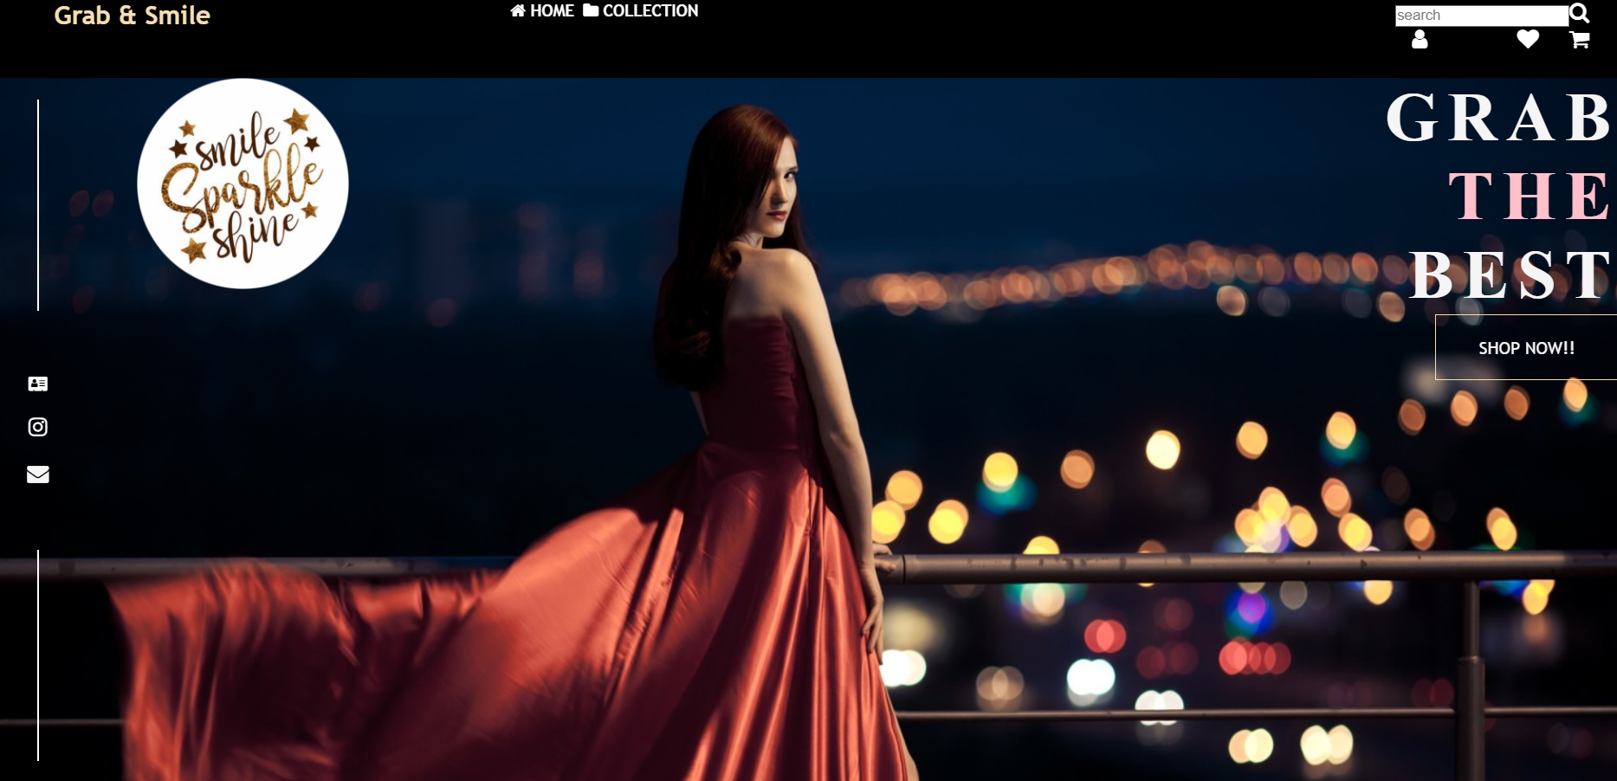

Login page

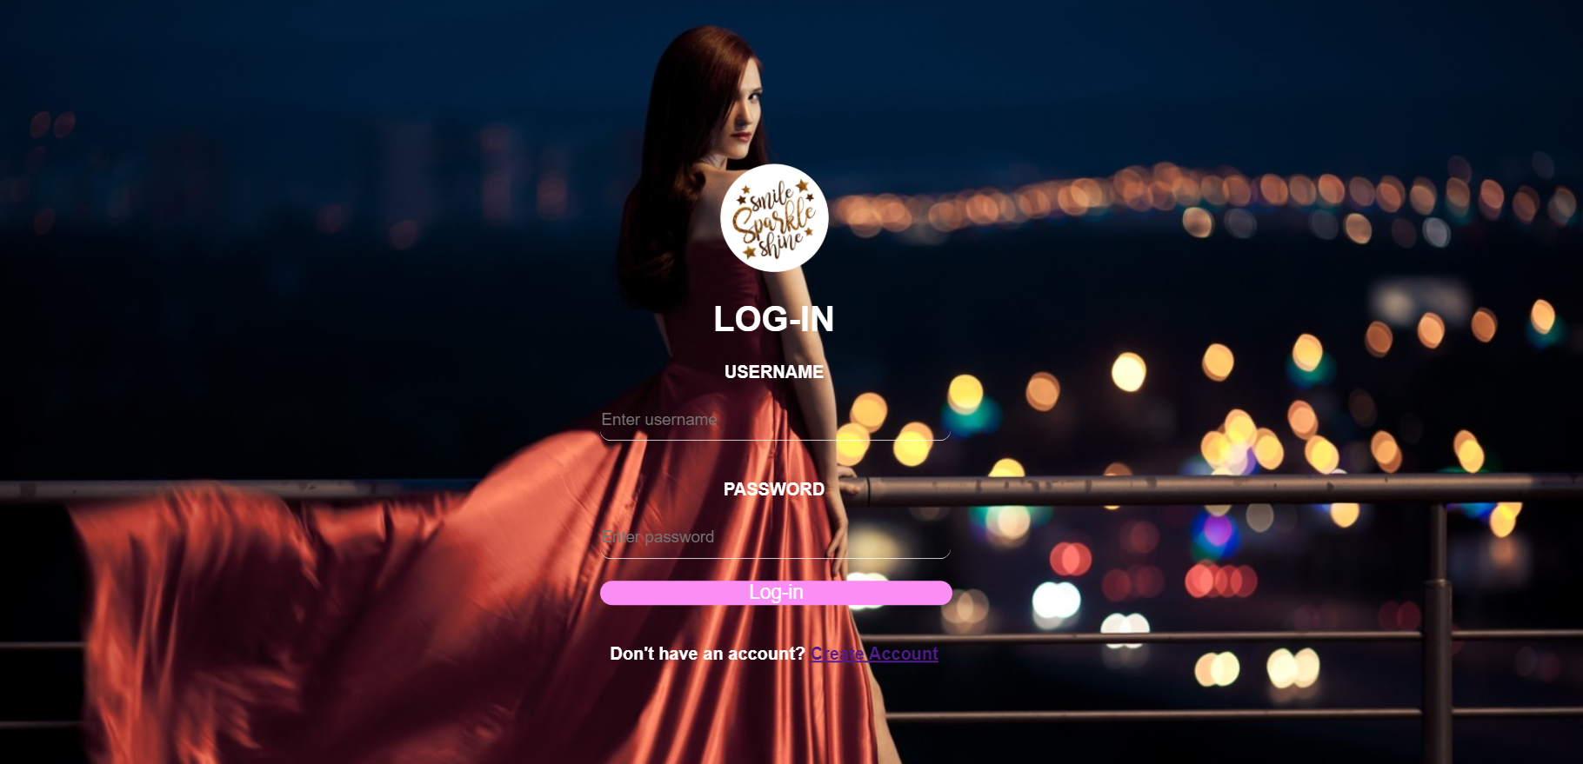

About us page

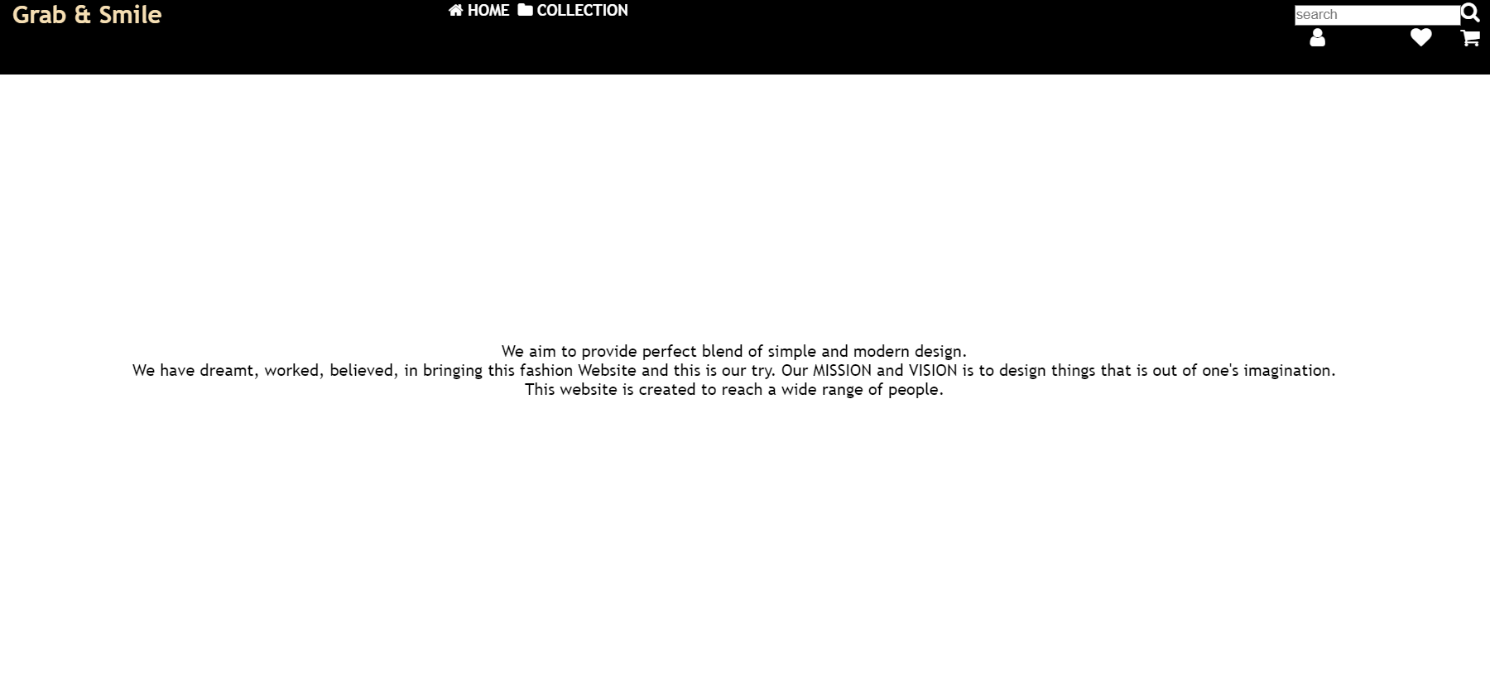

Shop now page

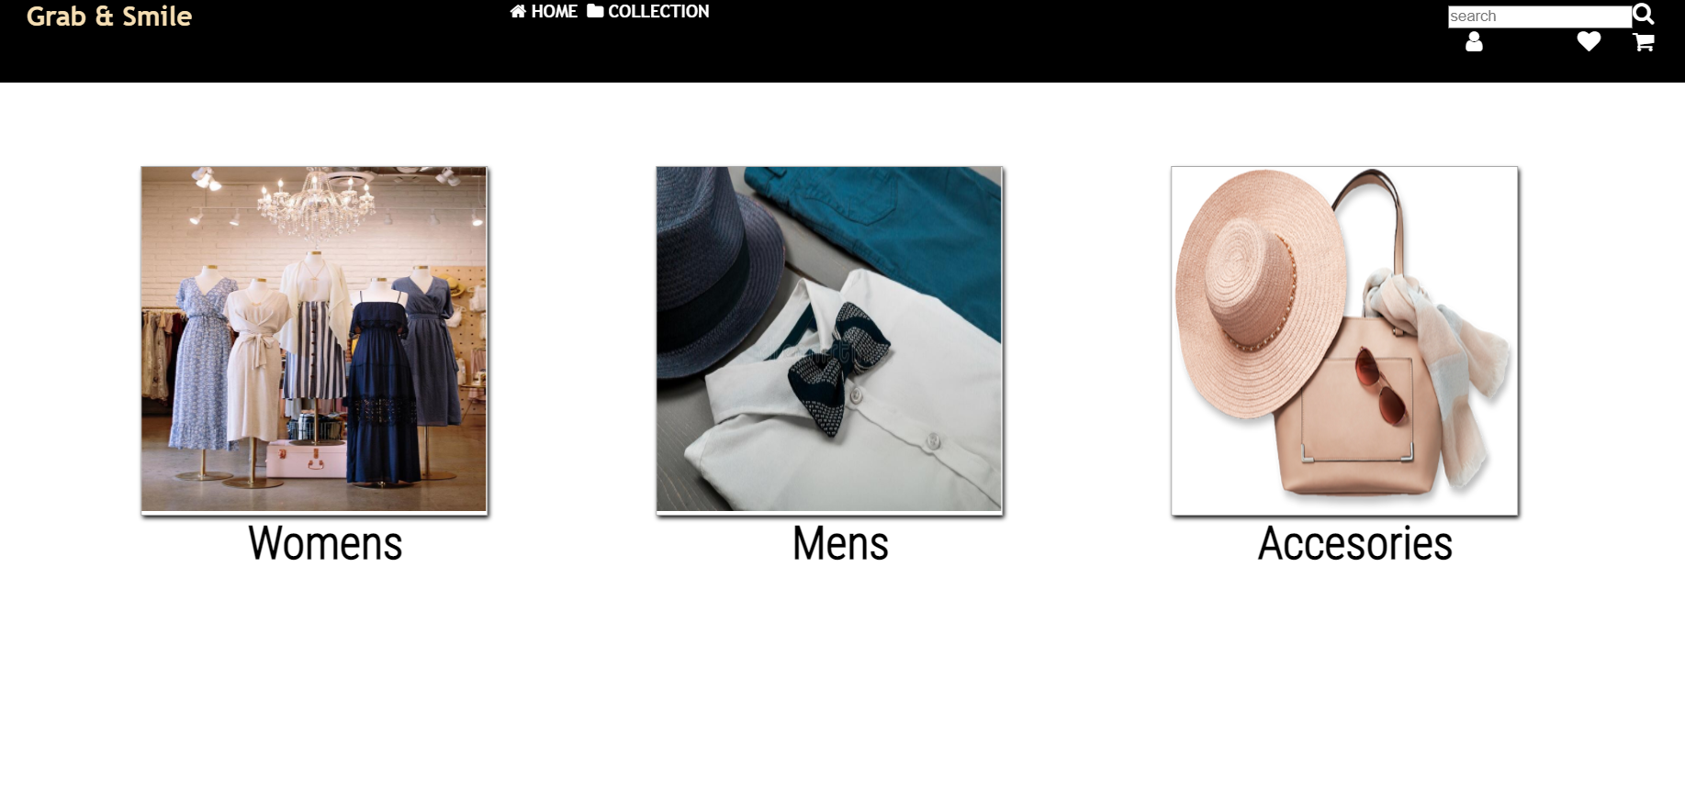

Women page

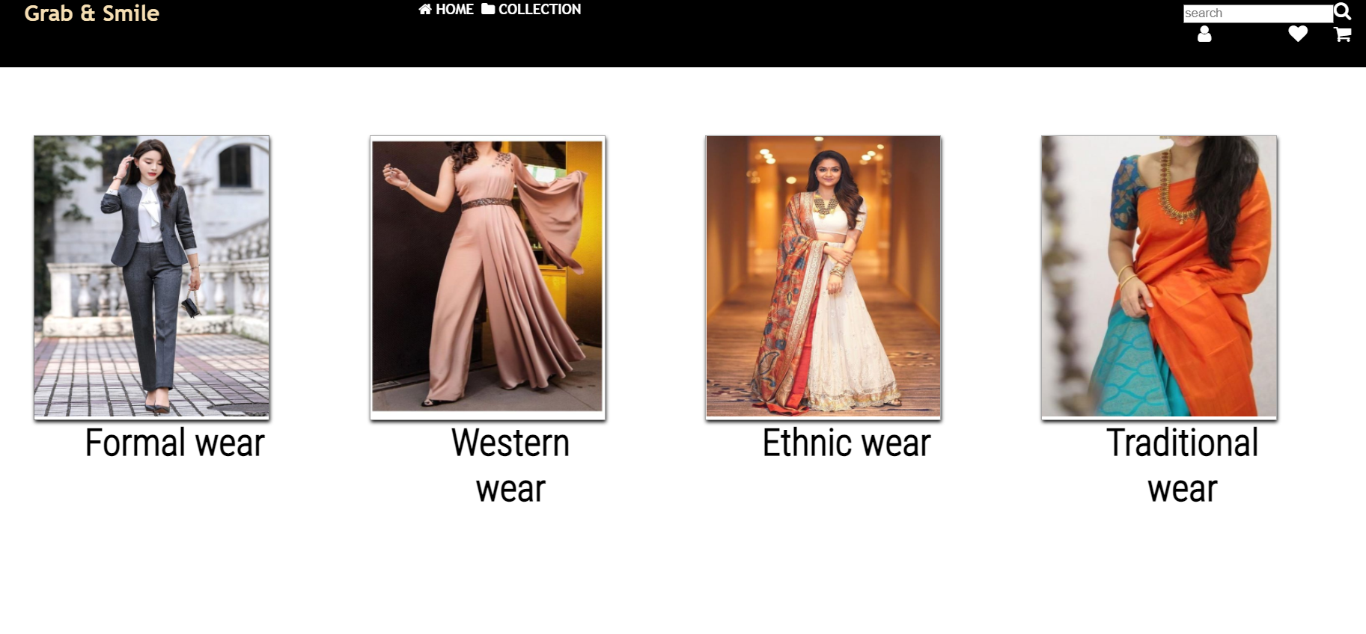

Women formal page

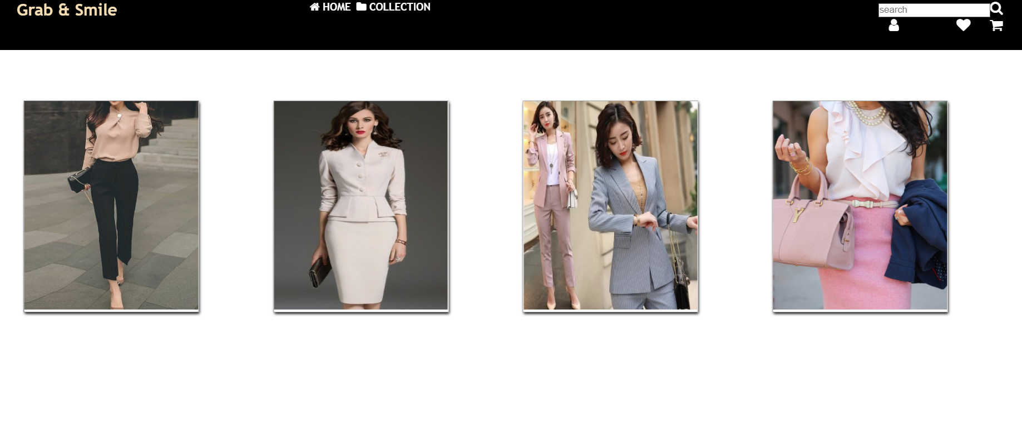

Women western wear

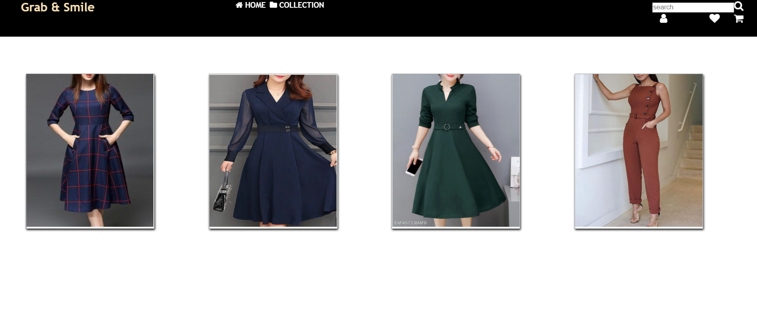

Women ethnic wear

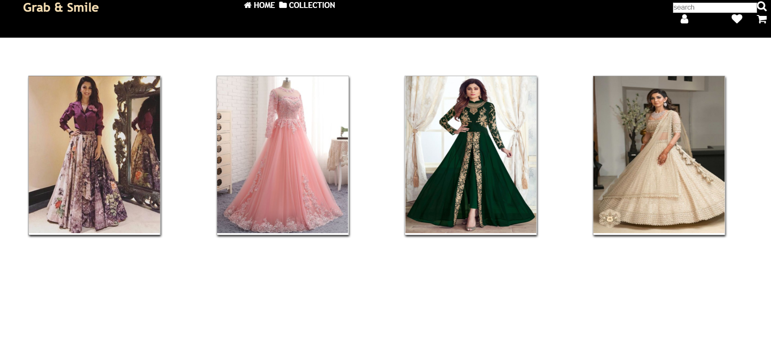

Women traditional wear

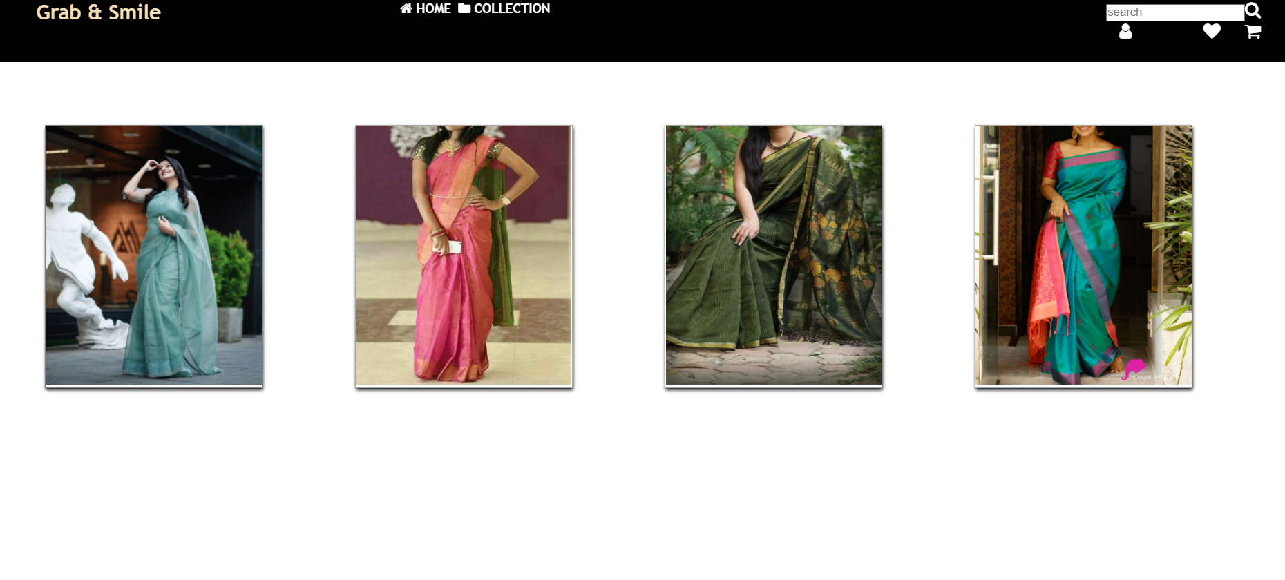

Mens page

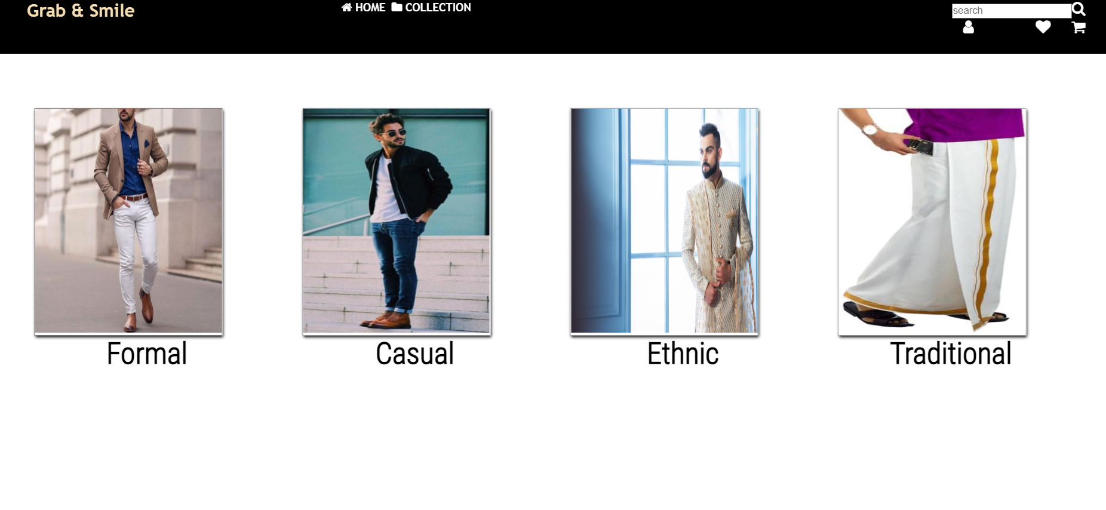

Mens formal page

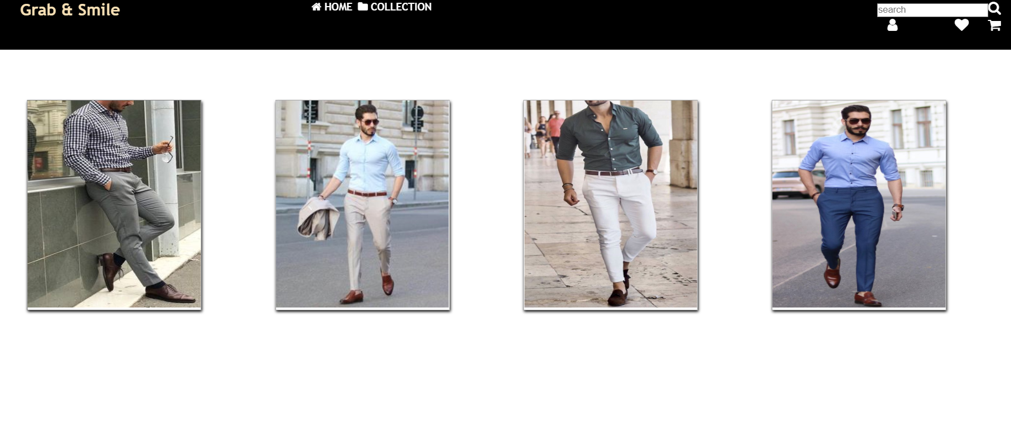

Mens casual page

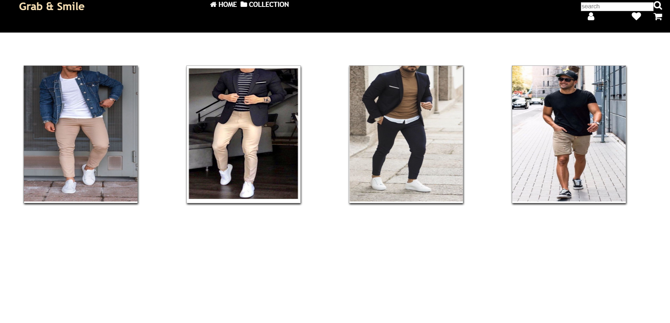

Mens ethnic page

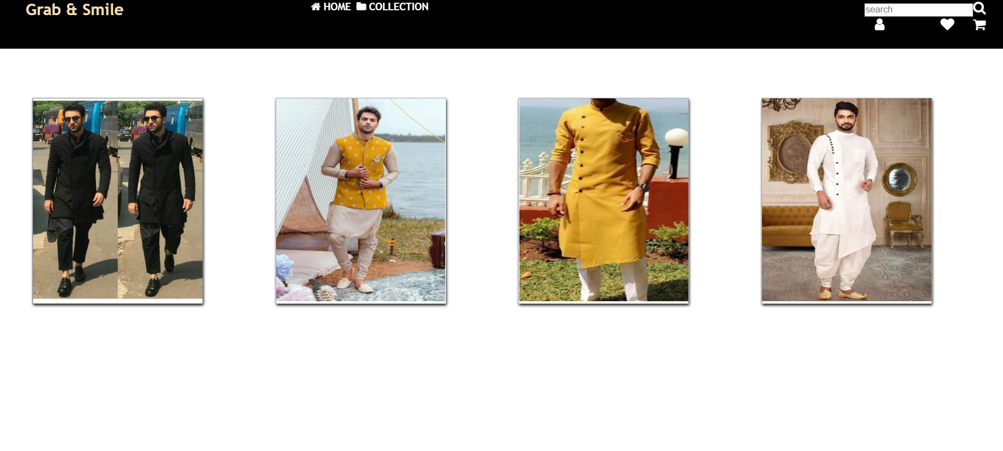

Mens traditional page

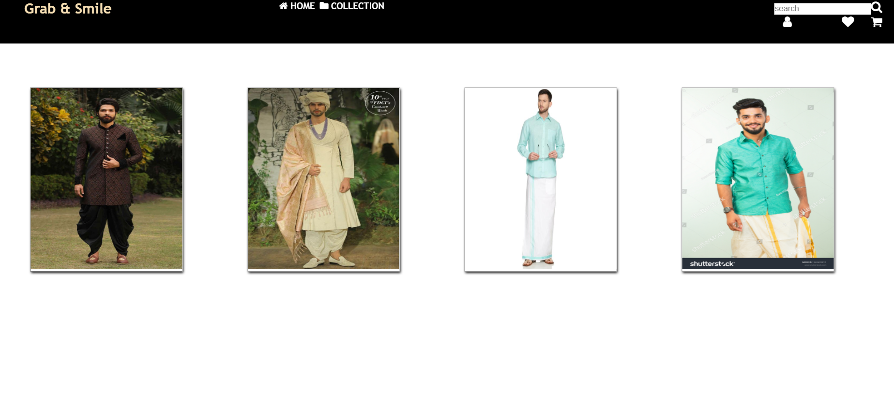

Accessories page

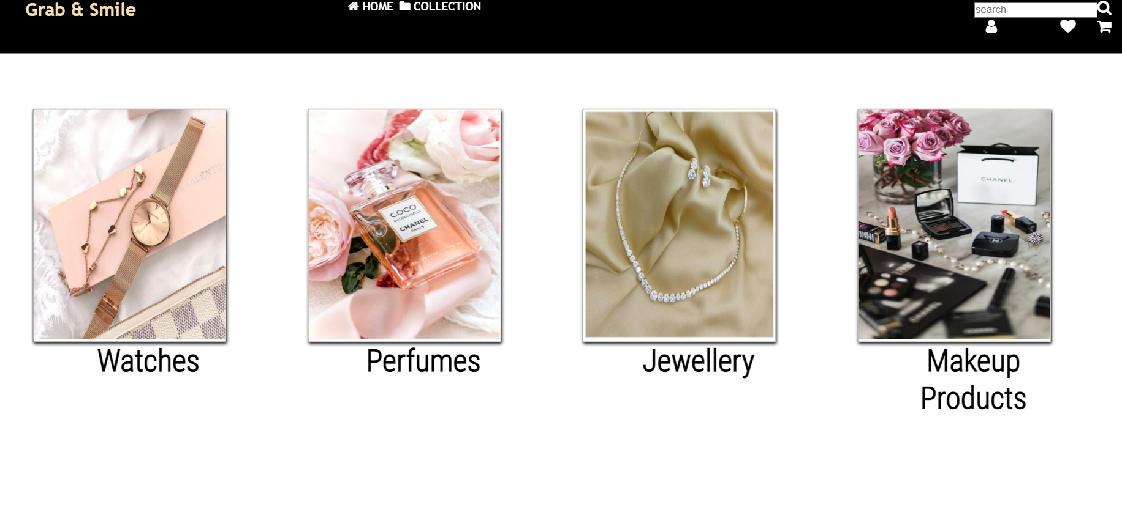

Watch page

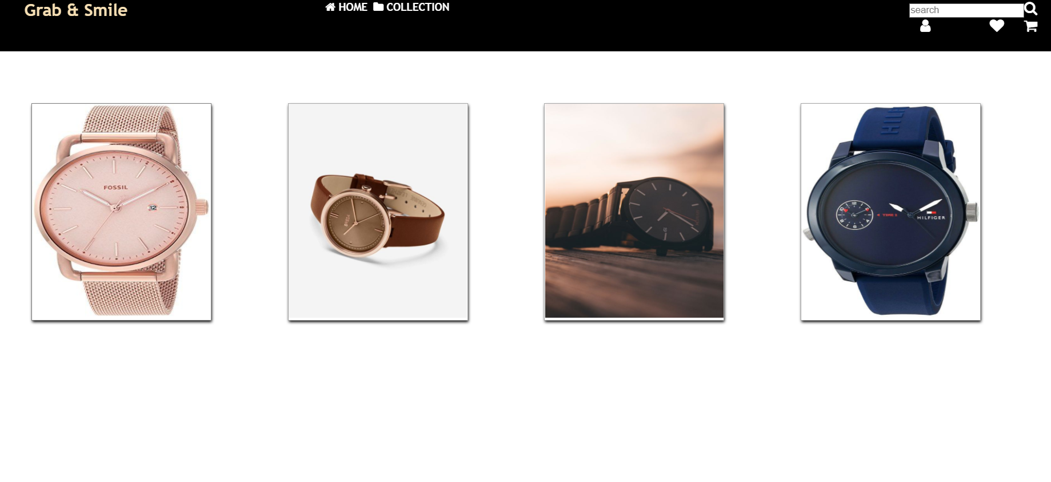

Perfume page

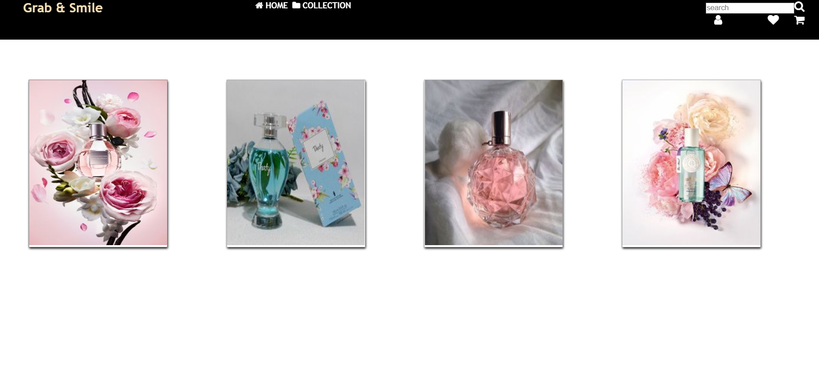

Jewellery page

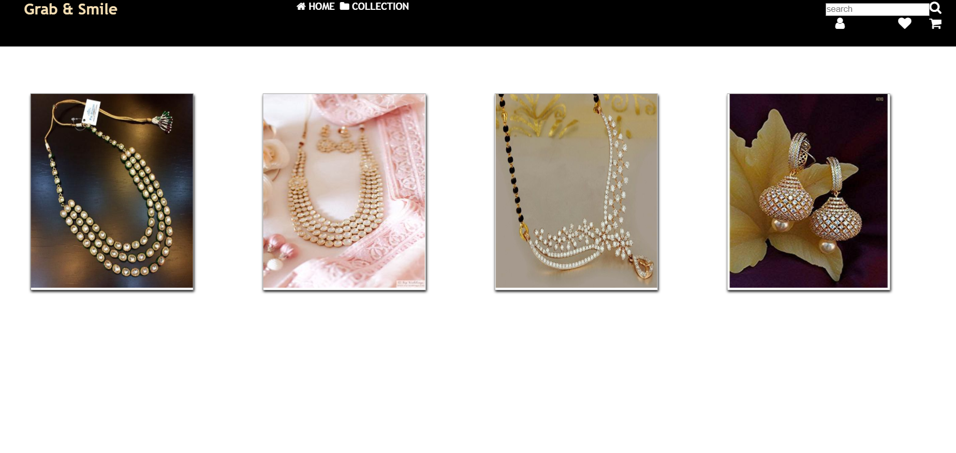

Makeup page

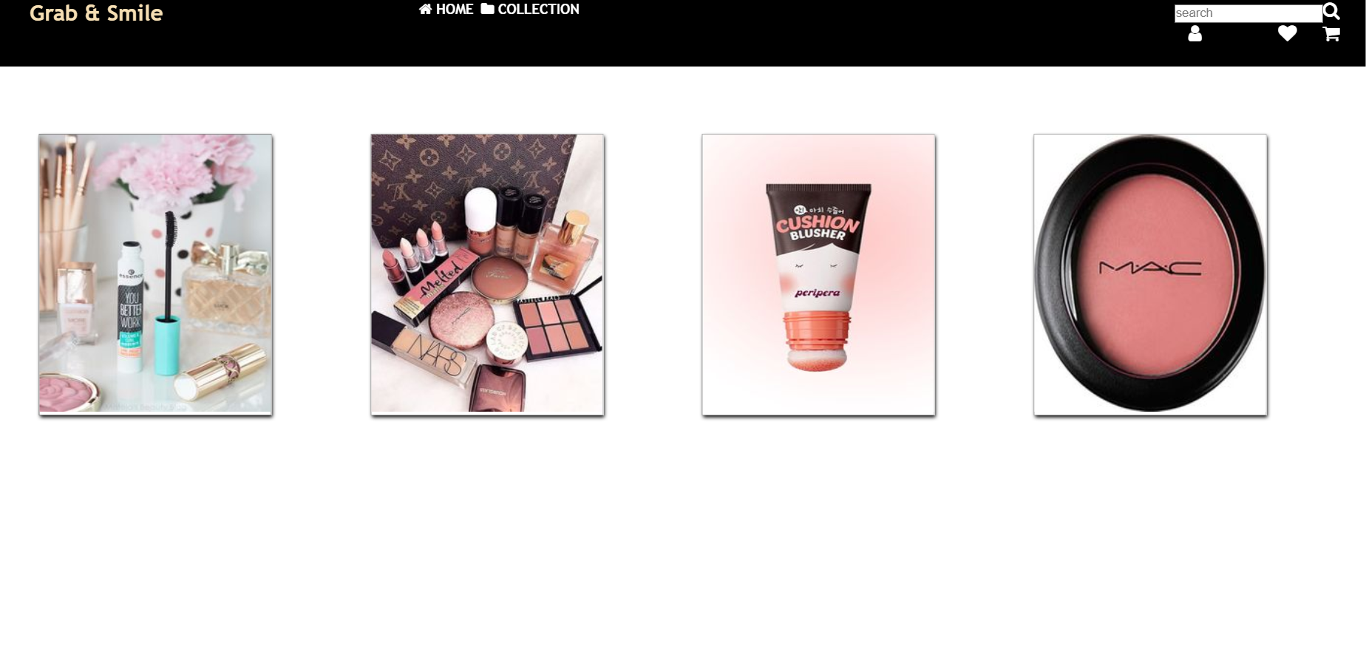

ANGULAR

FASHION WEBSITE

**AIM:** The main objective of this fashion website is to keep the viewer in the site long enough for them to see the latest collect. Here, I have used HTML, CSS, Bootstrap and angular to design a fashion website with the motive to promote growing fashion designers. I have used the concepts routing, navigation bar, popover, form options and so on to build a website.

**CODE:**

COMPONENT:

HEADER.COMPONENT.HTML:

<div class="contact-box">

    <div class="first">RA designs</div>

</div>

<mat-progress-bar mode="indeterminate" *ngIf="loadingEnable"></mat-progress-bar>

<div class="header-box">

    <div class="container">

        <div class="mobile-view">

            <mat-icon (click)="toggelSidenav()">menu</mat-icon>

        </div>

        <!-- <form class="example-form">

                <mat-form-field class="example-full-width">

                    <input matInput placeholder="Search">

                    <mat-icon matSuffix>search</mat-icon>

                </mat-form-field>

            </form> -->

        <div class="menu">

            <ul class="list">

                <li class="contain" [routerLink]="['/home']" routerLinkActive="active"><span>HOME</span></li>

                <li class="contain" [routerLink]="['/products']" routerLinkActive="active"><span>PRODUCTS</span></li>

                <li class="contain" [routerLink]="['/images']" routerLinkActive="active"><span>ABOUT US</span></li>

                <li class="contain" [routerLink]="['/contact-us']" routerLinkActive="active"><span>CONTACT US</span>

                </li>

                <li class="contain" *ngIf="!user">

                    <button mat-stroked-button color="primary" class="button" (click)="openLoginDialog()">LOGIN</button>

                </li>

                <li class="contain profile dropdown" *ngIf="user">

                    <img src="https://img1a.flixcart.com/www/linchpin/fk-cp-zion/img/profile-pic-male_2fd3e8.svg"

                        width="25px">

                    <div class="dropdown-content">

                        <a [routerLink]="['/myprofile']">My Profile</a>

                        <a>Orders</a>

                        <a>Wishlist</a>

                        <a>Notifications</a>

                        <a (click)="logout()">Logout</a>

                    </div>

                </li>

                <li class="contain" *ngIf="user" [routerLink]="['/shopping-cart']">

                    <mat-icon>add_shopping_cart</mat-icon>

                </li>

            </ul>

        </div>

        <div class="cart-icon mobile-view" *ngIf="!user">

            <button mat-stroked-button color="primary" class="button" (click)="openLoginDialog()">LOGIN</button>

        </div>

        <div class="cart-icon mobile-view" *ngIf="user">

            <a [routerLink]="['/myprofile/notifications']">

                <mat-icon>notification_important</mat-icon>

            </a>&nbsp; &nbsp;

            <a [routerLink]="['/shopping-cart']">

                <mat-icon>add_shopping_cart</mat-icon>

            </a>

        </div>

    </div>

</div>

HEADER.COMPONENT.CSS:

.contact-box{

    background: #262626;

    display: flex;

    justify-content: center;

    color: #fff;

    font-size: 12px;

    padding: 0px 2%;

}

.contact-box .first{

    flex: 1;

    align-items: center;

}

.contact-box .second{

    flex: 2;

}

.contact-box .third{

    flex: 2;

}

.header-box{

    background-color: white;

    box-shadow: 0px 1px 6px rgba(0,0,0,0.3);

}

.container{

    display: flex;

    justify-content: space-between;

    text-align: center;

    padding: 10px 2%;

}

.menu{

    display: flex;

}

.list{

    list-style: none;

}

.list .contain:hover {

    color: #3f51b5;

}

.list li{

    display: inline-block;

    cursor: pointer;

    margin: 0px 20px;

    transition: all 0.3s ease 0s;

    vertical-align: middle;

}

.list .contain:focus {

    outline: none;

}

.list .active {

    color: #3f51b5;

    outline: none;

}

// .login-box{

//     list-style: none;

// }

// .login-box .contain:hover {

//     color: #3f51b5;

// }

// .login-box li{

//     display: inline-block;

//     cursor: pointer;

//     margin: 0px 20px;

//     transition: all 0.3s ease 0s;

//     vertical-align: middle;

// }

// .login-box .contain:focus {

//     outline: none;

// }

// .login-box .active {

//     color: #3f51b5;

//     outline: none;

// }

.logo{

    display: flex;

    justify-content: center;

    align-items: center;

    cursor: pointer;

}

.mobile-view {

    display: none;

}

.sidenavEnable{

    display: none;

}

.profile-menu{

    display: none;

}

.dropdown {

    position: relative;

  }

  .dropdown-content {

    display: none;

    position: absolute;

    background-color: #f9f9f9;

    min-width: 120px;

    box-shadow: 0px 8px 16px 0px rgba(0,0,0,0.2);

    z-index: 2;

  }

  .dropdown:hover .dropdown-content {

    display: block;

  }

.dropdown-content a {

    color: black;

    padding: 3px 8px;

    text-decoration: none;

    display: block;

    text-align: left;

    font-size: 12px;

  }

  .dropdown-content a:hover{

      background-color: #3f51b5;

      color: white;

  }

  @media (max-width: 1080px) {

    .contact-box {

          display: none;

    }

    .menu{

        display: none;

    }

    .mobile-view{

        display: block !important;

        font-size: 30px;

    }

    .sidenavEnable{

        display: inline !important;

        transform: translateY(-50%) scaleY(0);

    }

    .container{

        padding: 10px 5%;

    }

}

.example-container {

  width: 400px;

  height: 100%;

  margin: 12px;

  border: 1px solid #555;

  z-index: 2;

}

mat-drawer-content {

  padding: 12px;

  display: flex;

  flex-direction: column;

  align-items: flex-start;

}

HEADER.COMPONENT.TS:

import { Component, OnInit, Output } from '@angular/core';

import { MatDialog } from '@angular/material';

import { LoginComponent } from '../../login/login.component';

import { LoginService } from '../../services/login.service';

import { User } from '../../interfaces/Ilogin';

import { EventEmitter } from '@angular/core';

import { Router } from '@angular/router';

import { BehaviorSubject } from 'rxjs';

import { LoadingService } from 'src/app/services/loading.service';

@Component({

  selector: 'app-header',

  templateUrl: './header.component.html',

  styleUrls: ['./header.component.scss']

})

export class HeaderComponent implements OnInit {

  loadingEnable: boolean;

  sidenavEnable = false;

  user: User;

  @Output()

  sidenav = new EventEmitter();

  toggelSidenav() {

    this.sidenav.emit('toggel');

  }

  constructor(public dialog: MatDialog, private router: Router,

    public loginService: LoginService,

    public loadingService: LoadingService) { }

  ngOnInit() {

    this.loginService.loggedIn.subscribe(next => {

      this.user = next;

    });

    this.loadingService.progressEnable.subscribe(next => {

      this.loadingEnable = next;

    });

  }

  enableSidenav() {

    this.sidenavEnable = !this.sidenavEnable;

  }

  openLoginDialog(): void {

    const dialogRef = this.dialog.open(LoginComponent, {

    });

    dialogRef.afterClosed().subscribe(result => {

      console.log('The dialog was closed');

    });

  }

  logout() {

    this.user = null;

    this.loginService.loggedIn.next(this.user);

    this.router.navigate(['home']);

  }

}

HEADER.COMPONENT.SPEC.TS:

import { async, ComponentFixture, TestBed } from '@angular/core/testing';

import { HeaderComponent } from './header.component';

describe('HeaderComponent', () => {

  let component: HeaderComponent;

  let fixture: ComponentFixture<HeaderComponent>;

  beforeEach(async(() => {

    TestBed.configureTestingModule({

      declarations: [ HeaderComponent ]

    })

    .compileComponents();

  }));

  beforeEach(() => {

    fixture = TestBed.createComponent(HeaderComponent);

    component = fixture.componentInstance;

    fixture.detectChanges();

  });

  it('should create', () => {

    expect(component).toBeTruthy();

  });

});

FOOTER.COMPONENT.HTML:

<link

      rel="stylesheet"

      href="https://stackpath.bootstrapcdn.com/font-awesome/4.7.0/css/font-awesome.min.css"

      integrity="sha384-wvfXpqpZZVQGK6TAh5PVlGOfQNHSoD2xbE+QkPxCAFlNEevoEH3Sl0sibVcOQVnN"

      crossorigin="anonymous"

    />

    <link

      href="https://fonts.googleapis.com/css2?family=Montserrat:ital,wght@1,300&display=swap"

      rel="stylesheet"

    />

    <link

      href="https://fonts.googleapis.com/css2?family=Roboto+Condensed:wght@300&display=swap"

      rel="stylesheet"

    />

    <link

      href="https://fonts.googleapis.com/css2?family=Raleway:wght@300&display=swap"

      rel="stylesheet"

    />

<div class="footer">

    <div class="container">

        <div class="first">

            <h4>RA designs</h4>

            <p>

                creativity is nothing but a mind set free.

            </p>

        </div>

        <div class="second">

            <h4>HELP</h4>

            <ul class="list">

                <li>

                    Shipping Information</li>

                <li> Returns & Exchange</li>

                <li> Terms & Conditions</li>

                <li> Privacy Policy

                </li>

            </ul>

        </div>

    </div>

    <div class="copyright">

        <p style="text-align: center;"><a class="insta" href="https://www.instagram.com/radesigns_/"><i class="fa fa-instagram" aria-hidden="true" style="color: white;"></i></a> || <i class="fa fa-envelope" aria-hidden="true"> : rash.saravanan@gmail.com</i> </p>

    </div>

</div>

FOOTER.COMPONENT.CSS:

.footer{

    background: black;

    color: white;

}

.footer .container {

    padding: 0px 5%;

    display: flex;

    justify-content: space-between;

    align-items: center;

    flex-wrap: wrap;

}

.first {

    flex: 1;

}

.second {

    flex: 1;

    text-align: center;

}

.third {

    flex: 1;

}

.footer .copyright {

    margin-top: 20px;

    text-align: center;

}

.list {

    list-style: none;

    text-align: center;

    font-size: 12px;

}

FOOTER.COMPONENT.TS:

import { Component, OnInit } from '@angular/core';

@Component({

  selector: 'app-footer',

  templateUrl: './footer.component.html',

  styleUrls: ['./footer.component.scss']

})

export class FooterComponent implements OnInit {

  constructor() { }

  ngOnInit() {

  }

}

FOOTER.COMPONENT.SPEC.TS:

import { async, ComponentFixture, TestBed } from '@angular/core/testing';

import { FooterComponent } from './footer.component';

describe('FooterComponent', () => {

  let component: FooterComponent;

  let fixture: ComponentFixture<FooterComponent>;

  beforeEach(async(() => {

    TestBed.configureTestingModule({

      declarations: [ FooterComponent ]

    })

    .compileComponents();

  }));

  beforeEach(() => {

    fixture = TestBed.createComponent(FooterComponent);

    component = fixture.componentInstance;

    fixture.detectChanges();

  });

  it('should create', () => {

    expect(component).toBeTruthy();

  });

});

SLIDER.COMPONENT.HTML:

<owl-carousel

[options]="carouselOptions"

[items]="images"

[carouselClasses]="['owl-theme', 'row', 'sliding']">

<div class="item" *ngFor="let image of images;let i = index">

     <div class="thumbnail-image" >

        <img [src]="image.image" style="height: 700px;width: 1800px;"/>

    </div>

  </div>

</owl-carousel>

SLIDER.COMPONENT.TS:

import { Component, OnInit } from '@angular/core';

import { User } from 'src/app/interfaces/Ilogin';

import { LoginService } from 'src/app/services/login.service';

@Component({

  selector: 'app-slider',

  templateUrl: './slider.component.html',

  styleUrls: ['./slider.component.scss']

})

export class SliderComponent implements OnInit {

  carouselOptions =

    {

      items: 1,

      dots: true,

      navigation: false,

      loop:true,

      margin:10,

      autoplay:true,

      animateOut: 'fadeOut',

      autoHeight: true,

      autoHeightClass: 'owl-height',

  }

  images = [

    {

      text: "Festive Deer",

      image: "https://images.pexels.com/photos/3965545/pexels-photo-3965545.jpeg?auto=compress&cs=tinysrgb&dpr=2&h=650&w=940"

    },

    {

      text: "Festive Deer",

      image: "https://images.pexels.com/photos/996329/pexels-photo-996329.jpeg?auto=compress&cs=tinysrgb&dpr=2&h=650&w=940"

    }

  ];

  constructor() { }

  ngOnInit() {

  }

}

SLIDER.COMPONENT.SPEC.TS:

import { async, ComponentFixture, TestBed } from '@angular/core/testing';

import { SliderComponent } from './slider.component';

describe('SliderComponent', () => {

  let component: SliderComponent;

  let fixture: ComponentFixture<SliderComponent>;

  beforeEach(async(() => {

    TestBed.configureTestingModule({

      declarations: [ SliderComponent ]

    })

    .compileComponents();

  }));

  beforeEach(() => {

    fixture = TestBed.createComponent(SliderComponent);

    component = fixture.componentInstance;

    fixture.detectChanges();

  });

  it('should create', () => {

    expect(component).toBeTruthy();

  });

});

SIDE-NAV.COMPONENT.HTML:

<table *ngIf="user">

        <tr (click)="goToMyProfile()">

                <td>

                        <img src="https://img1a.flixcart.com/www/linchpin/fk-cp-zion/img/profile-pic-male_2fd3e8.svg" />

                </td>

                <td style="padding-left: 15px;">

                        <span>Hello</span>

                        <h3 style="margin: 0">Darshitha Murali</h3>

                </td>

                <td>

                        <mat-icon>chevron_right</mat-icon>

                </td>

        </tr>

</table>

<div class="login" *ngIf="!user">

        <button mat-stroked-button color="primary" class="button" (click)="openLoginDialog()">LOGIN</button>

</div>

<ul class="list">

        <li class="contain" (click)="toggelSidenav()" [routerLink]="['/home']" routerLinkActive="active">

                <table>

                        <tr>

                                <td>

                                        <mat-icon>home</mat-icon>

                                </td>

                                <td style="vertical-align: baseline;"><span style="margin-left: 10px;">HOME</span></td>

                        </tr>

                </table>

        </li>

        <li class="contain" (click)="toggelSidenav()" [routerLink]="['/products']" routerLinkActive="active">

                <table>

                        <tr>

                                <td>

                                        <mat-icon>add_to_photos</mat-icon>

                                </td>

                                <td style="vertical-align: baseline;"> <span style="margin-left: 10px;">PRODUCTS</span>

                                </td>

                        </tr>

                </table>

        </li>

</ul>

<ul class="list" *ngIf="user">

        <li *ngFor="let item of profileMenu" [routerLink]="[item.link]" routerLinkActive="active"

                (click)="toggelSidenav()">

                <table>

                        <tr>

                                <td>

                                        <mat-icon>{{item.icon}}</mat-icon>

                                </td>

                                <td style="vertical-align: baseline;">

                                        <span style="margin-left: 10px;">{{item.title}}</span>

                                </td>

                        </tr>

                </table>

        </li>

</ul>

<ul class="list" *ngIf="user">

        <li *ngFor="let item of myStuff" [routerLink]="[item.link]" routerLinkActive="active" (click)="toggelSidenav()">

                <table>

                        <tr>

                                <td>

                                        <mat-icon>{{item.icon}}</mat-icon>

                                </td>

                                <td style="vertical-align: baseline;">

                                        <span style="margin-left: 10px;">{{item.title}}</span>

                                </td>

                        </tr>

                </table>

        </li>

</ul>

<div *ngIf="user">

        <table>

                <tr (click)="logout()">

                        <td>

                                <mat-icon>power_settings_new</mat-icon>

                        </td>

                        <td style="vertical-align: baseline;">

                                <span style="margin-left: 10px;">Logout</span>

                        </td>

                </tr>

        </table>

</div>

SIDE-NAV.COMPONENT.CSS:

<table *ngIf="user">

        <tr (click)="goToMyProfile()">

                <td>

                        <img src="https://img1a.flixcart.com/www/linchpin/fk-cp-zion/img/profile-pic-male_2fd3e8.svg" />

                </td>

                <td style="padding-left: 15px;">

                        <span>Hello</span>

                        <h3 style="margin: 0">Darshitha Murali</h3>

                </td>

                <td>

                        <mat-icon>chevron_right</mat-icon>

                </td>

        </tr>

</table>

<div class="login" *ngIf="!user">

        <button mat-stroked-button color="primary" class="button" (click)="openLoginDialog()">LOGIN</button>

</div>

<ul class="list">

        <li class="contain" (click)="toggelSidenav()" [routerLink]="['/home']" routerLinkActive="active">

                <table>

                        <tr>

                                <td>

                                        <mat-icon>home</mat-icon>

                                </td>

                                <td style="vertical-align: baseline;"><span style="margin-left: 10px;">HOME</span></td>

                        </tr>

                </table>

        </li>

        <li class="contain" (click)="toggelSidenav()" [routerLink]="['/products']" routerLinkActive="active">

                <table>

                        <tr>

                                <td>

                                        <mat-icon>add_to_photos</mat-icon>

                                </td>

                                <td style="vertical-align: baseline;"> <span style="margin-left: 10px;">PRODUCTS</span>

                                </td>

                        </tr>

                </table>

        </li>

</ul>

<ul class="list" *ngIf="user">

        <li *ngFor="let item of profileMenu" [routerLink]="[item.link]" routerLinkActive="active"

                (click)="toggelSidenav()">

                <table>

                        <tr>

                               <td>

                                        <mat-icon>{{item.icon}}</mat-icon>

                                </td>

                                <td style="vertical-align: baseline;">

                                        <span style="margin-left: 10px;">{{item.title}}</span>

                                </td>

                        </tr>

                </table>

        </li>

</ul>

<ul class="list" *ngIf="user">

        <li *ngFor="let item of myStuff" [routerLink]="[item.link]" routerLinkActive="active" (click)="toggelSidenav()">

                <table>

                        <tr>

                                <td>

                                        <mat-icon>{{item.icon}}</mat-icon>

                                </td>

                                <td style="vertical-align: baseline;">

                                        <span style="margin-left: 10px;">{{item.title}}</span>

                                </td>

                        </tr>

                </table>

        </li>

</ul>

<div *ngIf="user">

        <table>

                <tr (click)="logout()">

                        <td>

                                <mat-icon>power_settings_new</mat-icon>

                        </td>

                        <td style="vertical-align: baseline;">

                                <span style="margin-left: 10px;">Logout</span>

                        </td>

                </tr>

        </table>

</div>

SIDE-NAV.COMPONENT.TS:

import { Component, OnInit, Output, EventEmitter } from '@angular/core';

import { Router } from '@angular/router';

import { LoginService } from 'src/app/services/login.service';

import { User } from 'src/app/interfaces/Ilogin';

import { MatDialog } from '@angular/material';

import { LoginComponent } from 'src/app/login/login.component';

@Component({

  selector: 'app-sidenav',

  templateUrl: './sidenav.component.html',

  styleUrls: ['./sidenav.component.scss']

})

export class SidenavComponent implements OnInit {

  @Output()

  sidenav = new EventEmitter();

  profileMenu = [

    {

      title: 'My Profile',

      link: '/myprofile/profile',

      icon: 'person'

    },

    {

      title: 'Saved Cards',

      link: '/myprofile/carddetails',

      icon:'account_balance'

    },

    {

      title: 'My Address',

      link: '/myprofile/address',

      icon: 'border_color'

    },

    {

      title: 'My Orders',

      link: '/myprofile/orders',

      icon: 'next_week'

    },

    {

      title: 'My Cart',

      link: '/shopping-cart',

      icon: 'add_shopping_cart'

    },

    {

      title: 'My Wishlist',

      link: '/myprofile/wishlist',

      icon:'shopping_cart'

    },

  ];

  myStuff = [

    {

      title: 'My Reviews',

      link: '/myprofile/reviews',

      icon: 'rate_review'

    },

    {

      title: 'My Rewards',

      link: '/myprofile/rewards',

      icon: 'rate_review'

    },

  ];

  toggelSidenav() {

    this.sidenav.emit('toggel');

  }

  constructor(public dialog: MatDialog, private router: Router, public loginService: LoginService) {

  }

  user:User;

  ngOnInit() {

    this.loginService.loggedIn.subscribe(next => {

      this.user = next;

    });

  }

  goToMyProfile(){

    this.toggelSidenav();

    this.router.navigate(['myprofile']);

  }

  logout() {

    this.toggelSidenav();

    this.user = null;

    this.loginService.loggedIn.next(this.user);

    this.router.navigate(['home']);

  }

  openLoginDialog(): void {

    this.toggelSidenav();

    const dialogRef = this.dialog.open(LoginComponent, {});

    dialogRef.afterClosed().subscribe(result => {

      console.log('The dialog was closed');

    });

  }

}

SIDE-NAV.COMPONENT. SPEC.TS:

import { async, ComponentFixture, TestBed } from '@angular/core/testing';

import { SidenavComponent } from './sidenav.component';

describe('SidenavComponent', () => {

  let component: SidenavComponent;

  let fixture: ComponentFixture<SidenavComponent>;

  beforeEach(async(() => {

    TestBed.configureTestingModule({

      declarations: [ SidenavComponent ]

    })

    .compileComponents();

  }));

  beforeEach(() => {

    fixture = TestBed.createComponent(SidenavComponent);

    component = fixture.componentInstance;

    fixture.detectChanges();

  });

  it('should create', () => {

    expect(component).toBeTruthy();

  });

});

HOME.COMPONENT.HTML:

<link

      rel="stylesheet"

      href="https://stackpath.bootstrapcdn.com/font-awesome/4.7.0/css/font-awesome.min.css"

      integrity="sha384-wvfXpqpZZVQGK6TAh5PVlGOfQNHSoD2xbE+QkPxCAFlNEevoEH3Sl0sibVcOQVnN"

      crossorigin="anonymous"

    />

    <link

      href="https://fonts.googleapis.com/css2?family=Montserrat:ital,wght@1,300&display=swap"

      rel="stylesheet"

    />

    <link

      href="https://fonts.googleapis.com/css2?family=Roboto+Condensed:wght@300&display=swap"

      rel="stylesheet"

    />

    <link

      href="https://fonts.googleapis.com/css2?family=Raleway:wght@300&display=swap"

      rel="stylesheet"

    />

<app-slider></app-slider>

<div class="products-container">

    <div class="title">

        New Products Arrival

        <button mat-button mat-raised-button color="primary" class="viewAllBtn">

            View All

        </button>

    </div>

    <div class="body">

        <mat-card class="example-card" *ngFor="let item of images" (click)="productHome()">

            <!-- <img class="productImg" mat-card-image src="{{item.image}}" alt="Photo of a Shiba Inu"> -->

            <owl-carousel [options]="carouselOptions" [items]="item.image"

                [carouselClasses]="['owl-theme', 'row', 'sliding']">

                <div class="item" *ngFor="let image of item.image; let i = index">

                    <div class="thumbnail-image">

                        <img [src]="image" class="productImg" mat-card-image />

                    </div>

                </div>

            </owl-carousel>

            <mat-card-content>

                <h3>rs 1500</h3>

                <span>fabric</span>

            </mat-card-content>

            <mat-card-actions>

                <button mat-button mat-stroked-button color="primary" class="button">

                    ADD TO CART &nbsp;&nbsp;<i class="fa fa-shopping-bag" aria-hidden="true"></i>

                </button>

                <button mat-button>SHARE

                </button>

            </mat-card-actions>

        </mat-card>

    </div>

</div>

<div class="mobile-view">

    <div class="title">

        New Products Arrival

        <button mat-button mat-raised-button color="primary" class="viewAllBtn">

            View All

        </button>

    </div>

    <div class="mobile-card" *ngFor="let item of images" (click)="productHome()">

        <div class="header">

            <owl-carousel [options]="carouselOptions" [items]="item.image"

                [carouselClasses]="['owl-theme', 'row', 'sliding']">

                <div class="item" *ngFor="let image of item.image; let i = index">

                    <div class="thumbnail-image">

                        <img [src]="image" class="productImg" mat-card-image />

                    </div>

                </div>

            </owl-carousel>

        </div>

        <div class="footer">

            asdfasdf

        </div>

    </div>

</div>

HOME.COMPONENT.CSS:

.search-box{

    width: 80%;

    margin-left: auto;

    margin-right: auto;

    background-color: white;

    box-shadow: 0px 1px 6px rgba(0,0,0,0.3);

    margin-top: 35px;

    display: flex;

}

.search-text {

    padding: 10px;

    flex: 20;

    font-size: 12px;

    color: #656565;

    line-height: 1.5;

}

.icon{

    border-right: 1px solid lightgrey;

    margin: 5px;

}

.icon , .close{

    flex: 1;

    color: #656565;

}

.leftIcon {

    padding: 2px;

    padding-left: 7px;

}

.products-container{

    background: #f8f9fa !important;

  //  padding: 1em 0;

    position: relative;

}

.title {

    border-left: 5px solid #3f51b5;

    padding-left: 10px;

    position: relative;

    font-size: 30px;

    font-weight: normal;

    color: #000000;

    margin-left: 2%;

    margin-right: 2%;

}

.viewAllBtn{

    float: right;

    margin-top: 10px;

    border-radius: 0;

}

.body{

    display: flex;

    margin-top: 10px;

    justify-content: center;

    flex-wrap: wrap;

}

.body .productImg {

    padding: 18px;

    width: 100%;

    height: 200px;

}

.example-header-image {

    background-image: url('https://material.angular.io/assets/img/examples/shiba1.jpg');

    background-size: cover;

}

.mobile-view{

    display: none;

}

.mobile-view .mobile-card {

    width: 48%;

    text-align: center;

    background: #fff;

    margin: 2px;

}

@media (max-width: 1080px) {

    .products-container {

        display: none;

    }

    .mobile-view {

        display: flex;

        justify-content: center;

        align-items: center;

        flex-wrap: wrap;

        margin-bottom: 20px;

    }

    .title {

        border-left: 5px solid #3f51b5;

        padding-left: 10px;

        position: relative;

        font-size: 20px;

        font-weight: 600;

        color: #000000;

        margin-left: 0.5%;

        width: 100%;

        margin-bottom: 20px;

    }

}

[HOME.COMPONENT.TS](http://home.component.ts):

import { Component, OnInit } from '@angular/core';

import {MatIconRegistry} from '@angular/material/icon';

import { DomSanitizer } from '@angular/platform-browser';

import { Router } from '@angular/router';

import { ProductService } from '../services/product.service';

@Component({

  selector: 'app-home',

  templateUrl: './home.component.html',

  styleUrls: ['./home.component.scss']

})

export class HomeComponent implements OnInit {

  carouselOptions =

  {

    items: 1,

    dots: false,

    navigation: false,

    loop:true,

    margin:10,

    autoplay:true,

    animateOut: 'fadeOut',

    autoHeight: true,

    autoHeightClass: 'owl-height',

}

images = [];

  constructor(iconRegistry: MatIconRegistry, sanitizer: DomSanitizer, private router: Router, private productService: ProductService) {

    this.images = this.productService.getAllProducts();

    iconRegistry.addSvgIcon(

        'thumbs-up',

        sanitizer.bypassSecurityTrustResourceUrl('assets/img/examples/thumbup-icon.svg'));

  }

  ngOnInit() {

  }

  productHome() {

    this.router.navigate(['product/12']);

    }

}

[HOME.COMPONENT.SPECT.TS](http://home.component.spect.ts):

import { async, ComponentFixture, TestBed } from '@angular/core/testing';

import { HomeComponent } from './home.component';

describe('HomeComponent', () => {

  let component: HomeComponent;

  let fixture: ComponentFixture<HomeComponent>;

  beforeEach(async(() => {

    TestBed.configureTestingModule({

      declarations: [ HomeComponent ]

    })

    .compileComponents();

  }));

  beforeEach(() => {

    fixture = TestBed.createComponent(HomeComponent);

    component = fixture.componentInstance;

    fixture.detectChanges();

  });

  it('should create', () => {

    expect(component).toBeTruthy();

  });

});

LOGIN.COMPONENT.HTML:

<form [formGroup]="loginForm">

<div class="example-container">

  <h2 style="font-weight: 100; text-align: center;">Please sign in</h2>

  <mat-form-field appearance="outline">

    <mat-label>Mobile Number</mat-label>

    <input matInput formControlName="mobileNumber" placeholder="Enter Your Mobile Number">

  </mat-form-field>

  <mat-form-field appearance="outline">

    <mat-label>Password</mat-label>

    <input matInput formControlName="password" placeholder="Enter Password">

  </mat-form-field>

  <button mat-button mat-raised-button color="primary" class="buy-now-button space" (click)="login()">LOGIN

  </button>

  <label style="text-align: center; margin-top: 5px; color:gray">Or</label>

  <button mat-button mat-stroked-button color="primary" class="button">SIGNUP NOW

  </button>

</div>

</form>

LOGIN.COMPONENT.CSS:

.example-container {

    display: flex;

    flex-direction: column;

    width: 280px;

  }

  .example-container > * {

    width: 100%;

  }

LOGIN.COMPONENT.TS:

import { Component, OnInit, Inject } from '@angular/core';

import { MatDialogRef, MAT_DIALOG_DATA } from '@angular/material';

import { LoginService } from '../services/login.service';

import { FormBuilder, FormGroup } from '@angular/forms';

import { Router } from '@angular/router';

import { User } from '../interfaces/Ilogin';

@Component({

  selector: 'app-login',

  templateUrl: './login.component.html',

  styleUrls: ['./login.component.scss']

})

export class LoginComponent implements OnInit {

  loginForm:FormGroup;

  user = {} as User;

  constructor(

    public dialogRef: MatDialogRef<LoginComponent>,

    @Inject(MAT_DIALOG_DATA) public data: any,

    private loginService: LoginService,

    private fb: FormBuilder,

    private router: Router) {}

    ngOnInit() {

      this.loginForm = this.fb.group({

        mobileNumber: [''],

        password: ['']

      })

    }

    login(){

      if (this.loginForm.valid){

        this.user.mobileNumber = this.loginForm.value.mobileNumber;

        this.loginService.loggedIn.next(this.user);

        this.onNoClick();

      }

    }

  onNoClick(): void {

    this.dialogRef.close();

  }

}

LOGIN.COMPONENT.SPEC.TS:

import { async, ComponentFixture, TestBed } from '@angular/core/testing';

import { LoginComponent } from './login.component';

describe('LoginComponent', () => {

  let component: LoginComponent;

  let fixture: ComponentFixture<LoginComponent>;

  beforeEach(async(() => {

    TestBed.configureTestingModule({

      declarations: [ LoginComponent ]

    })

    .compileComponents();

  }));

  beforeEach(() => {

    fixture = TestBed.createComponent(LoginComponent);

    component = fixture.componentInstance;

    fixture.detectChanges();

  });

  it('should create', () => {

    expect(component).toBeTruthy();

  });

});

MY-PROFILE.COMPONENT.HTML:

<div class="profile-container">

    <div class="sidebar">

        <div class="profile">

            <table>

                <tr>

                    <td>

                        <img src="https://img1a.flixcart.com/www/linchpin/fk-cp-zion/img/profile-pic-male_2fd3e8.svg">

                    </td>

                    <td style="padding-left: 15px;">

                        <span>Hello,</span>

                        <h3 style="margin: 0">Darshitha</h3>

                    </td>

                </tr>

            </table>

        </div>

        <div class="settings">

            <div class="list">

                <div class="left-icon contain">

                    <mat-icon>next_week</mat-icon>

                </div>

                <div class="title contain">

                    MY ORDERS

                </div>

                <div class="right-icon contain">

                    <mat-icon>chevron_right</mat-icon>

                </div>

            </div>

            <div class="list">

                <div class="left-icon contain">

                    <mat-icon>person</mat-icon>

                </div>

                <div class="title contain">

                    ACCOUNT SETTINGS

                </div>

                <div class="right-icon contain">

                    <mat-icon>chevron_right</mat-icon>

                </div>

                <div class="child-list">

                    <ul>

                        <a [routerLink]="['profile']" routerLinkActive="active">

                            <li>Personal Information</li>

                        </a>

                        <a [routerLink]="['address']" routerLinkActive="active">

                            <li>Manage Address</li>

                        </a>

                    </ul>

                </div>

            </div>

            <div class="list">

                <div class="left-icon contain">

                    <mat-icon>add_comment</mat-icon>

                </div>

                <div class="title contain">

                    PAYMENTS

                </div>

                <div class="right-icon contain">

                    <mat-icon>chevron_right</mat-icon>

                </div>

                <div class="child-list">

                    <ul>

                        <a [routerLink]="['carddetails']" routerLinkActive="active">

                            <li>Saved Cards</li>

                        </a>

                    </ul>

                </div>

            </div>

            <div class="list">

                <div class="left-icon contain">

                    <mat-icon>message</mat-icon>

                </div>

                <div class="title contain">

                    MY STUFF

                </div>

                <div class="right-icon contain">

                    <mat-icon>chevron_right</mat-icon>

                </div>

                <div class="child-list">

                    <ul>

                        <a [routerLink]="['rewards']" routerLinkActive="active">

                            <li>Rewards</li>

                        </a>

                        <a [routerLink]="['reviews']" routerLinkActive="active">

                            <li>Reviews</li>

                        </a>

                        <a [routerLink]="['wishlist']" routerLinkActive="active">

                            <li>My Wishlist</li>

                        </a>

                    </ul>

                </div>

            </div>

            <div class="list">

                <div class="left-icon contain">

                    <mat-icon>power_settings_new</mat-icon>

                </div>

                <div class="title contain">

                    LOGOUT

                </div>

                <div class="right-icon contain">

                    <mat-icon>chevron_right</mat-icon>

                </div>

            </div>

        </div>

    </div>

    <div class="main">

        <router-outlet></router-outlet>

    </div>

</div>

MY-PROFILE.COMPONENT.CSS:

.profile-container{

    background: #f8f9fa !important;

    min-height: 800px;

    display: flex;

    justify-content: space-between;

    padding: 20px 10%;

    color: black;

}

.profile-container .sidebar{

    min-height: 400px;

    flex: 2;

    margin-right: 20px;

}

.profile-container .sidebar .profile{

    min-height: 50px;

    background: #fff;

    padding: 10px;

    font-weight: 400;

    font-size: 14px;

    color: black;

}

.profile-container .sidebar .settings{

    margin-top: 20px;

    min-height: 650px;

    background: #fff;

}

.profile-container .main{

    min-height: 400px;

    background: #fff;

    flex: 4;

    padding: 20px;

    font-size: 12px;

}

.lastName {

    margin-left: 5px;

}

.settings{

    position: relative;

}

.settings .list{

    padding: 0px 5%;

    display: flex;

    min-height: 50px;

    flex-wrap: wrap;

    justify-content: space-between;

    border-bottom: 1px solid rgba(0, 0, 0, 0.05);

}

.left-icon{

    flex: 1;

}

.title {

    flex: 3;

}

.right-icon{

    flex: 1;

}

.settings .list .contain {

    margin-top: 6%;

    font-size: 14px;

    cursor: pointer;

}

.settings .list .contain:hover {

    color: #3f51b5;

}

.settings .list .child-list {

    flex: 0 0 100%;

}

.settings .list .child-list ul{

    list-style: none;

    padding: 0;

}

.settings .list .child-list li {

    padding-bottom: 10px;

    padding-top: 10px;

    padding-left: 20px;

    cursor: pointer;

}

.settings .list .child-list li:hover{

    color: #3f51b5;

    background: #f5faff;

}

.active{

    background: #f5faff;

}

@media (max-width: 1080px) {

    .sidebar{

        display: none;

    }

}

MY-PROFILE.COMPONENT.TS:

import { Component, OnInit } from '@angular/core';

@Component({

  selector: 'app-myprofile',

  templateUrl: './myprofile.component.html',

  styleUrls: ['./myprofile.component.scss']

})

export class MyprofileComponent implements OnInit {

  constructor() { }

  ngOnInit() {

  }

}

MY-PROFILE.COMPONENT.SPEC.TS:

import { async, ComponentFixture, TestBed } from '@angular/core/testing';

import { MyprofileComponent } from './myprofile.component';

describe('MyprofileComponent', () => {

  let component: MyprofileComponent;

  let fixture: ComponentFixture<MyprofileComponent>;

  beforeEach(async(() => {

    TestBed.configureTestingModule({

      declarations: [ MyprofileComponent ]

    })

    .compileComponents();

  }));

  beforeEach(() => {

    fixture = TestBed.createComponent(MyprofileComponent);

    component = fixture.componentInstance;

    fixture.detectChanges();

  });

  it('should create', () => {

    expect(component).toBeTruthy();

  });

});

MY-PROFILE:MANAGE-ADDRESS.COMPONENT.HTML:

<div class="container">

    <h3>Manage Addresses</h3>

    <!-- <div class="box">

        <mat-icon style="vertical-align: middle;">add</mat-icon> &nbsp; &nbsp;

        <span style="font-size: 14px; color: #3f51b5;">Add A New Address</span>

    </div> -->

    <div class="address-form">

        <form [formGroup]="addressForm">

            <div class="form-box">

                <mat-form-field appearance="outline">

                    <mat-label>First name</mat-label>

                    <input matInput formControlName="firstName" placeholder="Enter your first name">

                </mat-form-field>

                <mat-form-field appearance="outline">

                    <mat-label>Last name</mat-label>

                    <input matInput formControlName="lastName" placeholder="Enter your last name">

                </mat-form-field>

            </div>

            <div class="form-box">

                <mat-form-field appearance="outline">

                    <mat-label>Pincode</mat-label>

                    <input matInput formControlName="pincode" placeholder="Enter your pincode">

                </mat-form-field>

                <mat-form-field appearance="outline">

                    <mat-label>Locality</mat-label>

                    <input matInput formControlName="locality" placeholder="Enter locality">

                </mat-form-field>

            </div>

            <mat-form-field appearance="outline" style="width: 100%">

                <mat-label>Address</mat-label>

                <textarea matInput formControlName="address" placeholder="Enter full address"></textarea>

            </mat-form-field>

            <div class="form-box">

                <button mat-button mat-raised-button color="primary" class="buy-now-button">SAVE

                </button>

            </div>

        </form>

    </div>

</div>

MY-PROFILE:MANAGE-ADDRESS.COMPONENT.CSS:

.container {

    margin:10px;

}

.box{

    padding: 10px;

    background: #fff;

    box-shadow: 0 0 2px rgba(0,0,0,0.2);

}

.form-box{

    display: flex;

    justify-content: space-between;

    align-items: center;

    flex-wrap: wrap;

}

.form-box mat-form-field{

    flex: 1;

    margin-left: 10px;

}

MY-PROFILE:MANAGE-ADDRESS.COMPONENT.TS:

import { Component, OnInit } from '@angular/core';

import { FormGroup, FormBuilder } from '@angular/forms';

@Component({

  selector: 'app-manage-address',

  templateUrl: './manage-address.component.html',

  styleUrls: ['./manage-address.component.scss']

})

export class ManageAddressComponent implements OnInit {

  addressForm:FormGroup;

  constructor( private fb: FormBuilder) { }

  ngOnInit() {

    this.addressForm = this.fb.group({

      firstName: [''],

      lastName: [''],

      pincode:[],

      locality: [],

      address: []

    })

  }

}

MY-PROFILE:MANAGE-ADDRESS.COMPONENT.SPEC.TS:

import { async, ComponentFixture, TestBed } from '@angular/core/testing';

import { ManageAddressComponent } from './manage-address.component';

describe('ManageAddressComponent', () => {

  let component: ManageAddressComponent;

  let fixture: ComponentFixture<ManageAddressComponent>;

  beforeEach(async(() => {

    TestBed.configureTestingModule({

      declarations: [ ManageAddressComponent ]

    })

    .compileComponents();

  }));

  beforeEach(() => {

    fixture = TestBed.createComponent(ManageAddressComponent);

    component = fixture.componentInstance;

    fixture.detectChanges();

  });

  it('should create', () => {

    expect(component).toBeTruthy();

  });

});

MY-PROFILE:REWARDS.COMPONENT.HTML:

<div class="container">

    <div class="no-rewards">

        <p>gjhk</p>

    </div>

</div>

MY-PROFILE: REWARDS.COMPONENT.CSS:

.container {

    margin:10px;

}

.no-rewards{

    display: flex;

    justify-content: center;

    transform: translateY(100%);

}

MY-PROFILE: REWARDS.COMPONENT.TS:

import { Component, OnInit } from '@angular/core';

@Component({

  selector: 'app-my-rewards',

  templateUrl: './my-rewards.component.html',

  styleUrls: ['./my-rewards.component.scss']

})

export class MyRewardsComponent implements OnInit {

  constructor() { }

  ngOnInit() {

  }

}

MY-PROFILE: REWARDS.COMPONENT.SPEC.TS:

import { async, ComponentFixture, TestBed } from '@angular/core/testing';

import { MyRewardsComponent } from './my-rewards.component';

describe('MyRewardsComponent', () => {

  let component: MyRewardsComponent;

  let fixture: ComponentFixture<MyRewardsComponent>;

  beforeEach(async(() => {

    TestBed.configureTestingModule({

      declarations: [ MyRewardsComponent ]

    })

    .compileComponents();

  }));

  beforeEach(() => {

    fixture = TestBed.createComponent(MyRewardsComponent);

    component = fixture.componentInstance;

    fixture.detectChanges();

  });

  it('should create', () => {

    expect(component).toBeTruthy();

  });

});

MY-PROFILE: NOTIFICATION.HTML:

<p>notifications works!</p>

MY-PROFILE: NOTIFICATION.TS:

import { Component, OnInit } from '@angular/core';

@Component({

  selector: 'app-notifications',

  templateUrl: './notifications.component.html',

  styleUrls: ['./notifications.component.scss']

})

export class NotificationsComponent implements OnInit {

  constructor() { }

  ngOnInit() {

  }

}

MY-PROFILE: NOTIFICATION.SPEC.TS:

import { async, ComponentFixture, TestBed } from '@angular/core/testing';

import { NotificationsComponent } from './notifications.component';

describe('NotificationsComponent', () => {

  let component: NotificationsComponent;

  let fixture: ComponentFixture<NotificationsComponent>;

  beforeEach(async(() => {

    TestBed.configureTestingModule({

      declarations: [ NotificationsComponent ]

    })

    .compileComponents();

  }));

  beforeEach(() => {

    fixture = TestBed.createComponent(NotificationsComponent);

    component = fixture.componentInstance;

    fixture.detectChanges();

  });

  it('should create', () => {

    expect(component).toBeTruthy();

  });

});

MY-PROFILE: PROFILE-INFORMATION.COMPONENT.HTML:

<h3>Personal Information</h3>

<form [formGroup]="profileForm">

    <div class="form-box">

        <mat-form-field appearance="outline">

            <mat-label>first name</mat-label>

            <input matInput formControlName="firstName" placeholder="Placeholder" value="Darshitha">

        </mat-form-field>

        <mat-form-field appearance="outline" class="lastName">

            <mat-label>last name</mat-label>

            <input matInput formControlName="lastName" placeholder="Placeholder" value="Murali">

        </mat-form-field>

    </div>

    <div class="form-box">

        <mat-form-field appearance="outline">

            <mat-label>Email</mat-label>

            <input matInput formControlName="email" placeholder="Placeholder" value="darshitha.e0320043@sret.edu.in">

        </mat-form-field>

        <mat-form-field appearance="outline">

            <mat-label>Number</mat-label>

            <input matInput formControlName="mobile" placeholder="Placeholder" value="9487994121">

        </mat-form-field>

    </div>

    <p>Your Gender:</p>

    <div class="form-box">

        <mat-radio-group formControlName="gender" aria-label="Select an option" color="primary">

            <mat-radio-button selected value="1">Male</mat-radio-button> &nbsp; &nbsp;

            <mat-radio-button value="2">Female</mat-radio-button>

        </mat-radio-group>

    </div>

    <div class="form-box" style="margin-top:20px;">

        <button mat-button mat-raised-button color="primary" class="buy-now-button">SAVE

        </button>

    </div>

</form>

MY-PROFILE: PROFILE-INFORMATION.COMPONENT.CSS:

.form-box{

    display: flex;

    justify-content: space-between;

    align-items: center;

    flex-wrap: wrap;

}

.form-box mat-form-field{

    flex: 1;

    margin-left: 10px;

}

MY-PROFILE: PROFILE-INFORMATION.COMPONENT.TS:

import { Component, OnInit } from '@angular/core';

import { FormGroup, FormBuilder } from '@angular/forms';

@Component({

  selector: 'app-profile-information',

  templateUrl: './profile-information.component.html',

  styleUrls: ['./profile-information.component.scss']

})

export class ProfileInformationComponent implements OnInit {

  profileForm: FormGroup;

  constructor(private fb: FormBuilder) { }

  ngOnInit() {

    this.profileForm = this.fb.group({

      firstName: [''],

      lastName: [''],

      gender: [],

      mobile: [],

      email: []

    });

  }

}

MY-PROFILE: PROFILE-INFORMATION.COMPONENT.SPEC.TS:

import { async, ComponentFixture, TestBed } from '@angular/core/testing';

import { ProfileInformationComponent } from './profile-information.component';

describe('ProfileInformationComponent', () => {

  let component: ProfileInformationComponent;

  let fixture: ComponentFixture<ProfileInformationComponent>;

  beforeEach(async(() => {

    TestBed.configureTestingModule({

      declarations: [ ProfileInformationComponent ]

    })

    .compileComponents();

  }));

  beforeEach(() => {

    fixture = TestBed.createComponent(ProfileInformationComponent);

    component = fixture.componentInstance;

    fixture.detectChanges();

  });

  it('should create', () => {

    expect(component).toBeTruthy();

  });

});

MY-PROFILE: REVIEW-RATINGS.COMPONENT.HTML:

<p>reviews-rating works!</p>

MY-PROFILE: REVIEW-RATINGS.COMPONENT.TS:

import { Component, OnInit } from '@angular/core';

@Component({

  selector: 'app-reviews-rating',

  templateUrl: './reviews-rating.component.html',

  styleUrls: ['./reviews-rating.component.scss']

})

export class ReviewsRatingComponent implements OnInit {

  constructor() { }

  ngOnInit() {

  }

}

MY-PROFILE: REVIEW-RATINGS.COMPONENT.SPEC.TS:

import { async, ComponentFixture, TestBed } from '@angular/core/testing';

import { ReviewsRatingComponent } from './reviews-rating.component';

describe('ReviewsRatingComponent', () => {

  let component: ReviewsRatingComponent;

  let fixture: ComponentFixture<ReviewsRatingComponent>;

  beforeEach(async(() => {

    TestBed.configureTestingModule({

      declarations: [ ReviewsRatingComponent ]

    })

    .compileComponents();

  }));

  beforeEach(() => {

    fixture = TestBed.createComponent(ReviewsRatingComponent);

    component = fixture.componentInstance;

    fixture.detectChanges();

  });

  it('should create', () => {

    expect(component).toBeTruthy();

  });

});

SAVED-CARDS.COMPONENT.HTML:

<div class="container">

    <h3>Manage Cards</h3>

    <!-- <div class="box">

        <mat-icon style="vertical-align: middle;">add</mat-icon> &nbsp; &nbsp;

        <span style="font-size: 14px; color: #3f51b5;">Add A New Card</span>

    </div> -->

    <div class="address-form">

        <form [formGroup]="cardForm">

            <div class="form-box">

                <mat-form-field appearance="outline">

                    <mat-label>Card Number</mat-label>

                    <input matInput placeholder="Enter your card number">

                </mat-form-field>

                <mat-form-field appearance="outline">

                    <mat-label>Card validity</mat-label>

                    <input matInput placeholder="Card validity">

                </mat-form-field>

            </div>

            <div class="form-box">

                <mat-form-field appearance="outline">

                    <mat-label>Name on card</mat-label>

                    <input matInput placeholder="Enter name on card">

                </mat-form-field>

                <mat-form-field appearance="outline">

                    <mat-label>Name This Card for future use</mat-label>

                    <input matInput placeholder="Enter name of this card for future use">

                </mat-form-field>

            </div>

            <div class="form-box">

                <button mat-button mat-raised-button color="primary" class="buy-now-button">SAVE

                </button>

            </div>

        </form>

    </div>

</div>

SAVED-CARDS.COMPONENT.CSS:

.container {

    margin:10px;

}

.box{

    padding: 10px;

    background: #fff;

    box-shadow: 0 0 2px rgba(0,0,0,0.2);

}

.form-box{

    display: flex;

    justify-content: space-between;

    align-items: center;

    flex-wrap: wrap;

}

.form-box mat-form-field{

    flex: 1;

    margin-left: 10px;

}

SAVED-CARDS.COMPONENT.TS:

import { Component, OnInit } from '@angular/core';

import { FormGroup, FormBuilder } from '@angular/forms';

@Component({

  selector: 'app-saved-cards',

  templateUrl: './saved-cards.component.html',

  styleUrls: ['./saved-cards.component.scss']

})

export class SavedCardsComponent implements OnInit {

  cardForm: FormGroup;

  constructor(private fb: FormBuilder) { }

  ngOnInit() {

    this.cardForm = this.fb.group({

      firstName: [''],

      lastName: [''],

      pincode: [],

      locality: [],

      address: []

    })

  }

}

SAVED-CARDS.COMPONENT.SPEC.TS:

import { async, ComponentFixture, TestBed } from '@angular/core/testing';

import { SavedCardsComponent } from './saved-cards.component';

describe('SavedCardsComponent', () => {

  let component: SavedCardsComponent;

  let fixture: ComponentFixture<SavedCardsComponent>;

  beforeEach(async(() => {

    TestBed.configureTestingModule({

      declarations: [ SavedCardsComponent ]

    })

    .compileComponents();

  }));

  beforeEach(() => {

    fixture = TestBed.createComponent(SavedCardsComponent);

    component = fixture.componentInstance;

    fixture.detectChanges();

  });

  it('should create', () => {

    expect(component).toBeTruthy();

  });

});

SHOPPING-CART.COMPONENT.HTML:

<div class="shopping-cart-conatiner">

    <div class="title">

        My Cart

    </div>

    <div class="header">

        <div class="img">

        </div>

        <div class="name">

            Product

        </div>

        <div class="price">

            Price

        </div>

        <div class="quantity">

            Quantity

        </div>

        <div class="total">

            Total

        </div>

        <div class="close">

        </div>

    </div>

    <div class="body" *ngFor="let item of cart">

        <div class="img">

            <img class="productImg" src="{{item.image}}" alt="Photo of a Shiba Inu">

        </div>

        <div class="name">

            <h3> fabric</h3>

        </div>

        <div class="price">

            150rs

        </div>

        <div class="quantity">

            <mat-icon class="close-icon">add</mat-icon><input

                style="height: 20px; margin-right: 5px; text-align: center;" type="text" size="1" value="1" />

            <mat-icon class="close-icon">remove</mat-icon>

        </div>

        <div class="total">

            150rs

        </div>

        <div class="close">

            <mat-icon class="close-icon">close</mat-icon>

        </div>

    </div>

    <div class="cart-total">

        <div class="checkout-button">

            <button mat-stroked-button color="primary" class="button full-button">PROCEED TO CHECKOUT</button>

        </div>

    </div>

</div>

SHOPPING-CART.COMPONENT.CSS:

.shopping-cart-conatiner {

    background: #f8f9fa !important;

    padding: 1em 0;

    position: relative;

}

.header {

    margin-top: 20px;

    display: flex;

    justify-content: space-between;

    align-items: center;

    margin: 10px 10%;

    min-height: 50px;

    color: black;

    flex-wrap: wrap;

    text-align: center;

}

.body {

    background: #fff;

    margin-top: 20px;

    display: flex;

    justify-content: space-between;

    align-items: center;

    margin: 10px 10%;

    color: black;

    text-align: center;

    flex-wrap: wrap;

}

.title {

    border-left: 5px solid #3f51b5;

    padding-left: 10px;

    position: relative;

    font-size: 30px;

    font-weight: 600;

    color: #000000;

    margin-left: 10%;

}

.img{

    flex: 2;

    margin-right: 5px;

}

.productImg {

    width: 120px;

    height: 100px;

}

.name {

    flex: 2;

    margin-right: 5px;

}

.total{

    flex: 1;

}

.quantity{

    flex: 1;

    margin-right: 5px;

    min-width: 140px;

}

.price{

    flex: 1;

    margin-right: 5px;

}

.close-icon{

    color: gray;

    font-size: 20px;

    overflow: hidden;

    text-align: left;

    vertical-align: middle;

}

.checkout-button {

    text-align: center;

    margin: 20px;

}

.full-button {

    width: 40%;

}

SHOPPING-CART.COMPONENT.TS:

import { Component, OnInit } from '@angular/core';

@Component({

  selector: 'app-shopping-cart',

  templateUrl: './shopping-cart.component.html',

  styleUrls: ['./shopping-cart.component.scss']

})

export class ShoppingCartComponent implements OnInit {

  cart = [

    {

      text: "Everfresh Flowers",

      image: "https://th.bing.com/th/id/OIP.mcb_U4jJrOzLGiJE2oQ9uQHaHa?w=200&h=200&c=7&o=5&dpr=1.5&pid=1.7"

    },

    {

      text: "Festive Deer",

      image: "https://th.bing.com/th/id/OIP.6zhUlKTkKaWNiXA7V807-QHaLH?w=200&h=300&c=7&o=5&dpr=1.5&pid=1.7"

    },

    {

      text: "Morning Greens",

      image: "https://th.bing.com/th/id/OIP.25k70p1mSw4lgFR_gG2mhgHaOw?w=175&h=350&c=7&o=5&dpr=1.5&pid=1.7"

    },

    {

      text: "Everfresh Flowers",

      image: "https://th.bing.com/th/id/OIP.am9HFLitmUDq2j-PZryoIAHaLH?w=200&h=300&c=7&o=5&dpr=1.5&pid=1.7"

    },

  ];

  constructor() { }

  ngOnInit() {

  }

}

SHOPPING-CART.COMPONENT.SPEC.TS:

import { async, ComponentFixture, TestBed } from '@angular/core/testing';

import { ShoppingCartComponent } from './shopping-cart.component';

describe('ShoppingCartComponent', () => {

  let component: ShoppingCartComponent;

  let fixture: ComponentFixture<ShoppingCartComponent>;

  beforeEach(async(() => {

    TestBed.configureTestingModule({

      declarations: [ ShoppingCartComponent ]

    })

    .compileComponents();

  }));

  beforeEach(() => {

    fixture = TestBed.createComponent(ShoppingCartComponent);

    component = fixture.componentInstance;

    fixture.detectChanges();

  });

  it('should create', () => {

    expect(component).toBeTruthy();

  });

});

MY-PROFILE: WISHLIST.COMPONENT.HTML:

<p>wishlist works!</p>

MY-PROFILE: WISHLIST.COMPONENT.TS:

import { Component, OnInit } from '@angular/core';

@Component({

  selector: 'app-wishlist',

  templateUrl: './wishlist.component.html',

  styleUrls: ['./wishlist.component.scss']

})

export class WishlistComponent implements OnInit {

  constructor() { }

  ngOnInit() {

  }

}

MY-PROFILE: WISHLIST.COMPONENT.SPEC.TS:

import { async, ComponentFixture, TestBed } from '@angular/core/testing';

import { WishlistComponent } from './wishlist.component';

describe('WishlistComponent', () => {

  let component: WishlistComponent;

  let fixture: ComponentFixture<WishlistComponent>;

  beforeEach(async(() => {

    TestBed.configureTestingModule({

      declarations: [ WishlistComponent ]

    })

    .compileComponents();

  }));

  beforeEach(() => {

    fixture = TestBed.createComponent(WishlistComponent);

    component = fixture.componentInstance;

    fixture.detectChanges();

  });

  it('should create', () => {

    expect(component).toBeTruthy();

  });

});

PRODUCT.COMPONENT.HTML:

<link

      rel="stylesheet"

      href="https://stackpath.bootstrapcdn.com/font-awesome/4.7.0/css/font-awesome.min.css"

      integrity="sha384-wvfXpqpZZVQGK6TAh5PVlGOfQNHSoD2xbE+QkPxCAFlNEevoEH3Sl0sibVcOQVnN"

      crossorigin="anonymous"

    />

    <link

      href="https://fonts.googleapis.com/css2?family=Montserrat:ital,wght@1,300&display=swap"

      rel="stylesheet"

    />

    <link

      href="https://fonts.googleapis.com/css2?family=Roboto+Condensed:wght@300&display=swap"

      rel="stylesheet"

    />

    <link

      href="https://fonts.googleapis.com/css2?family=Raleway:wght@300&display=swap"

      rel="stylesheet"

    />

<div class="products-container">

    <div class="sidebar">

        <div class="title">

            Categories

        </div>

        <div class="list">

            <mat-tree class="list-items" [dataSource]="dataSource" [treeControl]="treeControl">

                <!-- This is the tree node template for leaf nodes -->

                <mat-tree-node *matTreeNodeDef="let node" matTreeNodePadding>

                    <!-- use a disabled button to provide padding for tree leaf -->

                    <button mat-icon-button disabled></button>

                    {{node.name}}

                </mat-tree-node>

                <!-- This is the tree node template for expandable nodes -->

                <mat-tree-node *matTreeNodeDef="let node;when: hasChild" matTreeNodePadding>

                    <button mat-icon-button matTreeNodeToggle [attr.aria-label]="'toggle ' + node.name">

                        <mat-icon class="mat-icon-rtl-mirror">

                            {{treeControl.isExpanded(node) ? 'expand_more' : 'chevron_right'}}

                        </mat-icon>

                    </button>

                    {{node.name}}

                </mat-tree-node>

            </mat-tree>

        </div>

        <br>

        <div class="filters">

            Price range

            <mat-slider style="width: 100%" color="primary" tickInterval="auto" thumbLabel min="0" max="1000" step="100"

                value="100"></mat-slider>

        </div>

    </div>

    <div class="body">

        <mat-card class="example-card" *ngFor="let item of products" (click)="productHome(item.id)">

            <owl-carousel [options]="carouselOptions" [items]="item.image"

                [carouselClasses]="['owl-theme', 'row', 'sliding']">

                <div class="item" *ngFor="let image of item.image; let i = index">

                    <div class="thumbnail-image">

                        <img [src]="image" class="productImg" mat-card-image />

                    </div>

                </div>

            </owl-carousel>

            <mat-card-content>

                <p>fabric</p>

                <p>Rs 1500.00</p>

            </mat-card-content>

            <mat-card-actions>

                <button mat-button mat-stroked-button color="primary" class="button">

                    ADD TO CART&nbsp;&nbsp;<i class="fa fa-shopping-bag" aria-hidden="true"></i>

                </button>

                <button mat-button>SHARE

                </button>

            </mat-card-actions>

        </mat-card>

    </div>

</div>

<div class="mobile" *ngFor="let item of products" (click)="productHome(item.id)">

    <div class="mobile-card-container">

        <div class="mobile-card-img">

            <owl-carousel [options]="carouselOptions" [items]="item.image"

                [carouselClasses]="['owl-theme', 'row', 'sliding']">

                <div class="item" *ngFor="let image of item.image; let i = index">

                    <div class="thumbnail-image">

                        <img [src]="image" class="productImg" mat-card-image style="height: 130px;" />

                    </div>

                </div>

            </owl-carousel>

        </div>

        <div class="mobile-card-details">

            <h3>fabric</h3>

            <p>Rs 1500.00</p>

        </div>

    </div>

    <div class="mobile-card-footer">

        <button mat-button mat-stroked-button color="primary" class="button">

            ADD TO CART

        </button>

        <button mat-button>SHARE

        </button>

    </div>

</div>

PRODUCT.COMPONENT.CSS:

.products-container{

    background: #f8f9fa !important;

    padding: 1em 0;

    position: relative;

    display: flex;

    padding: 0px 2%;

}

.sidebar{

    flex: 1;

    margin-top: 20px;

    font-size: 20px;

    text-transform: uppercase;

    color: black;

}

.sidebar  .list {

    list-style: none;

    text-align: left;

    padding: 0;

}

.sidebar .list .list-items{

    font-size: 12px;

    background: transparent;

}

.body{

    flex: 6;

    display: flex;

    margin-top: 10px;

    justify-content: center;

    flex-wrap: wrap;

}

.body .productImg {

    padding: 18px;

    width: 100%;

    height: 200px;

}

.mobile{

    display: none;

}

.mobile-card-container{

    display: flex;

    justify-content: space-between;

    align-items: center;

    position: relative;

    margin: 10px;

}

.mobile-card-img{

    flex: 1;

    display: flex;

    justify-content: center;

    align-items: center;

}

.mobile-card-details {

    flex: 3;

    margin-left: 20px;

}

@media (max-width: 1080px) {

    // .sidebar {

    //     display: none;

    // }

    // .products-container {

    //     padding: 0;

    // }

    // .example-card {

    //     max-width: 100%;

    //     width: 100%;

    //     margin: 10px 0px;

    // }

    // .body .productImg {

    //     padding: 18px;

    //     width: 100%;

    // }

    .products-container {

        display: none;

    }

    .mobile {

        display: block;

        background: #fff;

        margin: 20px 0px;

        padding: 10px;

    }

}

PRODUCT.COMPONENT.TS:

import { Component, OnInit } from '@angular/core';

import { FlatTreeControl } from '@angular/cdk/tree';

import { MatTreeFlattener, MatTreeFlatDataSource } from '@angular/material';

import { Router } from '@angular/router';

import { ProductService } from '../services/product.service';

@Component({

  selector: 'app-products',

  templateUrl: './products.component.html',

  styleUrls: ['./products.component.scss']

})

export class ProductsComponent implements OnInit {

  carouselOptions =

  {

    items: 1,

    dots: false,

    navigation: false,

    loop:true,

    margin:10,

    autoplay:true,

    animateOut: 'fadeOut',

    autoHeight: true,

    autoHeightClass: 'owl-height',

}

  products = [];

  constructor(private router: Router, private productService: ProductService) {

    this.dataSource.data = TREE_DATA;

    this.products = this.productService.getAllProducts();

   }

  private _transformer = (node: FoodNode, level: number) => {

    return {

      expandable: !!node.children && node.children.length > 0,

      name: node.name,

      level: level,

    };

  }

  ngOnInit() {

  }

  treeControl = new FlatTreeControl<ExampleFlatNode>(

    node => node.level, node => node.expandable);

treeFlattener = new MatTreeFlattener(

    this._transformer, node => node.level, node => node.expandable, node => node.children);

dataSource = new MatTreeFlatDataSource(this.treeControl, this.treeFlattener);

hasChild = (_: number, node: ExampleFlatNode) => node.expandable;

productHome(id) {

  this.router.navigate(['product/'+id]);

}

}

/**

 * Food data with nested structure.

 * Each node has a name and an optiona list of children.

 */

interface FoodNode {

  name: string;

  children?: FoodNode[];

}

const TREE_DATA: FoodNode[] = [

  {

    name: 'Mens',

    children: [

      {name: 'Shirt'},

      {name: 'Shoes'},

      {name: 'tie'},

    ]

  }, {

    name: 'Womens',

    children: [

      {name: 'tops'},

      {name: 'sandals'},

      {name: 'frock'},

    ]

  },{

    name: 'Child',

    children: [

      {name: 'tops'},

      {name: 'Shoes'},

      {name: 'frocks'},

    ]

  },

];

/** Flat node with expandable and level information */

interface ExampleFlatNode {

  expandable: boolean;

  name: string;

  level: number;

}

PRODUCT.COMPONENT.CSS:

import { async, ComponentFixture, TestBed } from '@angular/core/testing';

import { ProductsComponent } from './products.component';

describe('ProductsComponent', () => {

  let component: ProductsComponent;

  let fixture: ComponentFixture<ProductsComponent>;

  beforeEach(async(() => {

    TestBed.configureTestingModule({

      declarations: [ ProductsComponent ]

    })

    .compileComponents();

  }));

  beforeEach(() => {

    fixture = TestBed.createComponent(ProductsComponent);

    component = fixture.componentInstance;

    fixture.detectChanges();

  });

  it('should create', () => {

    expect(component).toBeTruthy();

  });

});

SINGLE-PRODUCT.COMPONENT.HTML:

<div class="conatiner" *ngIf="product">

    <div class="product-img-container">

        <img class="productImg" mat-card-image style="width: 100%; padding: 20px;" [src]="product.image"

            alt="Photo of a Shiba Inu">

    </div>

    <div class="product-description">

        <h2 style="font-weight: 400;"> fabric</h2>

        <div class="rating-container">

        </div>

        <h2 style="font-weight: 400;"> Rs 1500.00 </h2>

        <div>

            <mat-form-field>

                <mat-label>Size</mat-label>

                <mat-select>

                    <mat-option *ngFor="let food of foods" [value]="food.value">

                        {{food.viewValue}}

                    </mat-option>

                </mat-select>

            </mat-form-field>

        </div>

        <div class="button-group">

            <button mat-button mat-raised-button color="primary" class="buy-now-button space">BUY NOW

            </button>

            <button mat-button mat-stroked-button color="primary" class="button">

                ADD TO CART

            </button>

        </div>

    </div>

</div>

SINGLE-PRODUCT.COMPONENT.CSS:

.conatiner {

    background: #f8f9fa !important;

    display: flex;

    justify-content: center;

    padding: 20px 2%;

    font-weight: 400;

    color: black;

}

.product-img-container {

    flex: 1;

    display: flex;

    justify-content: center;

    align-items: center;

    margin-right: 20px;

    background: #fff;

}

.product-description {

    flex: 1;

}

.buy-now-button {

    border-radius: 0;

}

.buy-now-button.space {

    margin-right: 10px;

}

.rating {

    margin-left: 10px;

}

.sold{

    margin-left: 10px;

}

.description {

    font-size: 14px;

    color: gray;

    animation: animate 1s linear forwards;

}

@keyframes animate {

    0% {

       // opacity: 0;

       // transform: rotateY(90deg);

        filter: blur(1px);

    }

    100% {

        //opacity: 1;

        //transform: rotateY(0deg);

        filter: blur(0);

    }

}

.description-tabs{

    margin: 0px 2%;

    min-height: 300px;

    color: black;

}

.img-box{

    flex: 1;

    text-align: center;

}

.detail-box{

 flex: 12;

}

.products-container{

    background: #f8f9fa !important;

    padding: 1em 0;

    position: relative;

}

.title {

    border-left: 5px solid #3f51b5;

    padding-left: 10px;

    position: relative;

    font-size: 30px;

    font-weight: 600;

    color: #000000;

    margin-left: 2%;

    margin-right: 2%;

}

.viewAllBtn{

    float: right;

    margin-top: 10px;

    border-radius: 0;

}

.body{

    display: flex;

    margin-top: 10px;

    justify-content: center;

    flex-wrap: wrap;

}

.body .productImg {

    padding: 18px;

    width: 100%;

    height: 200px;

}

.example-header-image {

    background-image: url('https://material.angular.io/assets/img/examples/shiba1.jpg');

    background-size: cover;

}

.mobile-view{

    display: none;

}

.mobile-view .mobile-card {

    width: 48%;

    text-align: center;

    background: #fff;

    margin: 2px;

}

@media (max-width: 1080px) {

    .conatiner {

        display: block;

        padding: 20px 5%;

    }

    .products-container {

        display: none;

    }

    .description-tabs{

        margin: 0px 2%;

        margin-bottom: 10px;

    }

    .mobile-view {

        display: flex;

        justify-content: center;

        align-items: center;

        flex-wrap: wrap;

        margin-bottom: 20px;

    }

    .title {

        border-left: 5px solid #3f51b5;

        padding-left: 10px;

        position: relative;

        font-size: 20px;

        font-weight: 600;

        color: #000000;

        margin-left: 0.5%;

        width: 100%;

        margin-bottom: 20px;

    }

}

SINGLE-PRODUCT.COMPONENT.TS:

import { Component, OnInit } from '@angular/core';

import { ProductService } from '../services/product.service';

import { Route } from '@angular/compiler/src/core';

import { ActivatedRoute } from '@angular/router';

@Component({

  selector: 'app-single-product',

  templateUrl: './single-product.component.html',

  styleUrls: ['./single-product.component.scss']

})

export class SingleProductComponent implements OnInit {

  simillarProducts = [];

  product: any;

  constructor(private productService: ProductService, private route: ActivatedRoute) {

    this.simillarProducts = this.productService.getSimillarProducts();

    this.productService.getSingleProduct(Number(this.route.snapshot.params.id)).subscribe(res => {

      this.product = res;

    });

  }

  ngOnInit() {

  }

SINGLE-PRODUCT.COMPONENT.SPEC.TS:

import { async, ComponentFixture, TestBed } from '@angular/core/testing';

import { SingleProductComponent } from './single-product.component';

describe('SingleProductComponent', () => {

  let component: SingleProductComponent;

  let fixture: ComponentFixture<SingleProductComponent>;

  beforeEach(async(() => {

    TestBed.configureTestingModule({

      declarations: [ SingleProductComponent ]

    })

    .compileComponents();

  }));

  beforeEach(() => {

    fixture = TestBed.createComponent(SingleProductComponent);

    component = fixture.componentInstance;

    fixture.detectChanges();

  });

  it('should create', () => {

    expect(component).toBeTruthy();

  });

});

APP-ROUTING.MODULE.TS:

import { NgModule } from '@angular/core';

import { Routes, RouterModule } from '@angular/router';

import { HomeComponent } from './home/home.component';

import { ProductsComponent } from './products/products.component';

import { SingleProductComponent } from './single-product/single-product.component';

import { ShoppingCartComponent } from './myprofile/shopping-cart/shopping-cart.component';

import { MyprofileComponent } from './myprofile/myprofile.component';

import { ProfileInformationComponent } from './myprofile/profile-information/profile-information.component';

import { ManageAddressComponent } from './myprofile/manage-address/manage-address.component';

import { ReviewsRatingComponent } from './myprofile/reviews-rating/reviews-rating.component';

import { SavedCardsComponent } from './myprofile/saved-cards/saved-cards.component';

import { WishlistComponent } from './myprofile/wishlist/wishlist.component';

import { MyRewardsComponent } from './myprofile/my-rewards/my-rewards.component';

import { NotificationsComponent } from './myprofile/notifications/notifications.component';

import {AuthService } from './services/auth-service';

const routes: Routes = [

  {

    path: 'home',

    component: HomeComponent

  },

  {

    path: 'products',

    component: ProductsComponent

  },

  {

    path: 'product/:id',

    component: SingleProductComponent

  },

  {

    path: 'shopping-cart',

    component: ShoppingCartComponent

  },

  {

    path: 'myprofile',

    component: MyprofileComponent,

    canActivate: [AuthService],

    children: [

      {

        path: 'profile',

        component: ProfileInformationComponent

      },

      {

        path: 'address',

        component: ManageAddressComponent

      },

      {

        path: 'notifications',

        component: NotificationsComponent

      },

      {

        path: 'reviews',

        component: ReviewsRatingComponent

      },

      {

        path: 'carddetails',

        component: SavedCardsComponent

      },

      {

        path: 'wishlist',

        component: WishlistComponent

      },

      {

        path: 'rewards',

        component: MyRewardsComponent

      },

      {

        path: '',

        redirectTo: 'profile',

        pathMatch: 'full'

      }

    ]

  },

  { path: '', redirectTo: 'home', pathMatch: 'full' },

  { path: '*', redirectTo: 'home', pathMatch: 'full' }

];

@NgModule({

  imports: [RouterModule.forRoot(routes)],

  exports: [RouterModule]

})

export class AppRoutingModule { }

APP.COMPONENT.HTML:

<mat-drawer-container hasBackdrop="true" >

    <mat-drawer #drawer class="example-sidenav" mode="over" style=" overflow: hidden;">

        <!-- <ul *ngFor="let item of sideNavMenu">

            <li><a [routerLink]="[item.link]" (click)="toggelNavbar()" routerLinkActive="active">{{item.title}}</a></li>

        </ul> -->

        <app-sidenav (sidenav)="toggelNavbar($event)"></app-sidenav>

    </mat-drawer>

    <app-header (sidenav)="toggelNavbar($event)"></app-header>

    <router-outlet></router-outlet>

    <app-footer></app-footer>

</mat-drawer-container>

APP.COMPONENT.CSS:

.example-container {

    height: 100%;

  }

  .example-sidenav-content {

    display: flex;

    height: 100%;

    align-items: center;

    justify-content: center;

  }

  .example-sidenav {

    padding: 20px;

  }

  mat-drawer-container {

    position: absolute;

    right: 0px;

    left: 0px;

    bottom: 0px;

    top: 0px;

  }

APP.COMPONENT.SPEC.TS:

import { TestBed, async } from '@angular/core/testing';

import { RouterTestingModule } from '@angular/router/testing';

import { AppComponent } from './app.component';

describe('AppComponent', () => {

  beforeEach(async(() => {

    TestBed.configureTestingModule({

      imports: [

        RouterTestingModule

      ],

      declarations: [

        AppComponent

      ],

    }).compileComponents();

  }));

  it('should create the app', () => {

    const fixture = TestBed.createComponent(AppComponent);

    const app = fixture.debugElement.componentInstance;

    expect(app).toBeTruthy();

  });

  it(`should have as title 'e-comm'`, () => {

    const fixture = TestBed.createComponent(AppComponent);

    const app = fixture.debugElement.componentInstance;

    expect(app.title).toEqual('e-comm');

  });

  it('should render title in a h1 tag', () => {

    const fixture = TestBed.createComponent(AppComponent);

    fixture.detectChanges();

    const compiled = fixture.debugElement.nativeElement;

    expect(compiled.querySelector('h1').textContent).toContain('Welcome to RA-DESIGNS!');

  });

});

APP.COMPONENT.TS:

import { Component, ViewChild, ElementRef } from '@angular/core';

import { MatSidenav } from '@angular/material';

@Component({

  selector: 'app-root',

  templateUrl: './app.component.html',

  styleUrls: ['./app.component.scss']

})

export class AppComponent {

  @ViewChild('drawer', {static: false}) drawer: MatSidenav;

  title = 'e-comm';

  toggelNavbar () {

    this.drawer.toggle();

  }

   sideNavMenu = [

     {

       title: 'home',

       link: '/home'

     },

     {

      title: 'products',

      link: '/products'

    },

    {

      title: 'images',

      link: ''

    },

    {

      title: 'contact-us',

      link: ''

    }

   ];

}

APP.MODULE.TS:

import { BrowserModule } from '@angular/platform-browser';

import { NgModule } from '@angular/core';

import { BrowserAnimationsModule } from '@angular/platform-browser/animations';

import { AppRoutingModule } from './app-routing.module';

import { AppComponent } from './app.component';

import { HeaderComponent } from './common/header/header.component';

import { HomeComponent } from './home/home.component';

import { HttpClientModule } from '@angular/common/http';

import { SidenavComponent } from './common/sidenav/sidenav.component';

import { OwlModule } from 'ngx-owl-carousel';

import {

  MatAutocompleteModule,

  MatButtonModule,

  MatButtonToggleModule,

  MatCardModule,

  MatCheckboxModule,

  MatChipsModule,

  MatDatepickerModule,

  MatDialogModule,

  MatExpansionModule,

  MatGridListModule,

  MatIconModule,

  MatInputModule,

  MatListModule,

  MatMenuModule,

  MatNativeDateModule,

  MatProgressBarModule,

  MatProgressSpinnerModule,

  MatRadioModule,

  MatRippleModule,

  MatSelectModule,

  MatSidenavModule,

  MatSliderModule,

  MatSlideToggleModule,

  MatSnackBarModule,

  MatStepperModule,

  MatTableModule,

  MatTabsModule,

  MatToolbarModule,

  MatTooltipModule,

  MatTreeModule

} from '@angular/material';

import { SliderComponent } from './common/slider/slider.component';

import { FooterComponent } from './common/footer/footer.component';

import { ProductsComponent } from './products/products.component';

import { SingleProductComponent } from './single-product/single-product.component';

import { LoginComponent } from './login/login.component';

import { ShoppingCartComponent } from './myprofile/shopping-cart/shopping-cart.component';

import { MyprofileComponent } from './myprofile/myprofile.component';

import { ProfileInformationComponent } from './myprofile/profile-information/profile-information.component';

import { ManageAddressComponent } from './myprofile/manage-address/manage-address.component';

import { SavedCardsComponent } from './myprofile/saved-cards/saved-cards.component';

import { MyRewardsComponent } from './myprofile/my-rewards/my-rewards.component';

import { ReviewsRatingComponent } from './myprofile/reviews-rating/reviews-rating.component';

import { NotificationsComponent } from './myprofile/notifications/notifications.component';

import { WishlistComponent } from './myprofile/wishlist/wishlist.component';

import { ReactiveFormsModule } from '@angular/forms';

@NgModule({

  declarations: [

    AppComponent,

    HeaderComponent,

    HomeComponent,

    SidenavComponent,

    SliderComponent,

    FooterComponent,

    ProductsComponent,

    SingleProductComponent,

    LoginComponent,

    ShoppingCartComponent,

    MyprofileComponent,

    ProfileInformationComponent,

    ManageAddressComponent,

    SavedCardsComponent,

    MyRewardsComponent,

    ReviewsRatingComponent,

    NotificationsComponent,

    WishlistComponent

  ],

  imports: [

    BrowserModule,

    AppRoutingModule,

    BrowserAnimationsModule,

    MatIconModule,

    HttpClientModule,

     // Material

     MatAutocompleteModule,

     MatButtonModule,

     MatButtonToggleModule,

     MatCardModule,

     MatCheckboxModule,

     MatChipsModule,

     MatDatepickerModule,

     MatDialogModule,

     MatExpansionModule,

     MatGridListModule,

     MatIconModule,

     MatInputModule,

     MatListModule,

     MatMenuModule,

     MatProgressBarModule,

     MatProgressSpinnerModule,

     MatRadioModule,

     MatRippleModule,

     MatSelectModule,

     MatSidenavModule,

     MatSlideToggleModule,

     MatSliderModule,

     MatSnackBarModule,

     MatStepperModule,

     MatTableModule,

     MatTabsModule,

     MatToolbarModule,

     MatTooltipModule,

     MatNativeDateModule,

     OwlModule,

     MatTreeModule,

     ReactiveFormsModule,

  ],

  providers: [],

  bootstrap: [AppComponent],

  entryComponents: [LoginComponent]

})

export class AppModule { }

AUTH-SERVICE.TS:

import { Injectable } from '@angular/core';

import { CanActivate, Router } from '@angular/router';

import { LoginService } from './login.service';

import { User } from '../interfaces/Ilogin';

@Injectable({

  providedIn: 'root'

})

export class AuthService implements  CanActivate {

  user:User;

  constructor(public loginService: LoginService, public router: Router) {}

  canActivate(): boolean {

    this.loginService.loggedIn.subscribe(next => {

      this.user = next;

    });

    if (this.user) {

      return true;

    }

   this.router.navigate(['home']);

   return false;

  }

}

LOADING-SERVICE.SPEC.TS:

import { TestBed } from '@angular/core/testing';

import { LoadingService } from './loading.service';

describe('LoadingService', () => {

  beforeEach(() => TestBed.configureTestingModule({}));

  it('should be created', () => {

    const service: LoadingService = TestBed.get(LoadingService);

    expect(service).toBeTruthy();

  });

});

LOADING-SERVICE.TS:

import { Injectable } from '@angular/core';

import { BehaviorSubject } from 'rxjs';

@Injectable({

  providedIn: 'root'

})

export class LoadingService {

  loading = false;

  progressEnable = new BehaviorSubject(this.loading);

  constructor() { }

}

LOGIN.SERVICE.SPEC.TS:

import { TestBed } from '@angular/core/testing';

import { LoginService } from './login.service';

describe('LoginService', () => {

  beforeEach(() => TestBed.configureTestingModule({}));

  it('should be created', () => {

    const service: LoginService = TestBed.get(LoginService);

    expect(service).toBeTruthy();

  });

});

LOGIN.SERVICE.TS:

import { Injectable } from '@angular/core';

import { BehaviorSubject } from 'rxjs';

import { User } from '../interfaces/Ilogin';

@Injectable({

  providedIn: 'root'

})

export class LoginService {

  user: User;

  loggedIn = new BehaviorSubject(this.user);

  constructor() { }

  isLoggedIn(): boolean {

    console.log(this.loggedIn);

    return true;

  }

}

PRODUCT.SERVICE.SPEC.TS:

import { TestBed } from '@angular/core/testing';

import { ProductService } from './product.service';

describe('ProductService', () => {

  beforeEach(() => TestBed.configureTestingModule({}));

  it('should be created', () => {

    const service: ProductService = TestBed.get(ProductService);

    expect(service).toBeTruthy();

  });

});

PRODUCT.SERVICE.TS:

import { Injectable } from '@angular/core';

import { timeout, delay } from 'q';

import { Observable, of } from 'rxjs';

import { LoadingService } from './loading.service';

@Injectable({

  providedIn: 'root'

})

export class ProductService {

  constructor(private loadingService: LoadingService) { }

  products = [

    {

      id: 1,

      text: "Everfresh Flowers",

      image: ["https://th.bing.com/th/id/Rcbd59c9478da2cf88be8323724513ccc?rik=RkKKZF%2bG7PUhNw&riu=http%3a%2f%2fwww.jivaana.com%2fblog%2fwp-content%2fuploads%2f2017%2f11%2fclothes-2.jpg&ehk=z%2fTj3hVrYsvQ%2fw4WrjSuZz4O%2fSD%2b3TW7fECFz8hgHro%3d&risl=&pid=ImgRaw"]

    },

    {

      id: 2,

      text: "Festive Deer",

      image: ["https://th.bing.com/th/id/OIP.psQ3n9hJcBQ2ykGRnwoO8QHaIq?w=200&h=234&c=7&o=5&dpr=1.5&pid=1.7"]

    },

    {

      id: 3,

      text: "Morning Greens",

      image: ["https://th.bing.com/th/id/OIP.GD5MfNIBZstqMYVEabLVAgHaLH?w=200&h=300&c=7&o=5&dpr=1.5&pid=1.7"]

    },

    {

      id: 4,

      text: "Everfresh Flowers",

      image: ["https://th.bing.com/th/id/OIP.M-JURxNqc8QShgGflkLXNwHaJ3?w=200&h=267&c=7&o=5&dpr=1.5&pid=1.7"]

    },

    {

      id: 5,

      text: "Festive Deer",

      image: ["https://th.bing.com/th/id/OIP.YLN05azO9RZ7KTA6cpKNFgHaHU?w=200&h=198&c=7&o=5&dpr=1.5&pid=1.7"]

    },

    {

      id: 6,

      text: "Everfresh Flowers",

      image: ["https://th.bing.com/th/id/OIP.B6YBvXZJwqktyVPfQFaz7wHaLH?w=200&h=300&c=7&o=5&dpr=1.5&pid=1.7"]

    },

    {

      id: 7,

      text: "Festive Deer",

      image: ["https://th.bing.com/th/id/OIP.3TITqoTFrekkEzXdjlhDTwHaLH?w=200&h=300&c=7&o=5&dpr=1.5&pid=1.7"]

    },

    {

      id: 8,

      text: "Morning Greens",

      image: ["https://th.bing.com/th/id/OIP.eFfTGtBNo3SwQCMqNAJ2OgHaLH?w=200&h=300&c=7&o=5&dpr=1.5&pid=1.7"]

    },

    {

      id: 9,

      text: "Everfresh Flowers",

      image: ["https://th.bing.com/th/id/OIP.mcb_U4jJrOzLGiJE2oQ9uQHaHa?w=200&h=200&c=7&o=5&dpr=1.5&pid=1.7"]

    },

    {

      id: 10,

      text: "Festive Deer",

      image: ["https://th.bing.com/th/id/OIP.6zhUlKTkKaWNiXA7V807-QHaLH?w=200&h=300&c=7&o=5&dpr=1.5&pid=1.7"]

    },

    {

      id: 11,

      text: "Morning Greens",

      image: ["https://th.bing.com/th/id/OIP.am9HFLitmUDq2j-PZryoIAHaLH?w=200&h=300&c=7&o=5&dpr=1.5&pid=1.7"]

    },

    {

      id: 12,

      text: "Everfresh Flowers",

      image: ["https://th.bing.com/th/id/OIP.25k70p1mSw4lgFR_gG2mhgHaOw?w=175&h=350&c=7&o=5&dpr=1.5&pid=1.7"]

    },

    {

      id: 13,

      text: "Festive Deer",

      image: ["https://th.bing.com/th/id/OIP.3xvNPWjO5yb7sWPCjHxOCAHaLH?w=200&h=300&c=7&o=5&dpr=1.5&pid=1.7"]

    },

    {

      id: 14,

      text: "Everfresh Flowers",

      image: ["https://th.bing.com/th/id/OIP._aRLUn4MoOYyexrknX7rswHaNK?w=187&h=333&c=7&o=5&dpr=1.5&pid=1.7"]

    },

  ];

  simillarProducts = [

    {

      id: 1,

      text: "Everfresh Flowers",

      image: ["https://ledscreensandlights.com/wp-content/uploads/2018/08/9.gif"]

    },

    {

      id: 2,

      text: "Festive Deer",

      image: ["https://cdn140.picsart.com/268948212025211.png?r1024x1024"]

    },

    {

      id: 3,

      text: "Morning Greens",

      image: ["http://pluspng.com/img-png/shoes-png-sneaker-png-transparent-image-2500.png"]

    },

    {

      id: 4,

      text: "Everfresh Flowers",

      image: ["https://i.pinimg.com/236x/36/9f/4c/369f4c4013e19c9b3c671de3dc696d2b.jpg"]

    },

  ];

  getAllProducts(): any {

    return this.products;

  }

  getSimillarProducts(): any {

    return this.simillarProducts;

  }

  public getSingleProduct(id: number): Observable<any> {

    let temp: any;

    this.products.forEach(element => {

      if (element.id == id) {

            temp = element;

      }

    });

    const loading = false;

    this.loadingService.progressEnable.next(loading);

    return new Observable((observer) => observer.next(temp));

  }

}

OUTPUT:

Products

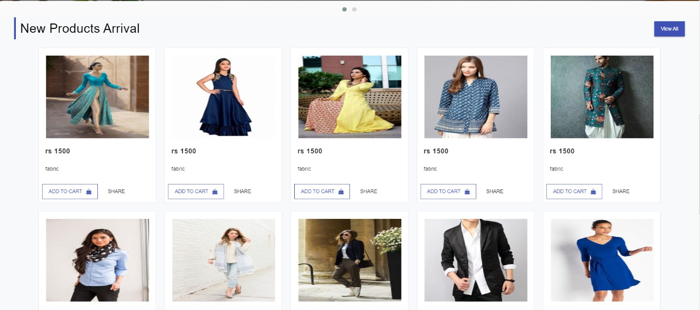

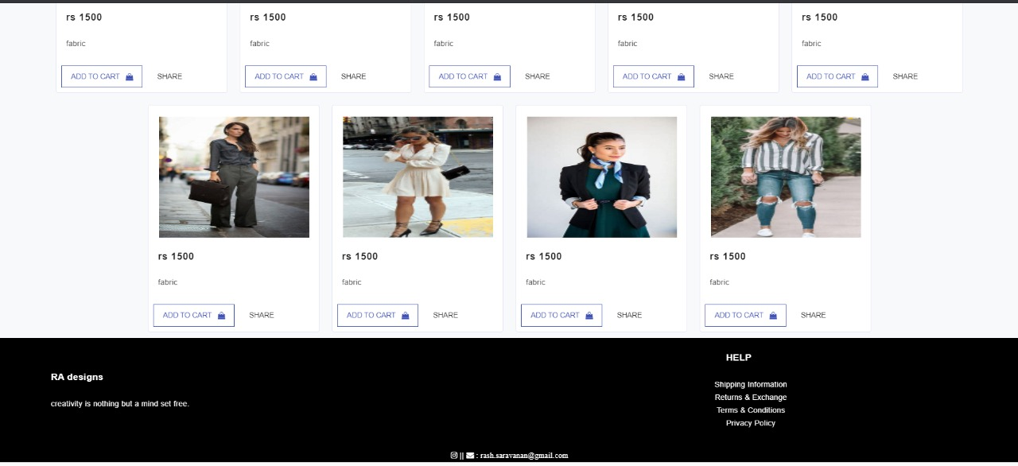

Navigation bar

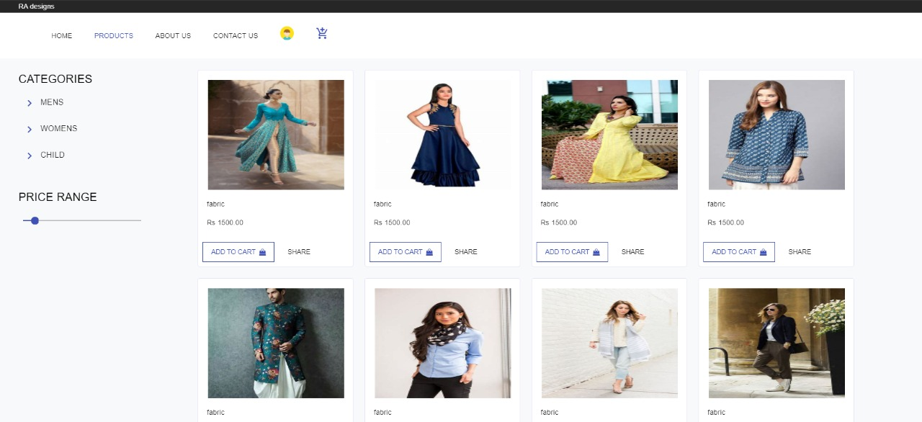

Home page

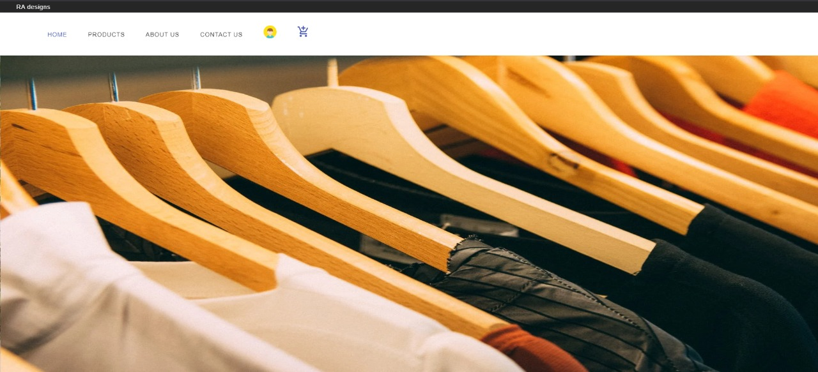

Managing cards

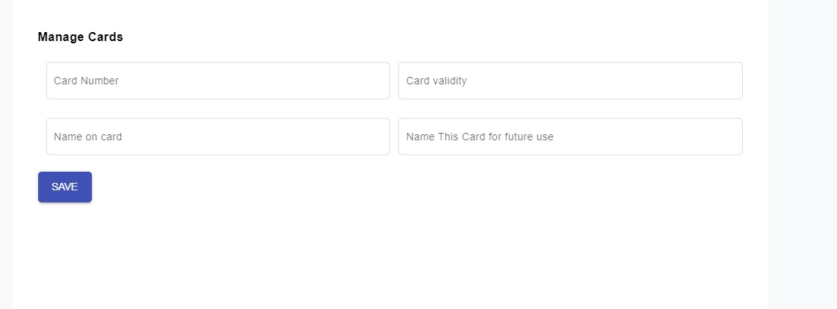

Login page

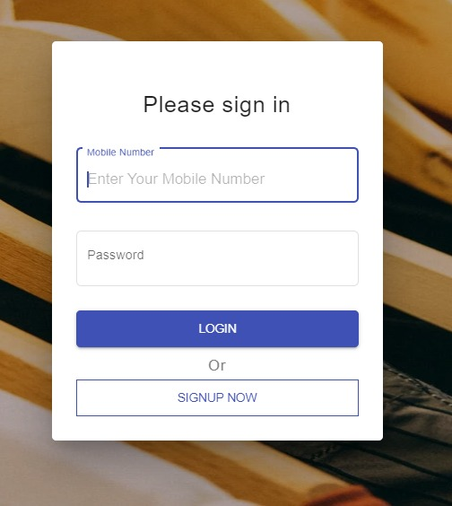

Profile

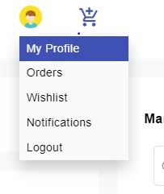

Managing address

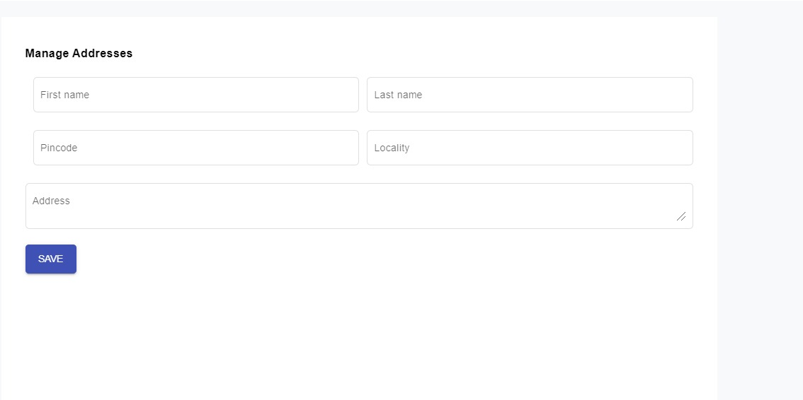

Personal information

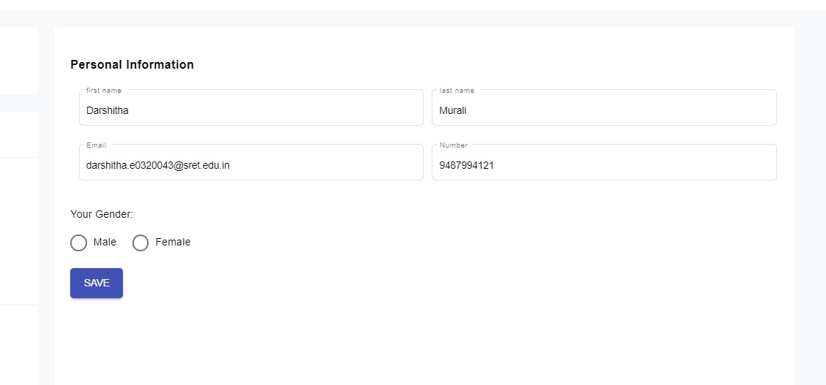

Dashboard

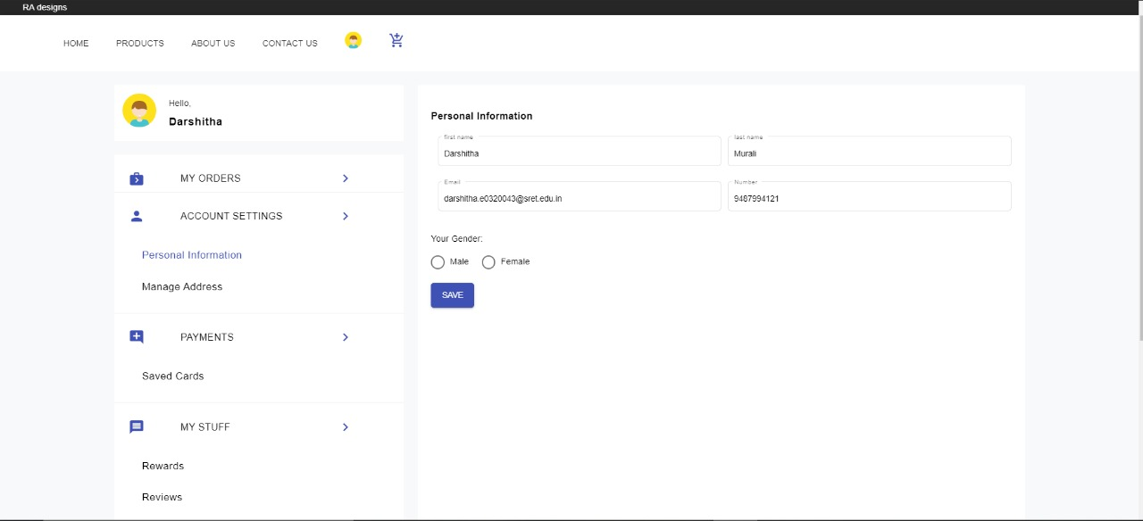

Cart

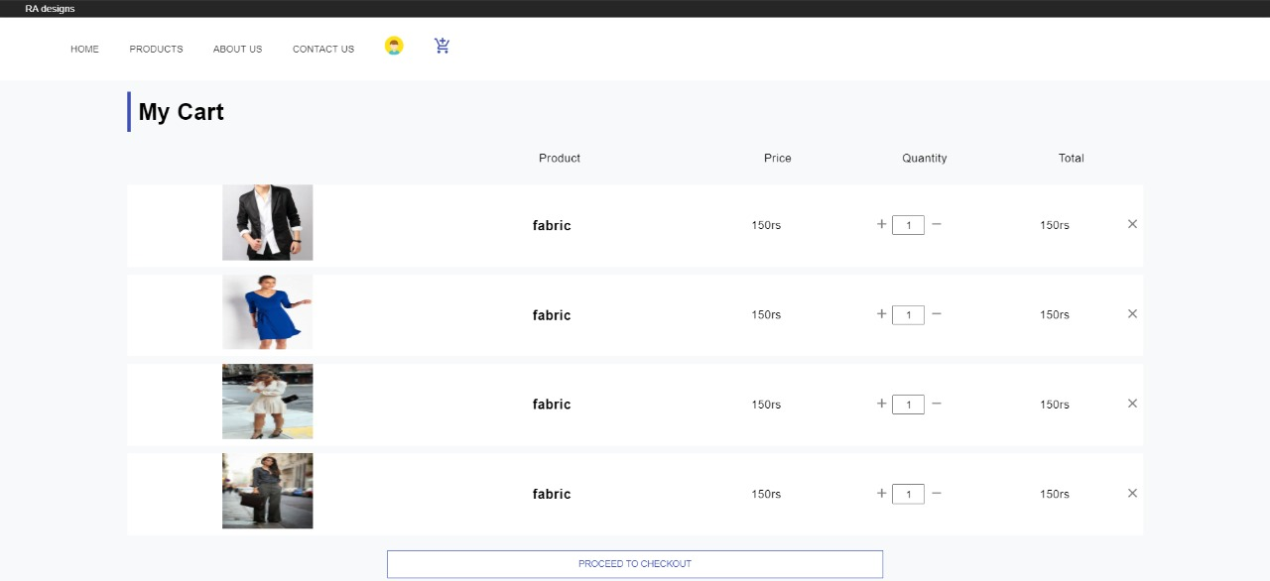

Checkout

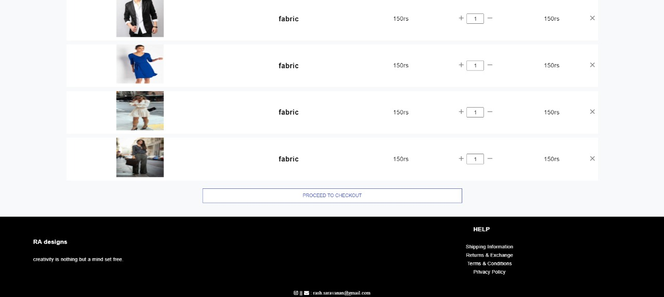

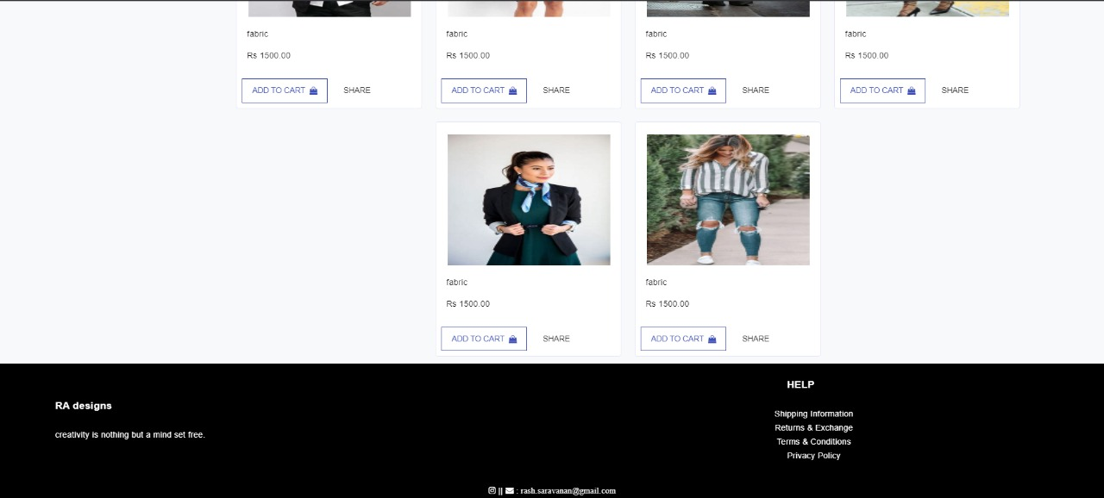

Separate image

